**Our Places of Worship**

**January – June at Union**

**July – December at Antioch**

**Directions to our Church Facilities**

**Our Union Facility**

**Coming from Dillwyn on RT 60, take a left on RT 24, go approximately 5 miles and turn right on Union Church Road. Union will be 1 mile on the left.**

**Coming from Appomattox on RT 24, turn left on Union Church Road. Union will be 1 mile on the left.**

**Our Antioch Facility**

**Coming from Dillwyn on RT 60, take a right onto Greenway Road, go 2.5 miles. Antioch will be on the left.**

**Coming from Appomattox on RT 24, turn left onto RT 60 and then turn right on Greenway Road. Antioch will be on the left.**

**Antioch Union weekly schedule**

**Sunday**

**9:30 am Choir Practice**

**10:00 am Sunday School**

**11:00 am Worship Service**

**Wednesday**

**7:00 pm Bible Study**

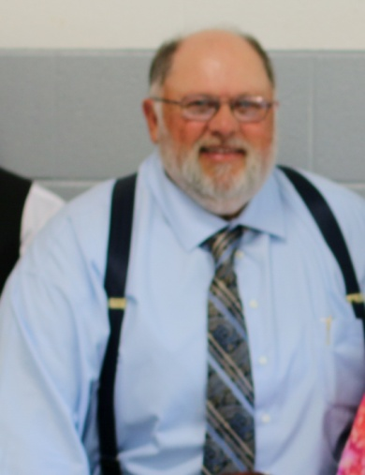

**Love the Lord Your God with all your heart…Love your neighbor as your self. Matthew 22:37-39**

**Pastor “Woody” Wood**

**Cell (434) 607-0795**

**Home (434) 983-3709**

**e-mail- tudder4440@aol.com**

**ANTIOCH UNION BAPTIST CHURCH**

***Join us as we all share in God’s Love***

**Help our Church, your Family, & Yourself Build for the Future**

Join us in a Sunday School Class

Join us for our Wed. night Bible study

Put your musical talents to work in our choir

Join us when we have special events

Encourage children and youth to be active in programs designed to help them grow spiritually

Put the gifts God has given you to work, volunteer with us in our church as we serve the Lord

**Welcome to Antioch Union Baptist Church**

The family of Antioch Union would like to welcome you with open arms. We pray that you find us to be welcoming and loving in a manner that you will feel the presence of God. As a church body we believe that God’s word provided to us in the Holy Bible is inerrant and inspired by the Holy Spirit. We embrace His word as the truth and believe that Jesus provided perfect guidance as to live our lives. Please join us as we strive to learn and live His word and share it with our community.

Join with us as we strive

* To reach out to the community and its physical and spiritual needs in the name of Jesus Christ.
* To volunteer and share our God given talents and gifts to help grow His kingdom.
* To grow spiritually in the study of His word and holding each other responsible as the bible teaches

Please join us in the spirit of love as Jesus taught us to love and share the gospel with our community.

**Pastor *Woody Wood***

**The following scriptures will help answer question you may have about you salvation!**

**Romans 3:23** “For all have sinned and come short of the glory of God”

**Romans 6:23a** “The wages of sin is death”

**Romans 5:8** “God demonstrates His own love for us in this: while we were still sinners, Christ died for us”

**Romans 6:23b** “The gift of God is eternal life through Jesus Christ our Lord”

**Romans 10:13** “Everyone who calls on the Lord will be saved”

If you have any questions about becoming a Christian, feel free to contact Pastor Woody.

For more information about Antioch Union and what we are doing, visit our web site at:

**www.antiochunion.org**

**A brief history of Antioch Union Baptist Church**

The history of Antioch Union Baptist church really involves two paths that lead to the same goal. It began in 1847 with a church known as Poplar Springs. There are no records of the events that took place in this church, but we do know that it burned to the ground in the early 1870’s. At that time Poplar Springs merged with another church whose name is unknown. The two built a sanctuary in 1872. And the name of the church changes to Union Baptist.

In 1893, another church about 7 miles north of Union was organized and took the name of Antioch Baptist. In Feb. 1894, this church bought land for $3.40 an acre and construction was begun on a sanctuary. Originally, five churches composed the field of which Antioch and Union were members. The three other churches included Maysville, Bagby and Pleasant Grove. In 1965 Antioch and Union withdrew from the field of churches and in the year that followed learned to work together in the undertaking of many mission projects.

On the second Sunday of June 1999, Antioch and Union took their biggest step ever in deciding to come together as one church family so they could have a greater impact upon the community for Jesus Christ.

As a church family we are proud of our heritage, but we are more excited about our future.