
THE SERVANT LINK
CHURCHES UNITED TO SERVE -
COMMITTED TO MAKING A DIFFERENCE
James River Baptist Association
P. O. Box 1219, Dillwyn, VA 23936
Mrs. Marilyn Snoddy – Moderator
www.jamesriverbaptistassociation.com
Tel: 434-983-7385 Email: jrba@embarqmail.com
Hours: Monday & Wednesday 8:30 AM – 2:30 PM
____________________________________________________________________________________________________________
Volume XIV December 2015 Edition XII

EVENTS DETAILS

LOTTIE MOON CHRISTMAS OFFERING
& WEEK OF PRAYER
FOR INTERNATIONAL MISSIONS
November 29 – December 6, 2015
Goal: $175 million
100% of your contributions support
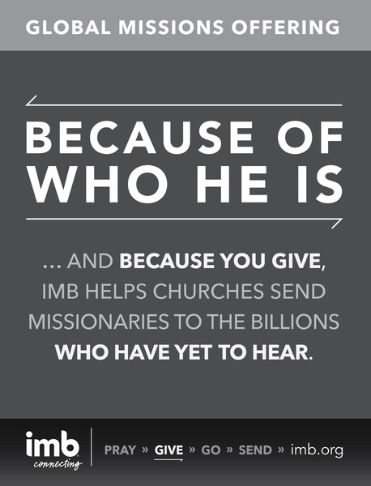
missionaries and their ministries.

December 2 Meet, Greet & Eat at Fitzgerald Memorial 6:00 PM
Special Guest: Charlie from Able Rest Home will be telling the story of The Night Before Christmas.
Everyone is invited to come out and enjoy the fellowship!

December 4 JRBA Pastors & Families Christmas Gathering at The Khols 6:00 PM
Located at 1924 Howardsville Road, Buckingham,VA 23921
For additional information, call Michael at 434-808-2383.

Joyful Noise Gospel Sing at Antioch (Scottsville) 7:00 PM
Held by the Boomer Sunday School Class. All are invited.

December 5 Annual Hunters’ Lucheon at Mt. Zion (Fellowship Hall) 11:00 AM – 1:00 PM
Not just for hunters, EVERYONE is invited! Home cooked chilli, soup, cornbread, dessert and drink for $7 donation.
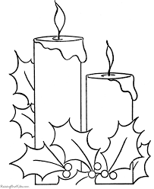
All proceeds benefit Madeline’s House.

December 6 Christmas Banquet at Tar Wallet Noon

Christmas Caroling at Cedar 3:00 PM
Everyone is invited to join the folks at Cedar as they go caroling!

JRBA Hispanic Fiesta at Buckingham 6:00 PM
Buckingham will be serving up tacos and all the fixings. Come out and support our Hispanic Ministry – bring
a side dish or dessert for all to enjoy. Invite your Hispanic friends and neighbors for an evening of Bi-Lingual
fun and fellowship.

December 9 Senior Citizens Fellowship at Mulberry Grove 11:00 AM
Bluegrass/Gospel Music & Covered Dish Lunch

December 11 Blue Ridge Food Distribution at Crystal Cathedral, Dillwyn
Volunteers needed at 9:30 AM

Christmas Play at Mt. Tabor 7:30 PM
All are invited. Refreshments will be served after the play.

December 13 Cumberland Christmas Parade 2:00 PM

Antioch Union’s Christmas Cantata @ Antioch facility 6:00 PM

Refreshments to follow.

Christmas Program at Cedar 6:00 PM
Refreshments will be served after the program. Everyone is invited!

1
December 13 Christmas Play, Traditional Christmas, at Mt. Zion 6:00 PM

Christmas Play at Antioch (Scottsville) 7:00 PM

The play, The Good Shepherd, will be presented – it was written and will be directed by Paula Aldridge.

Christmas Play at First Baptist Dillwyn 7:00 PM
365 Days of Christmas will be presented by the children in the church sanctuary.

Sharon Christmas Cantata, Appalachian Winter by Joseph Martin, presented by the choir. 7:00 PM
Composed in the spirit of folk music, with Shaker hymns and Appalachian melodies, this cantata features a blend of early
American carols, traditional carols, and spirituals, woven together in a tapestry of song and Scritpure. Bring family and friends

to join the folks at Sharon for a special evening of music and fellowship. Refreshments to follow the performance.

December 16 Children in Action Birthday Party for Jesus at Buckingham 6:00 PM
The story of the birth of Jesus will be told. Giving a gift to Jesus through a contribution to the Lottie Moon Christmas Offering will be emphasized. There will be a birthday cake for Jesus, a piñata, games, and gifts for the children. Come join in for a time of worship and fun.

December 18 Christmas Program at Arvon 7:00 PM
Contemporary music will be presented by the Arvon Choir.

December 19 Five Loaves & Two Fish Food Ministry at Antioch (Scottsville) 10:00 – 11:00 AM
Volunteers at 8:00 AM.

Spaghetti Dinner at Fitzgerald Memorial 6:00 PM
Proceeds from the dinner will benefit VBS - $5/person.
Christmas Program at Fitzgerald Memorial 7:00 PM
The children will be presenting The Christmas Window.

Christmas Caroling from Enon TBA
Meals will be delivered to shut-ins in the community.

December 20 Baby Dedication & Deacon Ordination at Antioch (Scottsville) 11:00 AM
Bruce Ward will be ordained as a deacon.

Christmas Cantata at First Baptist Dillwyn 11:00 AM
Breath of Heaven will be presented by the FBC Adult Choir.

Christmas Program at Jones Chapel 11:00 AM
Everyone is invited.

Christmas Lunch at Enon Noon

Christmas Caroling from Chestnut Grove 5:00 PM
Refreshments will be served after caroling.

Christmas Caroling from Fitzgerald Memorial 5:00 PM

Christmas Play at Buckingham 5:00 PM
Bring your favorite dessert or finger food for a time of refreshments and fellowshp following the play.

Mt. Zion’s Live Nativity at Oak Grove Chapel 6:00 – 8:00 PM
The chapel is located at 1031 Chapel Road, New Canton. You may drive by or stop in for some caroling, cookies,
hot chocolate, prayer and fellowship.

Christmas Program at Mulberry Grove 6:00 PM
Followed by heavy hors d’oeuvres
.
December 21 Christmas Cantata at First Baptist Dillwyn 7:00 PM
The Adult Choir will present Breath of Heaven.

December 23 Buckingham’s Children in Action and Youth Christmas Caroling to Gold Hill Village 5:00 PM
After caroling the children will return to the church for hot chocolate.


The JRBA OFFICE
will be
CLOSED
on
Wednesday, December 23, Monday, December 28, and Wednesday, December 30.
To reopen on Monday, January 4.
2


December 24 CHRISTMAS EVE SERVICES:
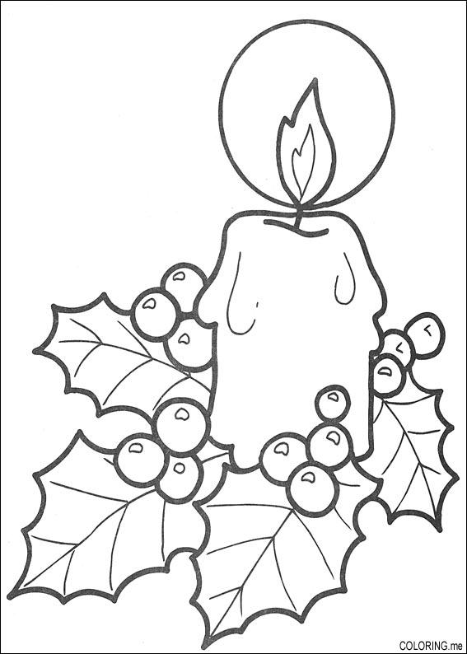
Candlelight Service at Fitzgerald Memorial 5:00 PM
Service at Cedar 6:00 PM
Service at Tar Wallet 6:00 PM
Service at Antioch (Scottsville) 7:00 PM
Christmas Program at Chestnut Grove 7:00 PM
The Christmas Pageant will be presented with refreshments afterwards.
Candlelight Service at First Baptist Dillwyn 7:00 PM
Communion Service at Antioch Union @ Antioch facility 7:30 PM

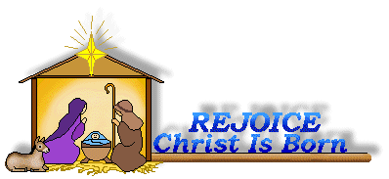
CHRISTMAS DAY
DECEMBER 25

December 31 Goshen & Salem UMC New Year’s Eve Service at Salem 10:00 PM

January 4 INFORMATION DUE TODAY BY 9:00 AM FOR THE JANUARY NEWSLETTER.
PLEASE NOTE THAT THE JANUARY NEWSLETTER WILL BE IN CHURCHES ON THE 2ND SUNDAY.

LOOKING AHEAD>>>

January 11, 2016 JRBA Executive Board Meeting at First Baptist Dillwyn 7:00 PM

March 10, 2016 JRBA Tax & Compensation Seminar at First Baptist Dillwyn 9:00 AM – Noon
Pastors, Church Treasurers & Stewardship Chairs mark your calendars!

May 15 – 20, 2016 JRBA Mission Trip to Bland Ministries
Pray about the possibility of going on this trip to help at the Bland County Ministry Center. We hope to have
a team of 15 adults. This is just the trip for all you folks who would enjoy being involved in a mission oppportunity
close to home at low cost! First come, first serve, so call Phyllis to sign up as soon as possible. (983-7385)

JRBA REACHES OUT>>>

JRBA MISSIONS COMMITTEE

- Hispanic Ministry – Our Christmas Fiesta, a great time of Christmas joy for our Hispanic friends and all of us, will be held on Sunday,
December 6, at Buckingham Baptist Church. The Fiesta will feature games, Christmas carols, delicious food, and a Christmas message.
Everyone is urged to attend and to bring a Spanish-speaking friend and a dish of food for the meal.
Rev. Michael Khol continues to lead a Bi-Lingual Bible Study (Spanish & English) on most Thursday nights at First Baptist Dillwyn. Michael
also leads a Spanish-speaking worship service at the Buckingham Correction Center on the fourth Sunday of each month.
- Stop Hunger Now – We sincerely thank the four churches that have contributed a total of $736 to Stop Hunger Now. I pray that each person
in each of our 18 churches will set aside money each day or each week for this very special mission offering. I pray that as our churches
regularly submit their Stop Hunger Now contributions to our associational office, we will have close to our goal of $7,000 by Monday, March
21, 2016.
- Our Blue Ridge Food Ministry will have one distribution in December on Friday, December 11. Volunteers are needed at 9:30 AM.
- Thanks for your mission support through your financial gifts to More Than Nets, Grace Inside (Prison Chaplaincey), our Alma Hunt Offering for
State Missions, and many others.
In Christ’s Love,
Jimmy Dunn
Rev. Jimmy Dunn, Chair

3

Alma Hunt 2015 Offering for State Missions


Antioch (Scottsville) | $ 1,015.00
Buckingham | $1,500.00
Cedar | $ 580.00
Chestnut Grove | $ 320.00
First Baptist Dillwyn | $ 385.00
Fitzgerald Memorial | $ 51.00
Goshen | $1,227.00
Jones Chapel | $ 155.00
Mt. Tabor | $ 322.00
Mt. Zion | $1,090.00
Mulberry Grove | $ 240.00
Sharon | $ 375.00
Tar Wallet | $ 490.00
TOTAL - $7,750

Samaritan’s Purse Operation Christmas Child Shoeboxes

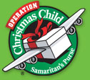
CHURCH | # BOXES
Antioch (Scottsville) | 72
Antioch Union | 60
Buckingham | 72
Cedar | 74
Chestnut Grove | 40
First Baptist Dillwyn | 114
Enon | 31
Fitzgerald Memorial | 77
Goshen | 71
Jones Chapel | 94
Mt. Zion | 62
Mulberry Grove | 74
Sharon | 68
Tar Wallet | 200
TOTAL – 1,109 shoeboxes

Hygiene & Stationery Kits for Prison Ministry

CHURCH | # KITS
Antioch (Scottsville) | 36 Hygiene Kits  Extra Items
Buckingham | 9 Hygiene + 5 Stationery + $50
Goshen | 21 (Hygiene + Stationery)
Mt. Zion | 16 Hygiene + 13 Stationery
Mulberry Grove | 15 Hygiene Kits
Tar Wallet | 66 Hygiene Kits  8 books stamps, 10 boxes envelopes, 22 writing tablets, 176 pencils, 498 cards

WAY TO GO, JRBA! KEEP UP THE GOOD WORK.
4

CHURCH OUTREACH>>>

The Boomer Sunday School Class of Antioch (Scottsville) will offer Christmas cookies on December 13, after the Worship Service. Donations for the cookies goes into the Boomer Fund to help the needy at Christmas. Their 5 Loaves, 2 Fish ministry for October was their Operation Inasmuch project – they served 175 hot meals and gave out clothing. Their food ministry meal in November served 255 individuals a hot Thanksgiving meal and gave out 92 food boxes, each containing a turkey! Antioch did 72 shoeboxes, 16 of which were done by the Girl Scout troop that meets at the church. The J.O.Y.(Just Older Youth) Group and church family prepared hygiene and stationery kits for the Fluvanna Women’s Prison. Antioch is currently planning to prepare care packages to send to one of their church members serving with the military in the Middle East and his other service members. Prayer is requested for Raymond and his family here until he returns home. Beginning December 27, Antioch will begin their Week of Prayer – Each member signs up to pray for one hour. This goes on around the clock for a week. Some members come to the church to pray, others pray at home. The J.O.Y. group have set up an Angel Tree in the back of the worship center. Many children have been adopted, and gifts are appearing under the tree to make their Christmases merry! Pastor David Vogt will be going to India in February along with Malcolm Warfield and his SEED ministry. They plan to plant a one acre garden. Antioch is raising funds for this trip and other mission trips in 2016. They currently have $11,000. If you’d like to donate, please send a check to Antioch Baptist, 4422 Antioch Rd., Scottsville, VA 24590. Please put Mission Trip Fund on the memo line of your check.

Antioch Union is assisting a family after a member had major surgery. The church also provided food and supplies for the football team for the Feed the Team Program twice.

A Thanksgiving fellowship meal was held at Buckingham after worship on November 22. There was good food, beautiful decorations, and good fellowship. A take-out meal was prepared for the shut-ins.

On November 9, Cedar had a “Shoebox Packing Party” aimed especially to the youth of the church so that they could get a real idea of what the shoebox ministry is all about. There was a pizza dinner first, then the youth made a couple of items that they could include in the shoeboxes. Each child made a copy of their handprint which was placed in the top of the boxes, after which the kids were led in a prayer for the children who would receive the gifts. There were 42 youngsters and helpers present and everyone there received a special blessing. This was Cedar’s first “Packing Party”, but they pray it will not be the last as the kids were really excited about it. 72 shoeboxes were filled. The Cedar family along with the Women on Mission distributed food, including a turkey and bag of potatoes, to five different families for Thanksgiving. Praise the Lord for such a generous church family!

Chestnut Grove is collecting for two local families this Christmas.

On Sunday, November 22, First Baptist Dillwyn cooked and delivered 119 Thanksgiving dinners to many homes of the area. FBC shared in a Veterans Day Service at the Buckingham Correction Center on Friday, November 13. The church choir sang patriotic songs and Vic Moss, an Army veteran of the Vietnam War spoke. Helping Hands hosted the Dakota Tribe of the Discovery School for a night of games and dinner on Thursday, November 19. The boys and Helping Hands members all had a great time.

Fork of Willis delivered three bags of groceries along with a turkey to four families on November 22. They had already delivered two complete meals to the families earlier. Fork of Willis members feel so blessed to help these families for the holidays.

Goshen took 35 Thanksgiving plates to the shut-ins in the community.

Jones Chapel is adopting five elderly families/individuals for Christmas and will be taking food boxes to them. They will also participate in the Christmas Mother program in Cumberland County. Food was given to a family in need during November and an electric bill paid for another family from the church Home Mission Fund. They continue to assist when they are made aware of needs.

On November 15, children and adults stayed after worship service at Jones Chapel to pack Operation Christmas Child shoe boxes. After eating a pizza lunch, a total of 94 boxes were packed. April Whaley delivered them to Bethlehem Baptist, the drop-off location. Pictured below are some of those who helped pack boxes.

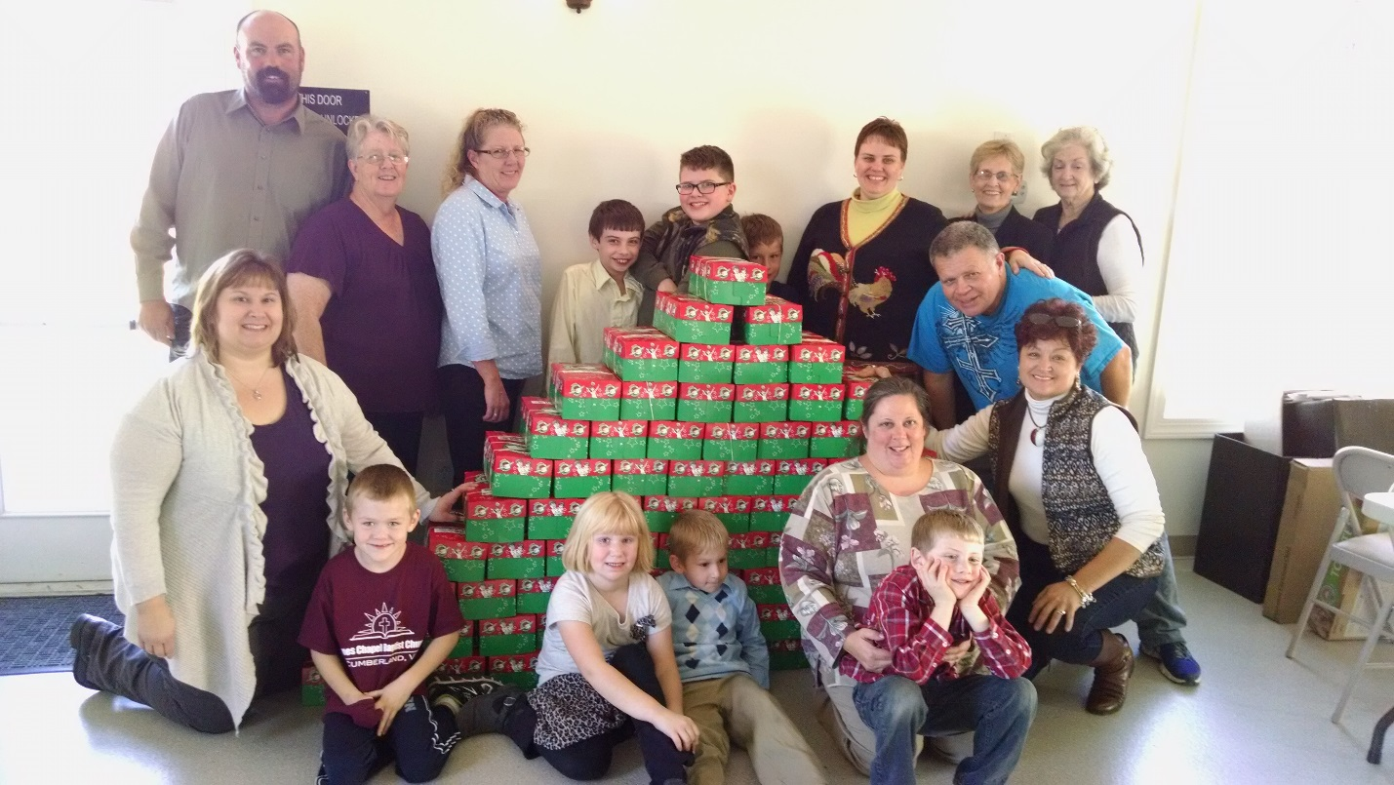

Mt. Zion fed the Buckingham Knights High School football team on Friday, November 13, before their first playoff game. The “Feed the Knights” program was started by Matt Allen, Coach and former player, so that all the youth would have a hot meal prior to their game. A hot meal of chicken, mashed potatoes, macaroni and cheese, green beans, rolls, and cookies was enjoyed by 32 players, 6 coaches, and 2 janitors. The folks from Mt. Zion were impressed by the great manners exhibited by all the players who were seated and waited for Coach Gill to bless the meal prior to fixing their plates. To go meals were also delivered to several church members who were ill. Mt. Zion contributed to the Shoes for Christmas project for national partners of a family serving IMB. The Youth gave $100 for a family (husband, wife, & 3 children); the Baptist Men gave $75 for another family (husband, wife, & 3 children; and Mt. Zion’s WMU gave $100 for another family (husband, wife, & 4 children). May God bless the work of our local family serving abroad. Mt. Zion’s WMU took a “blue envelope” at the WMU workshop from Dee Dee Hoosier for Bland County Ministries. The envelope they chose was 72, so they sent $72 to Bland. Mt. Zion sent $200 to the Southwest VA Partnership, Nickelsville, VA, serving people with home repairs. The youth packed hygiene kits for the Fluvanna Correctional Center. Mt. Zion donated a total of 29 kits for the women at Christmas.

The Mulberry Grove family worked on several projects in November. Individuals packed shoeboxes for Operation Christmas Child and hygiene kits for the Fluvanna Women’s Correctional Facility. The church delivered non perishable food items and a monetary donation to an individual who lost everything in a fire. Members continue to minister to the community with visits, food, and calls, as well as volunteering at the bimonthly food distribution at Crystal Cathedral and attending the Hispanic Bilingual weekly Bible study. December’s projects include the Lottie Moon Christmas Offering, collecting seeds for the SEED Ministry, doing exam care packages for Longwood and Hampden-Sydney, and contributing to the Hispanic Fiesta on December 6.

Special prayers of dedication were offered on Sunday, November 22, for Operation Christmas Child shoebox gifts beginning their long journey to children around the world. Rose of Sharon continues to deliver homemade soup to those who are sick or homebound, and contributes magazines to the Prison Ministry.

Tar Wallet held their Fall fest on October 31 from 3 – 5 PM. Over 100 people were in attendance. At 5:00 PM, they also held a Trunk-or-Treat for the children. Tar Wallet WMU and congregation provided 66 hygiene kits as well as many stationery items for the Fluvanna Women’s Prison Ministry. They held a “boxing party” on November 8 to pack 200 boxes for Operation Christmas Child.

5
LEARNS AND GROWS>>>

JRBA Pastors’ Huddle
On November 18, eight pastors* from JRBA met for a time of fellowship and encouragement. We had the pleasure of welcoming Rev. Richard Tuttle, the new pastor from Jones Chapel), to our group. In lieu of a huddle in December, we are getting together for a Christmas celebration. Pastors, please bring your families to my house on December 4, at 6:00 PM.
Michael
Rev. Michael Khol

*Dr. Jeff Cranford, Rev. Jimmy Dunn, Rev. Michael Khol, Rev. Richard Tuttle, Rev. Perry Clore, Rev. John Moxley, Joe Stanley, and Goshen’s pastor were in attendance.

Churches Learn and Grow>>>

Goshen has started youth groups with around 10 Children in Action and 3 – 4 Youth in Action. The groups meet once a month.

During the month of November, Jones Chapel and other churches in the community joined with Hatcher Baptist for “Wednesdays in the Word”. Each week they enjoyed a delicious meal, beautiful singing and an excellent Bible study on the Holy Spirit. The folks at Jones Chapel appreciate Pastor Cloud and their friends at Hatcher Baptist for inviting them each year.

Mt. Zion has a new ministry – Prayer Ministry. Carl Snoddy, leader, Brenda McAllister, John McAllister, Dorothy Davis, and Betsy Bryant are the members of the ministry group. On November 21, they opened the church at 9:00 AM to 3:00 PM so anyone could come and pray. They encouraged members to come and pray for the church, the community, the nation and the world, and give God thanks for all He has done for them. Matthew 18:19 – 20: Again, truly I tell you that if two of you on earth agree about anything, then ask for it, it will be done for them by my Father in Heaven. For where two or three gather in my name, there I am with them. The Prayer Ministry will meet again before Christmas.

Mt. Zion had four ladies go to the WMU Getaway. The Sunday following the retreat each one told the one thing that stood out to them:
BARBARA SNODDY: I enjoyed the breakout session on “All Roses Have Thorns”, led by Kathy Kim. A rose is a symbol of beauty, but every rose has thorns. The thorns are painful, but they help the rose to grow. We all have things in our lives that trouble us or cause great pan (thorns). Our thorns have a purpose and they are a part of who we are and make us stronger. They help us find peace in knowing that God is in control and builds our relationship with Jesus. Ms. Kim referenced II Corinthians when Paul pleaded with the Lord that the thorn in his flesh given to him by Satan would depart and God said, “My Grace is sufficient for you. His strength is made perfect in weakness.” The rose gives me this vision now.
DOROTHY DAVIS: The breakout session on “Songs of Advent and Christmas”, led by Keith Tan touched my heart. He told the meaning of the words which made the music come alive for me.
BRENDA MCALLISTER: To meet Tammy Stacks, Project Ruth, Romania, touched my heart because I’ve been to the Ruth School. To talk with her and hear how the school continues to grow just gave me a wonderful blessing.
MARILYN SNODDY: God spoke to me when our president, Pat Wright, said, “Every church needs a GA, even if there’s only one girl, because I was that one girl in my church and now I’m the WMUV President!” I came home and ordered GA literature and will get the GAs going again at Mt. Zion.

Five members of Rose of Sharon attended the Women’s Getaway at Eagle Eyrie, enjoying each other’s company as they joined their sisters in Christ from across the state for a wonderful time of worship and inspiration. Those attending were Audrey Ragland, Gayle Noble, Marie Fraticelli, Genie Bradshaw, and Liz Steger. Phyllis Tyler, Mulberry Grove, was happy to go with the ladies from Sharon.

JRBA Meets & Greets Muss!

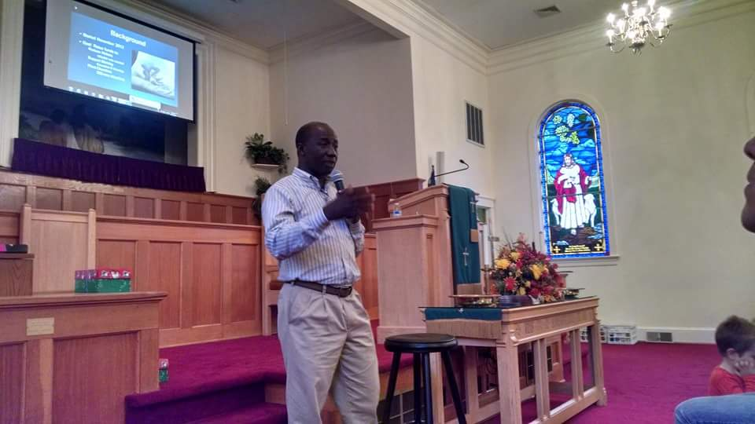

The James River Baptist Association hosted a “Meet & Greet Muss” on Thursday, October 29, at Mulberry Grove Baptist Church. Twenty-eight pastors and laypersons from seven area churches gathered to enjoy lunch and to hear about the “More Than Nets” partnership with Ghana Baptists. Emmanuel Mustapha, Director of Ghana Baptists, described how teams go into the villages surrounding Yendi, Ghana, distributing mosquito nets and the impact this ministry is making on the occurrence of malaria in that region. He told about the church plants, the training program for indigenous pastors, and the new women’s center where local women are trained in marketable skills to impact the economic status of their families. Muss explained how the $10/net is utilized through the More Than Nets program ( $6 – mosquito net, $2 – Education -teach them how to use the net, $1 – Transportation, $1 – Church Planting). Muss also informed us that Virginia Baptists have already donated 63,000 nets during the time of our partnership with Ghana Baptists, planted hundreds of churches, and seen thousands come to know the Lord and be baptized. He asked that we “pray, go, and give”. A donation of $400 (40 nets) was made by JRBA to More Than Nets. Some individuals also sent donations to the project. It was a good time of fellowship and learning.

If you or your church want to donate, please make your check payable to Baptist General Association of Virginia with “More Than Nets” on the memo line. Mail to BGAV, 2828 Emerywood Parkway, Richmond, VA 23294. If you or your church want more information on this partnership project, go to www.bgav.org and click on the Missions tab, then click on More Than Nets. You can read the information or download videos about the effort.

Ministers’ Wives Retreat at CrossRoads

The Ministers’ Wives Retreat had a “Garden Getaway” theme. We used Group’s retreat materials for women. It was a beautiful weekend, lots of sunshine and fall leaves. My favorite part was our walk after breakfast on Saturday. Each of us took our Garden Getaway booklets and were led on our own prayer walk to explore where God was speaking into our lives. I have attended this weekend for seven years and it is always a welcome and relaxing time away from home to rejuvenate and share with like-minded women.
Kristye Moxley

OTHER EVENTS>>>

Chestnut Grove had a great turnout for their Thanksgiving dinner on November 22. Everyone enjoyed the food and fellowship as well as the music by Michael Wayne Smith and The Hickmans. Their Scholarship Auction Sale cleared over $3,000.

Mt. Zion had an enjoyable Thanksgiving Dinner after worship services on Sunday, November 22, with turkey and all the trimmings.

Tar Wallet planned to hold a “Hanging of the Green” on November 28 at 2:00 PM to decorate the church for Christmas.

6

Missionary Moments>>>

December 1, 2015
…And the Lord added to the church daily such as should be saved.”
Acts 2:47
The leaders of the new church starts in 5 different towns in the Provence of Córdoba, Argentina, have begun and every week there are new believers committing their lives to the Lord. These new church leaders are confronting sin head on. Pray they would walk closely with the Lord and be a witness not only in their words, but also in their actions and that the Lord will guide them as they confront different problems.

Hope Martin, Prayer Coordinator
Central NorthernArgentina Affinity Mobilizer


JRBA CELEBRATES>>>

Antioch (Scottsville) had a new family join their church in November. Aaron and Wanda Pace and their family were welcomed into the Antioch fellowship.

Cedar welcomed into their church family Jason Atkinson by profession of faith on November 15, to be followed by baptism soon.

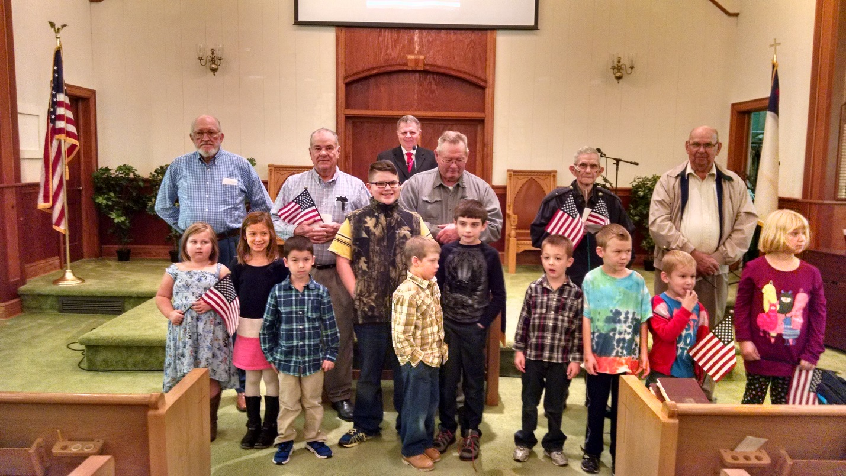

On November 11th, a Veterans Day screen presentation featured pictures of Jones Chapel’s veterans in uniform, both living and deceased. After this very moving tribute, the children presented the veterans who were present with thank you cards, and an American flag. Veterans pictured left to right are: Cleo Speas, Gene Bradbury, Jim Cook, Ray Martin and Billy Waycaster (Pastor Tuttle is at the pulpit). Children left to right: Savannah Skeens, Caitlin Whaley, Bryce Whaley, Mark Tuttle, Dustin McCollom, Hosten McCollom, Josh Whaley, Justin Parker, Jack Parker and Anna Parker.

On Sunday, November 22, the congregation of Sharon Baptist honored Rev. and Mrs. Perry Clore with a delicious covered-dish luncheon. In the spirit of Thanksgiving, it was good for the church family to just be together, and to share a special time of reflection and expression of love and gratitude for the many blessings the Lord continues to bestow upon them.

IN APPRECIATION>>>

November 6, 2015
JRBA,
I just want to thank you for the gift card and recognition of service. It means a lot, though I hope to be able to serve more in the future. I love our association and am so proud to be a part of it. May God continue to bless our efforts.
Love,
Liz Steger*

*Liz is the former JRBA Disaster Relief Coordinator.
November 8, 2015

JRBA,
Antioch and the Clore family want to thank you for the generous gift in memory of Rev. Earl Clore. The family will be told of your thoughtfulness and gift to our building fund.
Lemoyne Wentz
Administrative Assistant

November 8, 2015

JRBA,
I am just getting to many, many emails and I apologize for being late with this. We are so appreciative for the memorial gift in memory of Perry’s dad. We also thank each and everyone for all the prayers and concerns for Perry and our family during this time. We know his dad is in God’s presence and doing well.
God’s Blessings to All,
Perry & Shari Clore

IN LOVING MEMORY>>>

Antioch (Scottsville) lost another church member, Sam Roberts. Please keep his wife, Bernice, and family in your prayers.

FOR YOUR INFORMATION>>>

- Enon is planning a fundraiser beginning on December 4. They will be raffling off a handmade quilt. A donation of $2 is requested for each ticket. Proceeds from the fundraiser will go towards the purchase of a new church sign. Contact any Enon church member to obtain tickets.
- To support our troops with a Christmas card or note, send to:
Holiday Mail for Heroes
P. O. Box 5456
Capital Heights, MD 20791-5456
Show love and support – deadline December 6.
- PLEASE NOTE CHANGE IN JRBA MAGAZINE COLLECTION: We will no longer be collecting secular magazines for the prison. You can still bring in Religious/
Inspirational magazines and Sunday School literature for the Hope Aglow Prison Ministry. So please continue to bring in your leftover literature and magazines like Home Life and Guideposts, but do not bring others such as Good Housekeeping, Woman’s Day, Southern Living, etc.
- Please note that the JRBA Operation Inasmuch Missions Blitz was the lead story on the BGAV web site blog the week of November 23. If you want to see the post, go to www.bgav.org; under BGAV Blog, scroll down and click on “James River Baptist Association Serves Its Community”.
- JRBA WMU’s participation in the local Backpack Ministry was recently highlighted in the Buckingham Beacon. See the November 13 – December 10, 2015 edition, pp. 12-13.
- CORRECTION TO THE SUMMARY OF THE JRBA FALL MEETING – specifically, information on the IMB was misstated in the summary: “IMB president David Platt announced Thursday that the agency needs to cut at least 600 missionaries and staff in order to balance its budget. Those cuts are needed to make up for a $21 million deficit for 2015. The first of the cuts will come from voluntary retirements, followed by a restructuring. Overall, the IMB could release as many as 800 employees, according to a FAQ posted on the IMB’s website. Currently, the IMB has about 450 staff and about 4,700 missionaries overseas, down from 5,600 in 2009. Platt said earlier this year the total number of missionaries would likely drop to about 4,200 – a 25% decline from 2009.” (From Christianity Today, 8/27/15, and the 2016 IMB Fiscal Resources Strategy Plan.)

7

JRBA WMU

The JRBA WMU held their Fall Workshop on Sunday, October 11, at Buckingham Baptist with 40 people present. Nancy Morris, Chestnut Grove, provided the special music and Rev. Doug Adams, Buckingham, led in a short devotional after welcoming the group. Dee Dee Hoosier, Director, Bland Ministry Center, presented an overview of the many ministries offered at the center, including the food bank which serves many people in the area and surrounding counties. This is a lifesaver for the families who are either unemployed or underemployed. There is a clothes closet which provides clothing for many school children as well as adults. Ministry teams volunteer all summer, helping with construction projects for elderly people in the area who cannot afford the needed repairs. The Dental Clinic provides much needed dental help for those who qualify. Our association has taken a team for the last two summers. They have assisted at the Ministry Center, the Dental Clinic, and with various home repairs. Some at the workshop were interested in volunteering for our next trip in May, 2016. There are many needs in this depressed area.

The Associational WMU World Day of Prayer was held at First Baptist Dillwyn on November 2 in conjunction with our sister Africa American churches under the leadership of Betty Toney and Marie Gillespie. It was the 10-year anniversary of the event and to commemorate the occasion, a letter, composed by Marie Gillespie, was sent to all the churches involved, explaining the occasion and the history of the World Day of Prayer. An offering envelope was enclosed requesting that each church make a donation to the many ministries of the North American Baptist Women’s Association. The offering was the largest ever in the amount of $445.00. The meeting was memorable in that all former participants in the WDP programs were recognized and given a bookmark by Mrs. Gillespie, with the inscription, “I’m Appreciated”.

The new theme for the next five years is “Arise, Shine: When we rise up He shines through.” Isaiah 60:1. The new theme was explained by Betty Toney and the poster, donated by Valeria and Frank Breault, was explained by Marie Gillespie. Pastor John Moxley presented a devotional based on the scripture from Isaiah. A highlight of the program was the skit by Ruby Gray and Valeria and Frank Breault based on Luke 4:38-39 when Jesus healed Peter’s mother-in-law and straight-way she arose and served them. We are saved to serve!

Rev. Ilie Coada, a Baptist minister from Moldova, was portrayed by Rev. Michael Khol, Mulberry Grove. We learned that Rev. Coada has devoted his life and resources to preventing young girls from becoming victims of human trafficking. Mrs. Marion D. Scott portrayed Sela Koiya, from Papua, New Guinea, detailing her battle with TB and the HIV virus. After the testimonies, the group retired to the fellowship hall to pray in small groups for the needs of each continent. There were 34 present for the program.

I also want to thank the different groups who gave money for the Shoes for Christmas project for national leaders in partnership with a local family serving IMB. They send their thanks. Gift certificates will be presented to the leaders at their Christmas Party.

Also, thank you to Arvon, Buckingham, First Baptist Dillwyn, Mulberry Grove, Mt. Zion, Rocky Mt. UMC, and Barry Miles who contributed prescription bottles for The Malawi Project. The Malawi Project is an organization out of Indiana that collects and ships used prescription bottles to Malawi. The doctors and pharmacies there don’t have enough resources and are often forced to hand out pills wrapped in paper. Someone in Abingdon was our go-between in helping with this project. A special “Thank You” to Les & Skippy Brown for transporting the bottles to Bland to be picked up.

Betty Toney
JRBA WMU Director


KEEP IN PRAYER>>>

- Those who are lost and need to know the Savior
- Churches without a pastor: Arvon, Chestnut Grove, Enon, Mt. Zion
- JRBA Pastors
- JRBA Hispanic Ministry (Bi-Lingual Bible Study & Prison Ministry)
- Florica, JRBA WMU Project Ruth adoptee
- Local family serving IMB
- All those in our congregation who are ill or have lost loved ones.
…the prayers of the righteous please Him.
Psalm 15:8b

FROM YOUR MODERATOR>>>

Greeting to all and hope you had a Blessed Thanksgiving. We serve a Great God and to count our blessings and name them one by one, is really something to think about. Our world needs much prayer with all the terrorist attacks. About all we can do is pray, be ready, and cling to Jesus and His Word. 2 Timothy 4:6-8: For I am now ready to be offered, and the time of my departure is at hand. I have fought a good fight, I have finished my course, I have kept the faith; Hence forth there is laid up for me a crown of righteousness, which the Lord, the righteous judge, shall give me at that day; and not to me only, but unto all them also that love His appearing. However, whether by death or Jesus’ appearing, we need to BE READY, and help as many as we can to be ready also.”
In Christ’s Love,
Marilyn
Marilyn Snoddy

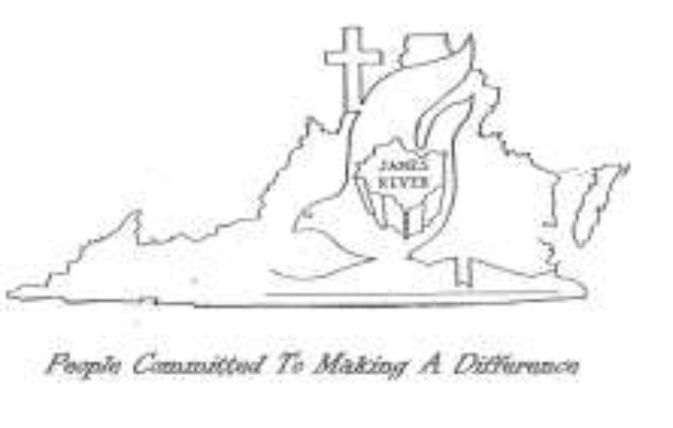

ACCOMPLISHING TOGETHER
WHAT WE CANNOT DO ALONE

8

ASSOCIATION FINANCES
2015 - 2016

CORRECTIONS TO FINANCIAL INFORMATION
NOVEMBER 2015 NEWSLETTER

- Stop Hunter Now Total should have been $636.00. (TYPO)
- Youth Encounter Balance of $400.00 was correct as $100 was utilized for the JRBA Youth Event at Sharon earlier in the 2014-2015 year.

Regular Budget Receipts
Church | November | Year-to-Date
Antioch(Scottsville) | $ 300.00 | $ 300.00
Antioch Union
Arvon
Buckingham | $ 261.74 | $ 261.74
Cedar
Chestnut Grove
Enon
First Baptist Dillwyn
Fitzgerald Memorial
Fork of Willis |  | $ 429.00
Gladstone Memorial |  | $ 331.25
Goshen
Jones Chapel | $ 115.76 | $ 216.09
Mt. Tabor
Mt. Zion
Mulberry Grove
Sharon |  | $ 391.00
Tar Wallet
Individuals |  | $ 100.00
VBMB – Alma Hunt
TOTAL | $ 677.50 | $2,029.08
Approved Budget for 2014 – 2015: $24,671.00

TREASURERS: Please note that unless a specific ministry or project is designated on the memo line of the check or in an accompanying note, the contribution will appear in the regular budget receipts.

ADDITIONAL MISSIONS FUND
No contribution or expenditures during November.
Earlier individual contribution: $100 (More Than Nets)
Earlier expenditures: BGAV More Than Nets - $400
BGAV Carolina Flooding - $300
Balance: $378.00

YOUTH ENCOUNTER
Carryover: $400.00
No contributions or expenditures in November.

LOCAL MISSIONS PROJECTS FUND
Carryover: $258.04
No Contributions or Expenditures in November.
Earlier Contributions: ½ Fall Meeting Plate Offering - $212.00
Individual - $100.00
Balance: $570.04

BGAV SYRIAN REFUGEE CRISIS
½ Fall Meeting Plate Offering: $212.00
October Expenditure $212.00



2016 Stop Hunger Now Event

Church | November | Total-to-Date
Antioch
Antioch Union
Arvon
Buckingham
Cedar
Chestnut Grove
Enon
First Baptist Dillwyn |  | $ 305.00
Fitzgerald Memorial
Fork of Willis
Gladstone Memorial |  | $ 321.00
Goshen
Jones Chapel |  | $ 10.00
Mt. Tabor
Mt. Zion
Mulberry Grove
Sharon
Tar Wallet | $ 100.00 | $ 100.00
Individuals
TOTAL | $ 100.00 | $ 736.00*
*Total includes funds given after the May 2015 event .

JRBA Hispanic Ministry

Church |  | Total-to-Date
Carryover |  | $ 850.82

No contributions or expenditures in November.
Balance on Hand: $ 695.62

John E. Mann, Sr. Benevolence Fund

Church | November | Total-to-Date
First Baptist Dillwyn |  | $ 500.00
Sharon |  | $ 200.00
TOTAL |  | $ 700.00
November Disbursements: $ 300.00
Balance on Hand: $ 2,936.99

Thank you to all Church Clerks for your hard work and dedication in compiling and returning your 2015 Annual Church Profiles. JRBA was 100% in reporting again this year!
Phyllis

9

