 THE SERVANT LINK
CHURCHES UNITED TO SERVE -
COMMITTED TO MAKING A DIFFERENCE
James River Baptist Association
P. O. Box 1219, Dillwyn, VA 23936
Mrs. Marilyn Snoddy – Moderator
www.jamesriverbaptistassociation.com
Tel: 434-983-7385 Email: jrba@embarqmail.com
Hours: Monday & Wednesday 8:30 AM – 2:30 PM
____________________________________________________________________________________________________________
Volume XV January 2016 Edition I

EVENTS DETAILS

January 3 Collegiate Ministries Day

January 8 & 22 Blue Ridge Food Services Food Distribution at Crystal Cathedral, Dillwyn
Volunteers needed at 9:30 AM.

January 11, 2016 JRBA Missions Committee at First Baptist Dillwyn 6:30 PM
JRBA Executive Board Meeting at First Baptist Dillwyn 7:00 PM
Pastors and Church Representatives are encouraged to attend.

January 13 Senior Citizens Fellowship at Mulberry Grove 11:00 AM
Bluegrass/Gospel Music & Covered Dish Lunch

January 14 D. MIN. Informational Lunch at Baptist Theolotical Seminary at Richmond 11:00 AM – 1:00 PM
For Ministers interested in pursuing a Doctor of Ministry degree. Come hear more about the program and dialogue with
current students and the Dean. Please register on the web site at www.btsr.edu.

January 17 Sanctity of Life Sunday

January 20 JRBA Pastors’ Huddle at First Baptist Dillwyn Noon

January 23 Five Loaves & Two Fish Food Ministry Meal at Antioch, Scottsville 10:00 – 11:00 AM
Volunteers at 8:00 AM.

January 31 5th Sunday Song Service followed by Soup & Sandwich Meal at Arvon

January 25 Information due today by 9:00 AM for the February newsletter.

LOOKING AHEAD>>>

February 7 – 14 WMU Focus Week

February 12 – 13 Vacation Bible School Curriculum Fair at The Resource Center
Located on the Virginia Union University Campus, 1500 Lombardy St., Richmond
The Resource Center is partnering with Cokesbury for special discounts!
Preview materials on Thursday, February 11, from 1 – 4 PM, Fair will be on Friday, 1 – 5 PM, and Saturday, 10 AM – 2 PM
For more info: Call 804-358-8306

February 13 Valentine Dinner & Movie at Enon 6:00 PM
Dinner at 6 PM, followed by a movie. All are invited to come and enjoy the fellowship!
Enon is currently holding a raffle for a homemade quilt. Tickets are $2.00 each and can be purchased from
any church member. Proceeds to the New Church Sign Fund. The drawing will be held at the Valentine event.

February 20 Missions Craft Retreat at CrossRoads
If interested in attending, call 800-255-2428, Ext. 8267.

March 10 JRBA Tax & Compensation Seminar at First Baptist Dillwyn 9:00 AM - Noon
Led by Dr. Jeff Cranford. Pastors, Church Treasurers, and Stewardship Chairs mark your calendars and plan to attend.
Register: angela.house@bgav.org or call 800-255-2428.

March 21 Due date for Stop Hunger Now contributions!
We need to have the funds in early this year so that we can apply for BGAV World Hunger assistance with our event.
The more we have in hand, the more likely we can receive additional funds.
1

STANDING ROCK MISSION TRIP
(Sponsored by WMUV)
July 24 – 29, 2016
TRAINING
February 20 – Virginia Baptist Resource Center, Richmond
New Volunteers: 9:00 AM – Noon Site Leaders: 1:00 – 4:00 PM
April 16 – Virginia Baptist Resource Center, Richmond
New Volunteers: 9:00 AM – Noon All Going on July Trip: 1:00 – 3:00 PM
Call 800-255-2428 if interested in going to Standing Rock this year!
Register for the Training events online at www.wmuv.org starting January 15.


May 1 JRBA Stop Hunger Now Meal Packing Event at Maysville Baptist Multipurpose Center 3:00 PM
Start now getting volunteers lined up to help with this event! We will need some strong folks at 2:00 PM to
set up and folks to remain and help clean up after we finish packing the meals. Let’s make this our BIGGEST
Meal Packing event ever! Contributions need to be in to the JRBA office by Monday, March 21.

May 10 Virginia Baptist Historical Society Annual Meeting
Terry Towler, FBC, representing JRBA

May 15 – 20, 2016 JRBA Mission Trip to Bland Ministries
Pray about the possibility of going on this trip to help at the Bland County Ministry Center. We hope to have
a team of 15 adults. This is just the trip for all you folks who would enjoy being involved in a mission oppportunity
close to home at low cost! First come, first serve, so call Phyllis to sign up as soon as possible. (983-7385)
Those already signed up: Nancy Morris (Chestnut Grove), Thelma Childress, Henry & Dixie Wood, Bruce & Jill
Falls (First Baptist Dillwyn), Carol Ragland (Goshen), Gwynn & Phyllis Tyler (Mulberry Grove).

JRBA REACHES OUT>>>

JRBA MISSIONS COMMITTEE

- Our next Stop Hunger Now packaging project will be held on Sunday, May 1, at the Maysville Baptist Multi-Purpose Center. In order to apply for a grant from our Virgnia Baptist General Association, we need to have most of our money in hand by Monday, March 21. So, I challenge each of us to set aside some money daily for Stop Hunger Now and turn it in as soon as possible. As all of us give generously to this special mission project, we can raise $6,000 by Sunday, March 21!
- Hispanic Ministry – A group of about 20 Hispanics and 30 Anglos were blessed by a very fine Christmas Fiesta at Buckingham Baptist Church on Sunday, December 6. The Fiesta featured delicious food, games, beautiful music, and a Christmas message by Rev. Michael Khol. Rev. Khol will resume the Bi-Lingual Bible Studies and other activities for our Hispanic friends early in January.
- Our JRBA will be sponsoring a mission trip to the Bland Mission Center May 15 – 20, 2016. We will need volunteers to do repair work, cut grass, paint, distribute food, operate the clothes closet, work in the dental clinic, and do other work as needed. If you would like to be a part of this team, please let Phyllis know right away. (Call 434-983-7385.)
- Mission Volunteers – We are very pleased that some volunteers from our association will be going on mission trips in the near future.
- Gwynn Tyler, Mulberry Grove, will be going with a group from Drakes Branch on a construction mission team to Honduras in February.
- Malcolm Warfield will be leading a mission trip from Antioch, Scottsville, on a SEEDS mission to India. Rev. Dave Vogt, Anthony Clore, and Daniel Wagner will be going with him this month. The team will teach the people of India how to raise gardens so that they can continually have wholesome food to eat.
- Rev. Michael Khol, Mulberry Grove, will be going on a mission trip to El Salvador in March.
Please pray for these and all mission teams that will be going forth to share the Gospel and help those in need.
- The Blue Ridge Food Ministry will be distributing food at the Crystal Cathedral on Friday, January 8, and Friday, January 22. If you can help with these distributions, please arrive at the Crystal Cathedral by 9:30 AM on the dates of the distribution.

Thanks for all you do to carry out the mission of our Lord through the mission work of our association and through your churches.
In Christ’s Love,
Jimmy Dunn
Rev. Jimmy Dunn, Chair

2

More on the Hispanic Fiesta
Betty Toney, WMU Director
The JRBA Hispanic Fiesta was held at Buckingham Baptist on Sunday, December 6, with about 20 Hispanics and 20 Anglos, making a total of about 40 people in attendance. The night started with a rousing game of musical chairs after which dinner was served. The table was laden with lots of food – some Hispanic , some American, and some just plain food. The Miller children, Cody, Annika, Felicia, and Kassidy, played some carols and sang several Christmas songs in Spanish. Rev. Michael Khol, Mulberry Grove, led in a short devotional/object lesson in Spanish and English about the need for Jesus to make us pure and cleanse us from sin. The youth were very attentive. There was a piñata for the younger children. It took quite a few hits to release the goodies inside. Cheryl Ange, along with members of Mulberry Grove, put together gift bags for the Hispanics present. Everyone agreed that it was a great evening. Thanks to Buckingham for hosting this event!

LOTTIE MOON CHRISTMAS OFFERING FOR FOREIGN MISSIONS

CHURCH | RECEIVED-TO-DATE
Antioch (Scottsville) | $ 1,500.00
Buckingham | $ 2,140.00
Cedar | $ 805.00
Chestnut Grove | $ 440.00
First Baptist Dillwyn | $ 550.00
Fork of Willis | $ 250.00
Goshen | $ 1,948.00
Jones Chapel | $ 235.00
Mt. Tabor | $ 430.00
Mt. Zion | $ 1,515.00
Sharon | $ 320.00
Tar Wallet | $ 980.00

CHURCH OUTREACH>>>
ANTIOCH, SCOTTSVILLE: Week of Prayer (beginning December 25 and running through New Year’s Eve) was held during which members signed up to pray for one hour at scheduled times, 24 hours a day. They prayed for their church, their community, the country, their leaders, and members who are ill, and for the lost. Pastor Dave, Anthony Clore, and Daniel Wagner will be going to India on a mission trip with Malcolm Warfield and the SEED Ministry. Pastor Dave will preach 5 sermons on this trip, and plans to go back again soon. The Five Loaves & Two Fish Ministry had a Christmas dinner on December 19. Gifts from Antioch’s Angel Tree were given to children who had been adopted. They had dinner for 86 families (245 people) and gave out 87 food boxes. Antioch has raised $15,000 for 2016 mission trips and outreach activities. An ongoing project, this should grow as the year progresses.

CEDAR: A group of 18 went to eight different homes on Sunday, December 6, and shared Christmas carols. On December 8, Cedar choir members and others from the church famly visited Heritage Hall Nursing Home sharing Christmas carols with the residents and giving each one a gift bag filled with lots of goodies. Through the generosity of the Cedar church family and the Women on Mission, their Angel Tree provided Christmas gifts for three families with a total of five children.

CHESTNUT GROVE: The members of Chestnut Grove contributed $337 to More Than Nets (Ghana) in memory of Aubrey Morris (husband of Gladys Morris), father of Charles and Kenny Morris and Pamela Waycaster. What a wonderful way to remember him and aid the people of Ghana!

FIRST BAPTIST DILLWYN: The Youth group presented a Live Nativity on the church lawn on December 5. They also went to Heritage Hall Nursing Home and handed out red carnations to all the residents and staff and sang Christmas carols in the residents’ rooms and in the hallways on Dec. 9.

FORK OF WILLIS: The church provided a ham or turkey with all the trimmings and lots of extras for seven families in December. They also helped a mother of four with toys, books, hats and gloves, candy and other items.

GOSHEN: Members took out 26 fruit baskets to shut-ins and families in need during December.

JONES CHAPEL: Christmas boxes that included a turkey breast, vegetables, and dessert were packed up for five church families and individuals who have been sick or homebound for a long period of time, and delivered before Christmas. These folks are missed at Jones Chapel and were wished a Merry Christmas. During Christmas week, a group headed out for Christmas caroling in homes of the sick or homebound. They had to go in several vehicles and stopped at five homes before heading back to the fellowship hall for hot chocolate, cookies, and other delicious snacks. There were over 20 adults and children who participated.

MT. ZION: The church hosted a Live Nativity at Oak Grove Chapel on Sunday, December 20, from 6 – 8 PM. Adults and children volunteered to portray Mary, Joseph, shepherds, angels, and wise men, along with carolers who provided inspirational Christmas music. Hot chocolate and cookies was served. Everyone enjoyed observing the nativity and a wonderful time of fellowship. Afterwards a candlelight service was held inside the chapel by the men of the church. This was a very moving service which concluded with everyone’s candle being lit and all being encouraged to go share the news of Jesus with the world. There was also a time of reminiscing about Christmas’ past. Bryant Grocery gave Mt. Zion bags of assorted candy and oranges to hand out to everyone who attended church the Sunday before Christmas and after the candlelight service at Oak Grove Chapel. There were enough bags left to take Christmas caroling to give folks in the community on December 22, and to some in nursing homes in the area.

MULBERRY GROVE: The main focus for December was the Lottie Moon Christmas offering. Members also contributed candy, fruit, cupcakes, and other items to make the gift bags for the annual Hispanic Fiesta at Buckingham Baptist. Individuals contributed cookies and cereal bars for the Longwood and Hampden Sydney exam care packages. Members continue to volunteer at the bi-monthly food distribution at the Crystal Cathedral, support the weekly bi-lingual Hispanic Bible Study, and reach out with food, calls, cards, and visits. During January, the church will be collecting seeds and donations for the SEED ministry. Some members who tracked their OCC Shoeboxes have learned that they have been delivered to Burundi, India, and Uganda.

SHARON: OCC Shoe box gifts from Sharon are on the way to children in Uganda, Burundi, and India. December projects included collecting toiletry items for gifts to Heritage Hall residents, and special collections to support the Lottie Moon Christmas offering, Christ in Christmas Chain, and the Chaplains Fund.
3

Processing OCC Shoeboxes

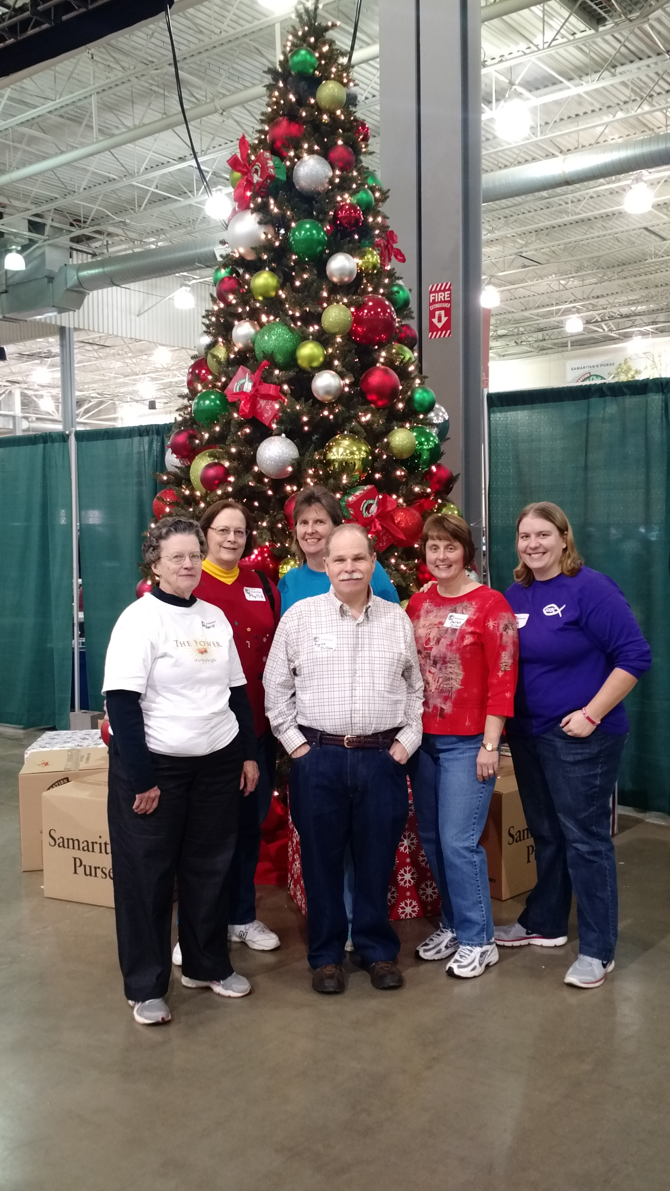

On December 5, Phyllis Tyler (Mulberry Grove) and 5 of her extended family members joined a Hales Ford Baptist Church group on a bus trip to Charlotte, NC, to volunteer at the Samaritan’s Purse Operation Christmas Child Processing Center. The group left Franklin County at 6:00 AM for the 4-hour bus trip to Charlotte. Upon arrival, the group was given an orientation talk about the work at the center and the directions for processing shoeboxes. There were four jobs to be done: Pre-Inspector – Remove the rubber bands and remove the payment envelope for Samaritan’s Purse from the box; Inspector – lift up contents and look for items that cannot be included and remove them/replace anything removed with items from the “filler” basket; Taper – place OCC tape around the box to secure the contents; Packer – place the box into a packing box as directed.
The orientation ended with prayer for the volunteers and for the recipients of the boxes. After the orientation, the group was taken to the warehouse floor and assigned to an inspection station of 7 or 8 volunteers, overseen by an experienced OCC volunteer. Phyllis was a shoebox inspector and looked through the items in the box to be sure that it contained no banned items. Both during the morning and afternoon, a break was called when we heard from a young woman, from Camaroon, who had been a recipient of a shoebox when she was 14 years old. It was the first gift she ever received and she said she unpacked and repacked it 7 times when she got home before she actually used anything in it. As a result of the Shoebox program, she and her family came to the Lord. What a blessing to hear first hand what an impact the shoebox gift made in her life. The group worked from around 10:30 – 12:30 and then took a lunch break. Most packed their lunches, but two vendors were on site if you wanted to purchase something. Dasani water and all brands of soda were available for 25ȼ. After lunch, the group went back to work and continued processing boxes until 4:20 PM. Individuals could take a break as needed. At the end of the day, every volunteer was given an OCC
t-shirt and Christmas ornament. The group returned to the bus for the trip home, stopped for dinner, and arrived back in Franklin County about 11 PM, tired, but blessed!

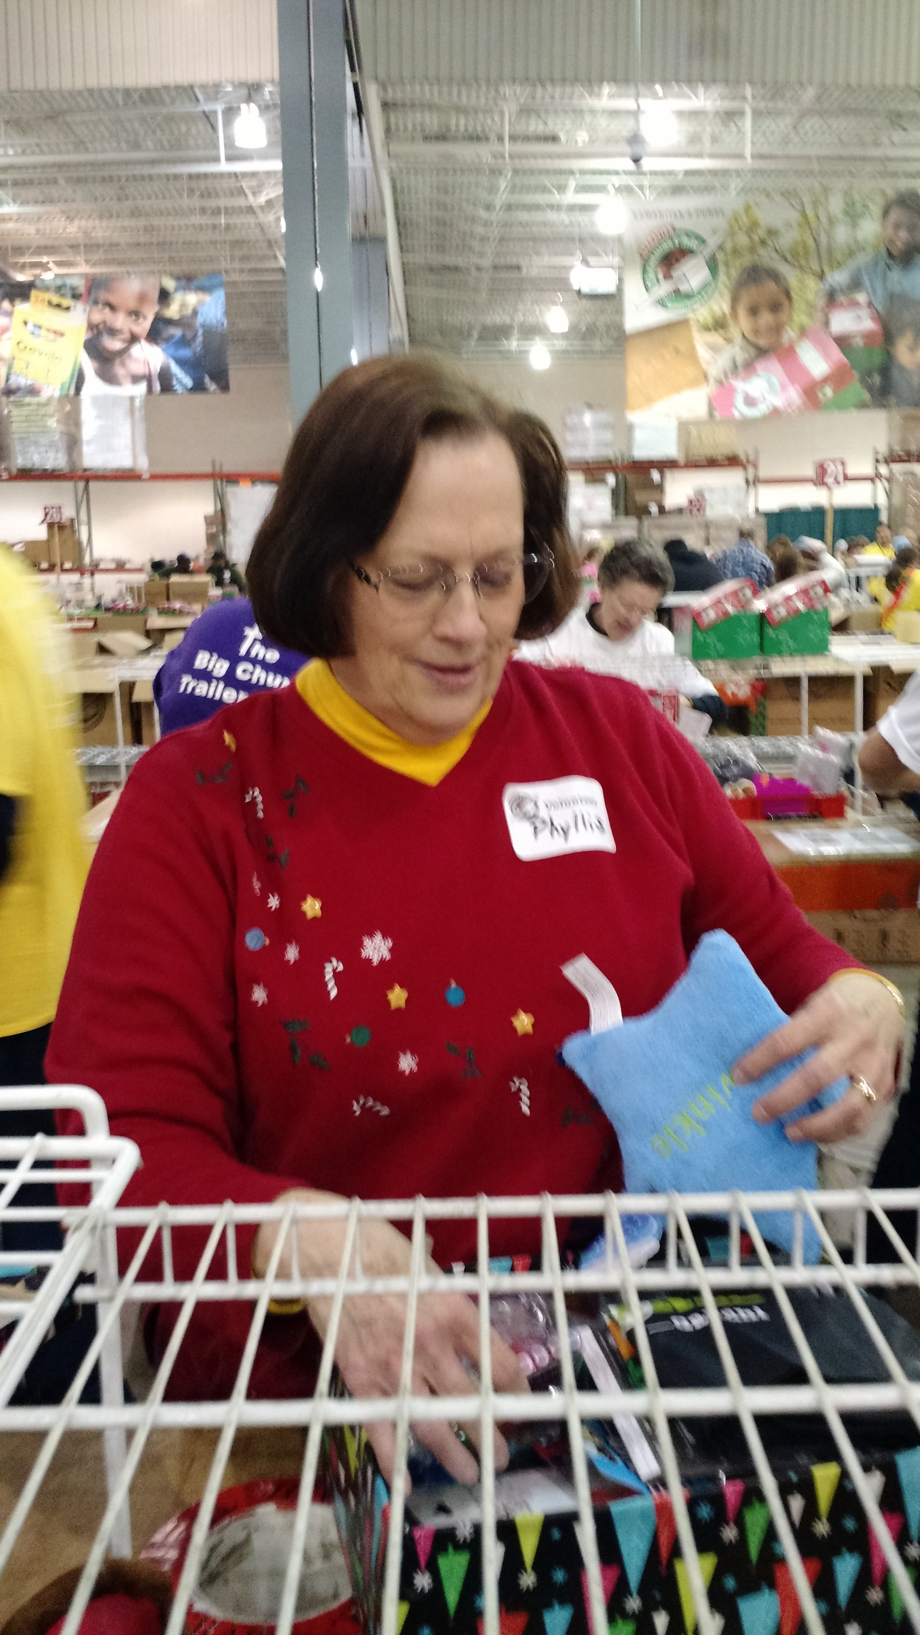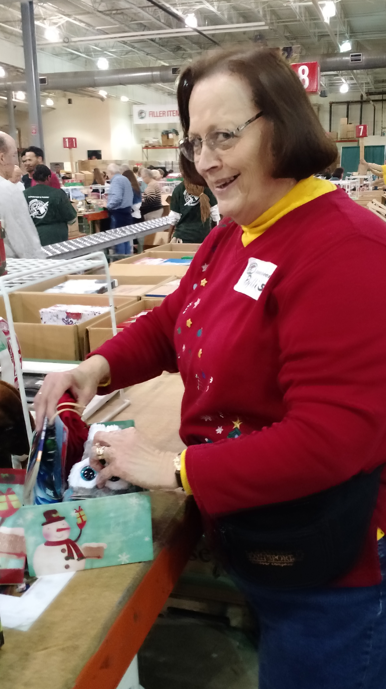
The trip was long, the concrete floor was hard, the “fillers” were sometimes disappointing, but seeing the thousands of boxes and the care that went into filling them was amazing. It was a real blessing to be part of the process! There were probably between 800 and 900 volunteers working together to process over 73,000 boxes, getting them ready to go to Zambia and North Africa. It was enlightening to see what care went into most of the packages and also to see the discrepancy among the boxes and what they contained. Some things I noted for my own “shoebox packing” for next year:
- Be sure to pack the box full enough! Be sure to include the hygiene items suggested (soap, washcloth, comb, toothbrush, toothpaste) and appropriate gifts for the age child you select. (It was surprising how many bottles of liquid had been included and had to be removed – shampoo, lotion, nail polish, etc. and also mirrors!) It seemed that there were less boxes “appropriately” filled for the 2 – 4 year olds.
- Be sure not to pack the box too full! It was very hard to get everything back into some of the boxes after lifting items to verify the contents. Be sure my box will stay closed before I put the rubber bands around it. Do an extra box instead of stuffing the others so full.
- Be sure not to include banned items – liquids, chocolate, food items other than hard candy, anything with camouflage or war-like toys. It came as a surprise to me that they asked us to remove stick gum (apparently it melts easily and can damage other items in the box), but bubble gum was okay! It is best to put the candy and gum in a zip lock bag, or better yet, include a small water bottle and fill it up with the goodies! This year items with a Pokémon or Harry Potter logo were banned. I guess this would vary by what is on the market in a given year.
- It is better not to put Irish Spring soap in a shoebox – the scent is overwhelming and permeates everything in the box. Ivory soap is best and it is good to place the soap in a zip loc bag.
- Be sure to include a stuffed animal, regardless of the age of the recipient.
- I was disappointed with the “filler” items, but realized that these, too, were donated. Apparently this year Tyco Toys had donated thousands of stuffed animals, but we saw very few toothbrushes and no toothpaste in the filler bins to add to the boxes. I’m thinking that donations of these two items directly to the processing center would be a good thing. There were also very few crayons available as fillers.
- Remove toys from the packaging in order to put in more items.
- Plastic boxes do NOT travel well. We saw many broken ones, which then had to be replaced by OCC boxes. Plus, the OCC boxes are a uniform size for packing 144 boxes to a flat for shipping.

Folks from all over (some from as far away as Ohio) worked together pleasantly and without complaint. The real Christmas spirit was in abundance throughout the day! I would do this again and encourage all of you to go if you have the opportunity.
Phyllis

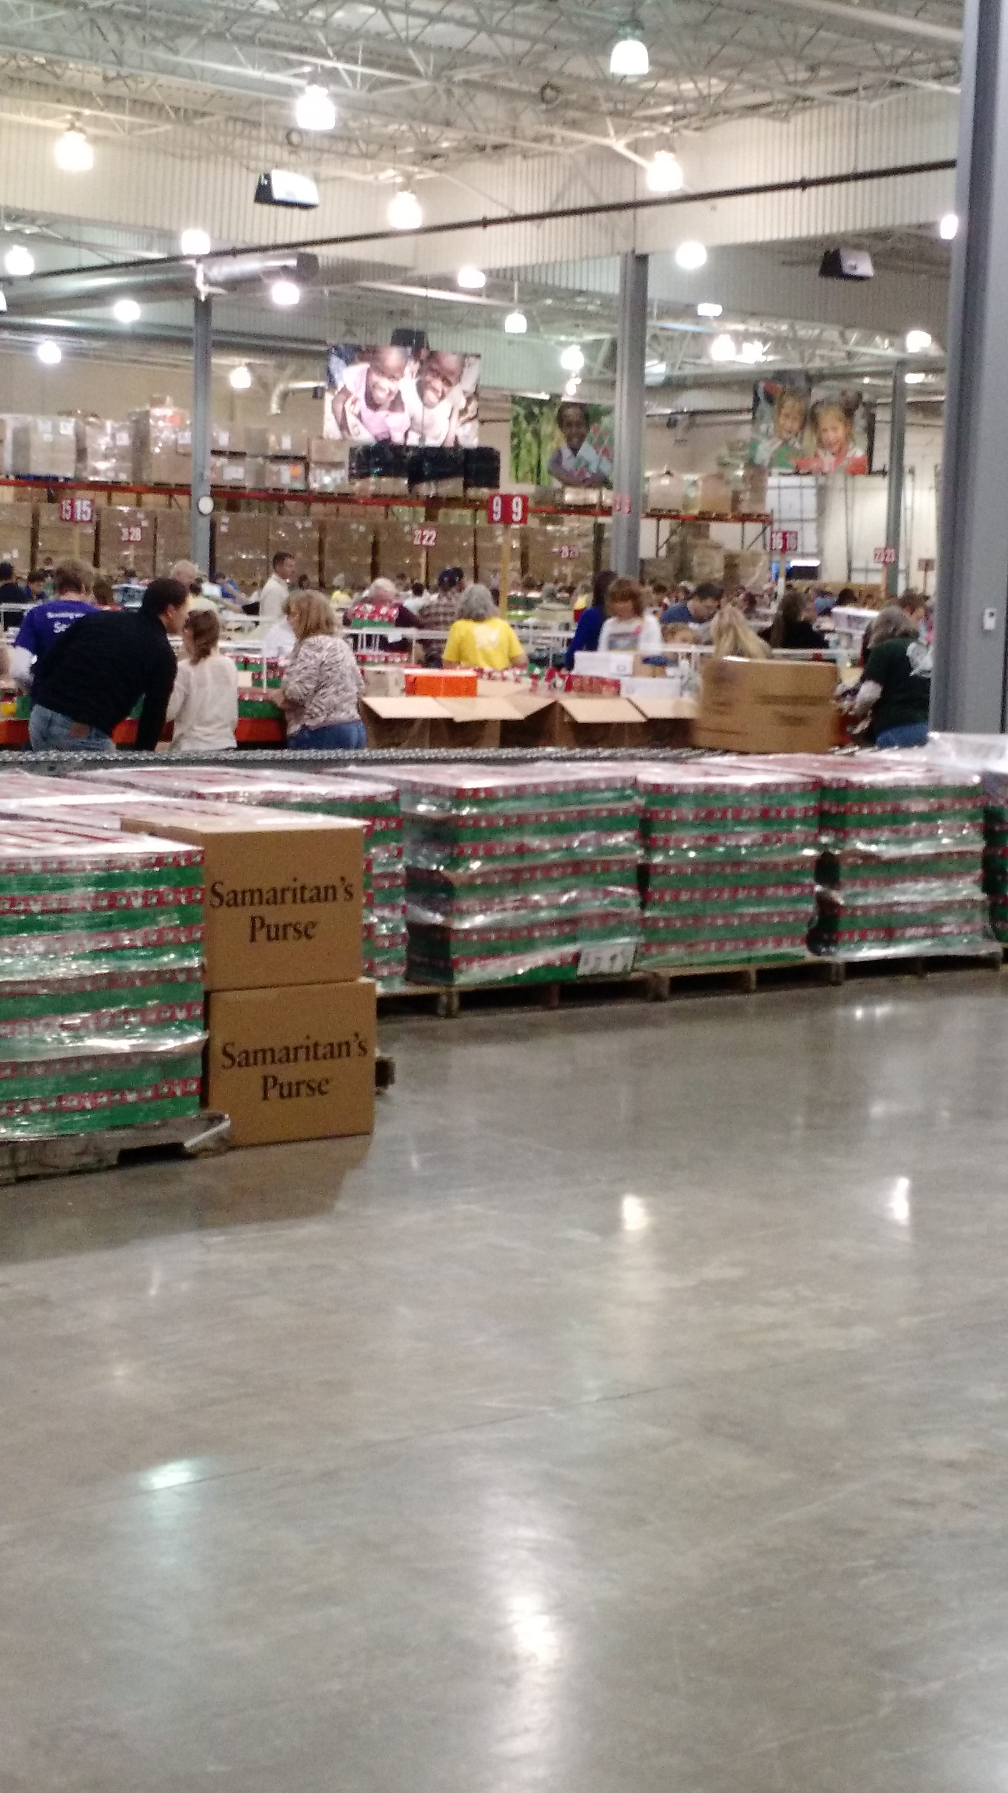

4
OTHER JRBA CHRISTMAS HAPPENINGS>>>

Antioch’s Christmas Eve Candlelight service was so well attended that they ran out of candles! How heartwarming to know that so many celebrated Jesus as the “reason for the season”!

Buckingham’s Children in Action held a Birthday Party for Jesus on December 16. The fellowship hall was decorated in blue and white and was very festive with balloons and banners. The account of the birth of Jesus was read from Luke 2. After cake and ice cream, the children had fun trying to break a piñata. They were treated with gift bags and reminded that the Lottie Moon Christmas Offering was a wonderful way to giave a gift to Jesus. The Youth Group helped with the party for the children. On Sunday, December 20, the chlIdren and youth presented the play, “God’s Gift to Us”. After the play everyone in attendance joined together for refreshments and a time of fellowship. Buckingham also held a Christmas Eve Candlelight Sevice. This provided an opportunity to reflect on the true meaning of Christmas.

Gladstone Memorial celebrated Christmas with a wondeful program and refreshments following. They ended the year with a challenge to use “Fish Hooks” in reaching people for Christ in 2016. Folks were challenged to use the “Hooks” of Encouragement, Empathy, Enlightenment, and Engagement.
On December 5, several members of Jones Chapel went to the Bethlehem Walk in Goochland and afterwards had dinnner together. They had a great time. The Christmas Program was held on December 20 at the 11 AM Worship Service. The story of busy shoppers, complaining about Christmas, incorporated he Nativity. Following the program, church members gave the Pastor and his famly a Christmas gift to show their love and aoppreciation.

Mulberry Grove celebrated Christmas in several ways. On December 20, children and adults presented “Cooking Up Christmas”, a delightful play, and handed out a cookbook with members’ recipes. It was followed by a time of fellowship with heavy hors d’oeuvres. The church held a candlelight service on December 24 during which Pastor Michael Khol, with the assistance of Noah Jones, presented the Christmas story in a unique way. Following the service, attendees were able to fellowship and wish each other a Merry Christmas.

It was a pleasure to have so many visitors at Sharon for the choir’s presentation of the Christmas cantata, “Appalachian Winter”, and the social gathering that followed. What a warm and inspirational evening – wonderful beginning to their celebration of Christmas. They send their best wishes to all for a blessed New Year!

Tar Wallet’s Christmas Eve Candlelight Service was well attended. Barbara and Richard Bersch and Tom and Diane Bishop did a wonderful job with the Christmas story and music.

WHAT A GREAT IDEA!!!!

Betty Toney, JRBA WMU Director, reports that a local couple read about he JRBA Backpack Ministry in the November/December issue of The Beacon. Thanks to Sue Miles’ coverage of this ministry, the couple decided to give unique gifts to their ten grandchildren for Christmas. Since the children were blessed to have what they need, the grandparents chose to donate to the Backpack Ministry in their honor. A recognition of the donation was given to each child. What a wondeful way to set the example of helping those in need and to leave a legacy of caring for others! Thank you to our anonymous contributors.

LEARNS AND GROWS>>>

Arvon is excited to announce that they now have Sunday School Classes for Preschoolers, Elementary grades, and Pre-Teen/Teens!
They are thrilled with having more young people in attendance and welcome everyone to join them.

Enon is also in the process of updating their youth program and children’s church (during worship services). They have a new class for 3 & 4-year olds and are very excited about the upsurge in attendance since welcoming Rev. Wayne Proffitt to their church family. Rev. Proffitt is also beginning a new Bible study class on January 6.
Gladstone Memorial will begin a series of messages on Lessons from the Upper Room in January. They extend an invitation to all to come and be a part of the wonderful fellowship there.

Tar Wallet will have a youth-led service very soon, but the date has not yet been established.

OTHER EVENTS>>>

Antioch’s New Years Eve Service was followed by a youth gathering at Pastor Dave and Laura’s home. 42 youth attended! At 10 PM, they left the Pastor’s house and went to the church where they testified and prayed the old year out and the new year in. These youth are amazing!


JRBA CELEBRATES>>>

Enon ordained Brad Edwards as a Deacon in December and looks forward to his faithful leadership.

Jones Chapel welcomed Caleb Tuttle, Pastor Richard & Michelle Tuttle’s oldest son, into their membership on January 3. He has been home during Christmas vacation and is enrolled in college in North Carolina. They are blessed to have this talented young musician, studying to be a youth minister, as part of the church family. He plays his guitar on the Sundays he can be at Jones Chapel.

There was a reason for celebration at Mulberry Grove on Sunday, November 29. A Baby Dedication was held for Tristan Jones, son of Seth and Jessica Jones, Lucy Alice Tyler, daughter of Ryan and Rebecca Tyler, and Ethan David Khol, son of Michael and Laura Khol. It was a special day for all of these families and the entire church family, too.

Pastor Bob and Lillian Johansen and their famly invited the members of Tar Wallet to their home for a New Year’s Eve party. There was plenty of food, games, and good fellowship!

IN LOVING MEMORY>>>

Sympathy is extended to Cedar’s Pastor, Tommy Armstrong, and his family, whose sister, Judy Armstrong, passed away on November 3.

BGAV MINISTRY MOMENTS>>>

After a devastating earthquake hit Haiti in 2010, Virginia Baptists and other Baptist partners came together to respond. Out of the rubble, the Source of Light Center was built in Port-au-Prince. The center serves as home for several dozen children while scores more attend school. Your faithful giving will ensure that the Source of Light Center can continue to be a beacon of light to the city. To learn more, go to www.SourceOfLightHaiti.org.

Taken from BGAV January calendar: Kingdom Stories

STAFF CHANGES>>>

Rev. Wayne Proffitt, and his wife, Rhonda, began their pastorate at Enon on December 5. JRBA welcomes the Proffitts and looks forward to working with them. Contact Information:
Rev. Wayne Proffitt
9120 Andersonville Road
Dillwyn, VA 23936
Phone 434-390-1784 (cell)
434-983-1686 (church)
Email: gwayneproff@yahoo.com
5
MISSIONARY MOMENTS>>>

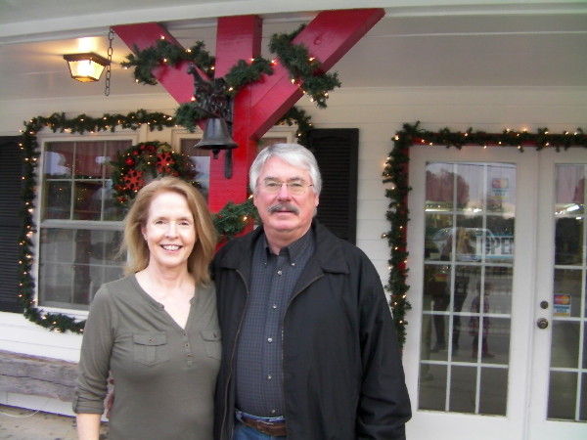

December 8, 2015

The gospel is bearing fruit and growing throughout the whole world – just as it has been doing among you since the day you heard it and truly understood God’s grace. Colossians 1:6

Dear Prayer Partners,
After almost 30 years of missionary service in Argentina, we are returning to the US. Due to the financial crisis at the IMB, 800 missionaries have decided to accept an early retirement incentive that the board is offering. We have been truly blessed to have witnessed the work of the Holy Spirit in so many places and in the lives of so many people. What a joy to have seen lives changed and order brought to families that were once in confusion.

Thank you for your prayer support and faithfully holding the ropes for us in giving to the Cooperative Program and the Lottie Moon Christmas Offering. What a wonderful privilege it has been to serve the Lord in a harvest field all these years where we have been able to join our Heavenly Father who is at work. It has been our passion to share the Gospel, disciple new believers, train leaders, and plant churches. To God be the Glory!

Please pray for us in this moment of transition back to the US and our desire to begin a new ministry. We know the Lord is faithful and are trusting Him to meet our needs. January 22, 2016, is the date of our return with initial plans to live in Greer, SC.

Blessings in Christ,
Hope & Asbury Martin
Central Northern Argentina

SPECIFIC PRAYER REQUEST ON JANUARY 5, 2016

The Lord sustains him on his sickbed; in his illness you restore him to full health. Psalm 41:3

Hope has developed a blood clot in the Safena vein in her right leg behind the knee about 5 mm from the entrance to the deep vein. It has grown since it was first detected to 6.6 inches. January 11 is the big day – Hope has another sonogram and a doctor’s appointment where it will be determined whether or not she will be cleared to travel as well as know if the treatment is working. Pray that the medication she is taking will be effective and dissolve the blood clot, and that it will not cause any complications. Please continue to pray for us as we are packing. Our belongings will be crated January 12 – 14.

Asbury Martin, Argentina

FOR YOUR INFORMATION>>>
- From Alan Gough, OCC Shoebox Relay Center Coordinator: The local goal was 1,400 – collected 1,403 at Bethlehem! The Central Virginia goal was 15,070 and we collected 15,796. Thank you to everyone who helped us surpass the goals and touch the lives of so many children around the world.
- We received Christmas greetings from the Habitat for Humanity ReStore in Farmville. At the ReStore, they work all year raising money to fight poverty housing. They take in doors, windows, toilets, sofas, chairs, tables, and countless other items and they turn them in to a decent place for a family to live as they attempt to eliminate poverty housing throughout the world. The staff and volunteers do it with love and kindness in a manner that truly defeats hate, greed and the many tools of the devil. At Habitat for Humanity, Jesus is not just the reason for the season, Jesus is the reason for their mission. Thank you to everyone who has contributed to this great cause. Remember that if you have unused furniture or working appliances, the ReStore will come and pick them up. They are also always looking for volunteers to help clean donated items and assist customers. If you are interested or have items to donate, contact restore@farmvillehabitat.org.
- For the 2016-17 academic year, students who are members of Virginia Baptist churches, may apply online for scholarships at the Virginia Baptist Foundation’s website beginning January 1. Go to www.vbfinc.org.
- The 2016 Cooperative Baptist Fellowship General Assembly will be held June 20 – 24 at the Sheraton Hotel and Koury Convention Center in Greensboro, NC. Register now at www.cbf.net/assembly.


KEEP IN PRAYER>>>
- Those who are lost and need to know the Savior
- Churches without a pastor: Arvon, Chestnut Grove, Mt. Zion
- JRBA Pastors
- JRBA Hispanic Ministry (Bi-Lingual Bible Study & Prison Ministry)
- Those going on mission trips:
Rev. Dave Vogt, Malcolm Warfield, Anthony Clore, and Daniel Wagner to India
Gwynn Tyler to Honduras
Rev. Michael Khol to El Salvador
- Asbury and Hope Martin, IMB, Argentina, returning to U.S.
- Florica, JRBA WMU Project Ruth adoptee
- Local family serving IMB
- All those in our congregations who are ill or have lost loved ones.
…the prayers of the righteous please Him.
Psalm 15:8b
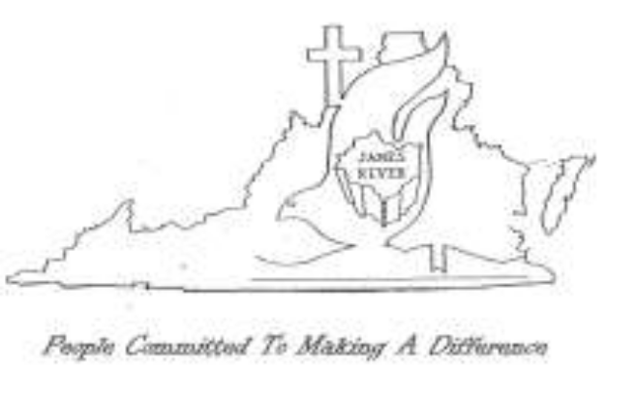ACCOMPLISHING TOGETHER
WHAT WE CANNOT DO ALONE

6
Baptist General Association of Virginia
Annual Meeting

The BGAV Annual Meeting was held on November 11 – 13, 2015, at the 2nd Baptist Church, Richmond. JRBA was well represented with the following messengers in attendance:
Buckingham – Rev. Doug Adams, Mrs. Betty Toney
FBC, Dillwyn – Rev. John Moxley, Rev. Jimmy Dunn, Jane Dunn,
Joe Stanley
Fitzgerald Memorial – Rev. David Peppler, Judy Coon, Betty
Newman, Riley Wilson, Geraldine Whaley
Jones Chapel – Gene Bradbury, Carol Ownby, Judy Ownby
Mulberry Grove – Rev. Michael Khol, Gwynn Tyler, Phyllis Tyler

Many informative breakout sessions were held on Tuesday afternoon and regional meetings were held to establish nominees to the Mission Council.

Business conducted included the approval of a resolution on the Sanctity of Marriage (a reaffirmation of a 1993 resolution on homosexual behavior and a 1998 resolution on the sanctity of marriage). A resolution on religious liberty was also approved. This resolution encourages churches and members to use Christian liberty to uphold the truth of the gospel of grace in a spirit of grace in order to reveal the attitudes of Christ in words and in deeds during these times of cultural change. A resolution on the sanctity of human life (dealing with euthanasia) was referred to the Christian Life Committee for study. A resolution on abortion was not passed as it did not receive the three-fourths majority required for it to pass. Since the motion failed, the BGAV continues to stand behind its previous resolution on abortion (passed in 1997). A resolution of appreciation to Second Baptist Church , those who planned the meeting, those who participated, those who volunteered and those who served in BGAV leadership was approved. Virginia Baptists entered into partnership with the Blessing House of Duke University (no money goes to this entity, but students from VA can apply for scholarships and BGAV churches can contact Duke for pastoral candidates). The 2015 budget of $10.5 million passed without discussion. This reflects a $1 million decrease from the 2015 budget. The following officers were elected for the coming year:

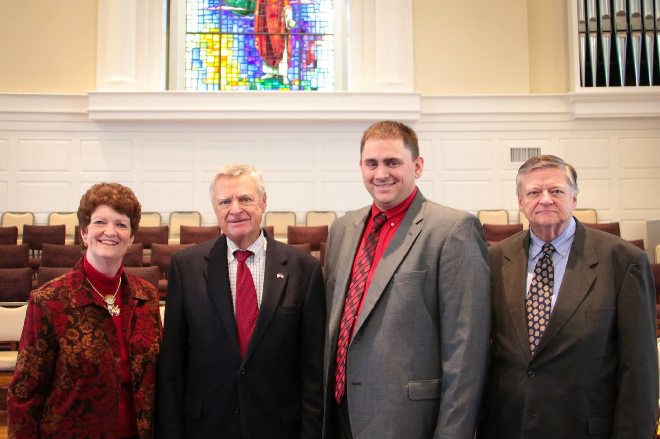

President – Rev. Nancy Stanton McDaniel, Pastor, Rhoadesville
Baptist, Orange
1st Vice President – Stuart Crow, Member, First Baptist, Waynesboro
2nd Vice President – Dr. Adam Tyler, Pastor, Grace Hills Baptist,
Appomattox (Former Pastor – Mt. Zion, New Canton)
Clerk – Fred Anderson, Member, River Road Baptist, Richmond

Additionally the following were elected:
Executive Board, Chair – Carl Johnson
Executive Board Members – Pat Ellis, Laurie Harris, Ben Jamison
(Former Pastor, Fitzgerald, Cumberland), Wayne Maness, and Katie
McKown (3 year terms)
Nominees were elected from their respective regions to round out the
newly formed Mission Council.

JRBA Nominees elected to the Mission Council were Rev. Doug Adams, Rev. Perry Clore, Rev. Jimmy Dunn, Chris Moss, and Judy Ownby. Gwynn Tyler will complete his current term.

All in attendance were blessed by challenging messages on the theme, Church Today, Church Tomorrow, by Ed Stetzer, Executive Director of LifeWay Research, and Alan Jamieson, Senor Pastor of South West Baptist Church in Christchurch, New Zealand. John Upton, Executive Director of the BGAV, shared many stories of how your prayers and faithfulness are making Kingdom impacts all over the world, and how BGAV will continue to do so in the future.

The 193rd Annual Meeting of the BGAV is scheduled for November 14-16, 2016, at Bonsack Baptist, Roanoke.

ASSOCIATION FINANCES
2015 - 2016

Regular Budget Receipts
Church | December | Year-to-Date
Antioch(Scottsville) | $ 300.00* | $ 300.00
Antioch Union
Arvon | $1,362.00 | $ 1,362.00
Buckingham | $ 261.74* | $ 261.74
Cedar | $2,000.00 | $ 2,000.00
Chestnut Grove
Enon
First Baptist Dillwyn
Fitzgerald Memorial
Fork of Willis |  | $ 429.00
Gladstone Memorial |  | $ 331.25
Goshen
Jones Chapel | $ 119.96 | $ 336.05
Mt. Tabor
Mt. Zion
Mulberry Grove
Sharon |  | $ 391.00
Tar Wallet
Individuals |  | $ 100.00
VBMB – Alma Hunt
TOTAL | $3,481.96 | $ 5,511.04
Approved Budget for 2014 – 2015: $24,671.00

*The donations by Antioch and Buckingham were reported in the November issue, but actually came in after December 1. From now on, only funds received during the calendar month will be reported in the next month’s newsletter so as to be less confusing (for me!). Therefore, if you want your contribution listed, be sure to get the check in by the newsletter deadline. Thanks much!

TREASURERS: Please note that unless a specific ministry or project is designated on the memo line of the check or in an accompanying note, the contribution will appear in the regular budget receipts.

ADDITIONAL MISSIONS FUND
No contribution or expenditures during December.
Earlier individual contribution: $100 (More Than Nets)
Earlier expenditures: BGAV More Than Nets - $400
BGAV Carolina Flooding - $300
Balance: $378.00

YOUTH ENCOUNTER
Carryover: $400.00
No contributions or expenditures in December.

7

LOCAL MISSIONS PROJECTS FUND
Carryover: $258.04
No Contributions or Expenditures in December.
Earlier Contributions: ½ Fall Meeting Plate Offering - $212.00
Individual - $100.00
Balance: $570.04

BGAV SYRIAN REFUGEE CRISIS
½ Fall Meeting Plate Offering: $212.00
October Expenditure $212.00

2016 Stop Hunger Now Event

Church | December | Total-to-Date
Antioch
Antioch Union
Arvon
Buckingham
Cedar
Chestnut Grove
Enon
First Baptist Dillwyn |  | $ 305.00
Fitzgerald Memorial
Fork of Willis
Gladstone Memorial |  | $ 321.00
Goshen
Jones Chapel | $ 23.19 | $ 33.19
Mt. Tabor
Mt. Zion | $ 200.00** | $ 200.00
Mulberry Grove
Sharon
Tar Wallet |  | $ 100.00
Individuals | $ 100.00 | $ 100.00
TOTAL | $ 323.19 | $1,059.19*
*Total includes all funds given after the May 2015 event .
**Correction – Mt. Zion donated to SHN in November. I apologize for the omission in the December issue.

JRBA Hispanic Ministry

Church | December | Total-to-Date
Carryover (2014-2015) |  | $ 850.82
Buckingham | $ 200.00 | $ 200.00

No expenditures in December.
Balance on Hand: $ 895.62

John E. Mann, Sr. Benevolence Fund

Church | December | Total-to-Date
Buckingham | $ 200.00 | $ 200.00
Cedar | $ 300.00 | $ 300.00
First Baptist Dillwyn |  | $ 500.00
Sharon |  | $ 200.00
TOTAL | $ 500.00 | $ 1,200.00
November Disbursements: $ 300.00
Balance on Hand: $ 3,336.99

TO CHALLENGE YOUR THINKING>>>

Bad Information for a Young Pastor*
By Bill Easum, 21st Century Strategies

Jim was right out of seminary and into his third year as pastor of his first church. He had worked hard all three years, but the church didn’t grow. In fact, if anything, it was smaller than when he arrived. His frustration level was high.

I ran into Jim at a seminar I was doing at Exponential a few years back. He seemed like a bright kid, one who was eager to learn. He sat in the front row and asked a lot of good questions. While I was packing up my equipment at the end of the seminar, Jim approached me with a question, “Just about everything you recommended flies in the face of what I was told in seminary and by my pastor friends. Who’s right, you or them?” I asked what he had been told. Here’s his answer, “I was told to spend the first two or three years getting to know the members better. So I did. I spent hours going to coffee and dinner with members or sitting with shut-ins listening to them talk about the past. I did my best to be in every home at least once. And after all that, the church declined.”

I had to bite my tongue for a moment. Then I said, “You were told to do everything wrong. My guess is that none of those giving you advice ever pastored a growing church. They couldn’t have, acting that way. The unchurched aren’t going to be found in church; they are found out in the public. You won’t grow a church by spending all your time with the members.”

The unchurched aren’t found in the church; they are found out in the public.

One of the basic rules of consulting is that a pastor can make more changes in the first year than in the second through the sixth year. The old adage is true: it is easier to ask for forgiveness than permission.

So what should a pastor do in his or her first year of tenure? The answer to that depends on the size of the church. At a church under 200 in worship, 80% of the time should be spent figuring out and implementing ways to bring in new people. In a church in the 200-500 range, much of the time has to be spent developing a staff and key leaders. In a church over 500, a strong emphasis has to be placed on taking staff to a level at which they need little to no supervision, which means that the pastor seldom has anything to do with hands-on ministry other than teaching. I could go on, but it should be apparent that no matter what size church you are pastoring, spending time taking care of the membership is never a priority for the pastor. It is for someone, but not the pastor.

Now, I can hear some old hats, who were successful years ago, say, “But we cared for the members first and our church grew.” That may have been true 30 years ago, but it isn’t now. 30 years ago, people came to church on their own. Not so today. Today you have to go to where they are to reach them. And that changes everything. Either the members drop their selfishness and embrace God’s mission for every church – to make disciples – or those churches die. It is that simple…

So the next time someone tells you to spend your first couple of years as a pastor simply loving your flock, turn a deaf ear and reach out to the unchurched. Hopefully you won’t lose your job.

*Copied from 3 Minutes, a portal to connect you with what is emerging in church leadership in the U.S. and around the world, through the Spence Network.

8

