 THE SERVANT LINK
CHURCHES UNITED TO SERVE -
COMMITTED TO MAKING A DIFFERENCE
James River Baptist Association
P. O. Box 1219, Dillwyn, VA 23936
Mrs. Marilyn Snoddy – Moderator
www.jamesriverbaptistassociation.com
Tel: 434-983-7385 Email: jrba@embarqmail.com
Hours: Monday & Wednesday 8:30 AM – 2:30 PM
____________________________________________________________________________________________________________
Volume XV September 2016 Edition IX



JRBA Operation InAsMuch Missions Blitz
Saturday, September 24, 2016.

Church OIAM Contact Persons: If you have not yet done so, please give
Valeria Breault a call at 434-969-4603 as soon as possible to let her know
what your church plans to do!

Events are being planned for our Operation InAsMuch Missions Blitz on Saturday, September 24, 2016, and some exciting things are happening! Churches are planning events to honor law enforcement, rescue squads, and other community workers. A free carwash, gift cards to local businesses, fall festivals, and cooking projects are just a few of the things I have heard about. JRBA is partnering with Spreading God’s Gifts to put a roof on a local house. Rev. Michael Khol is our contact if you need information on how to assist with this special project which will be a joint effort among our churches. (See below.)

Other information: Please keep a list of your projects and the number of volunteers who participate.
Take lots of pictures and get them to Rev. Michael Khol or the JRBA Office.
Encourage all volunteers to wear RED so that the community will be aware that you are part of Operation InAsMuch.
HAVE FUN blessing others and yourselves in JESUS’ name.

We want to have all 18 of our churches involved in this special outreach event.
Valeria Breault, JRBA OIAM Chair
434-969-4603 or vbreault@centurylink.net

JRBA Operation InAsMuch Roofing Project

We are partnering with Spreading God’s Gifts to repair a roof for a needy family in our community. We are hoping to raise the funds for the project ($600 - $800) as well as having 8+ volunteers to work on the roof under Wayne Davenport’s supervision (preferably people with some degree of handy skills) on Saturday, September 24. If you are interested in contributing financially or in person, please contact me A.S.A.P. so that I can determine how much of this project is feasible. I have already had a great response from 4 JRBA churches. Please consider partnering with us in this project. In Christ,
Michael Khol
434-808-2383 or mjkhol@gmail.com

1
EVENTS DETAILS

September 4 Missions Presentation at Antioch, Scottsville 11:00 AM
Anthony Clore will be presenting his pictures and experiences from his recent mission trip to Africa.

September 5 Labor Day – JRBA Office Closed

September 6 Tuesday Morning Bible Study at First Baptist Dillwyn (Every Tuesday) 10:00 AM
A verse-by-verse study of the Bible. Lunch coordinated by members. Current study is Leviticus.

September 7 JRBA PROGRAM COMMITTEE MEETING AT JRBA OFFICE 10:00 AM
Committee members please plan to attend to plan for our Annual Fall Meeting in October.

Called Business Meeting at Antioch, Scottsville to elect Deacons and Elders for the coming year.

BELIEVE Bible Study at First Baptist Dillwyn (Every Wednesday) 6:30 PM
BELIEVE: A study on Christian Beliefs, Practices and Applications.

Prayer Meeting at Goshen (Every Wednesday) 7:00 PM

September 8 South Central Virginia Operation Christmas Child Event at St. John’s Lutheran Church 7:00 PM
Located at 1301 Milnwood Road, Farmville, VA 23901.
An opportunity locally to hear the story of a shoebox recipient! Yves Dushime, from Togo, Africa, will share his powerful story of how a simple shoebox gift impacted his life. For additional information: 434-223-8988.
This event will also include special music, refreshments, OCC boxes and promotional materials, and fellowship with likeminded people who love OCC.

September 9 & 23 Blue Ridge Food Services Food Distribution at Crystal Cathedral, Dillwyn
Volunteers needed at 9:30 AM.

September 11 GRANPARENTS’ DAY

Homecoming at Arvon 11:00 AM

Homecoming at Fork of Willis
Sunday School at 10:00 AM and Worship Service at 11:00 AM.
Dinner on the Grounds immediately following the Worship Service.
Special Music by Bob Stone and the Virginia Gospel Singers.

Missionary Visit at Chestnut Grove 11:00 AM
Come out and hear about a special ministry in South India.

Patriots Day Worship Service at First Baptist Dillwyn 11:00 AM
Recognizing our local law enforcement, emergency workers, and first responders.
Special Remembrance of 15th Anniversary of 9/11.

Pastoral Installation Service at Mt. Zion 2:00 PM
Pastors and others are invited to this special service to install Rev. Woody Moore as Mt. Zion’s new pastor.

Youth Group at Goshen 5:00 PM


2
September 14 Senior Citizens Fellowshp at Mulberry Grove 11:00 AM
Bluegrass/Gospel Music. Covered dish lunch.

WMU & Brotherhood at Goshen 7:00 PM

September 15 Virginia Network of Interim Ministers at Presbytery of the James, Richmond 10:00 AM – 3:00 PM
Located at 3218 Chamberlayne Avenue. Interim Ministers who are interested can email Becky
(becky.joubert@bgav.org) or call 800-255-2428 for details.

September 16 – 18 Fall Volunteer Event (WMUV) at CrossRoads Camp & Conference Center
Call WMUV for information: 1-800-255-2428, Ext. 8267.

September 17 – 20 Antioch Union’s 6th Annual Tent Revival at Pearson Construction, Rt. 24 7:00 PM
Saturday, September 17: Hot Dog Supper at 6:00 PM
Nightly Worship Services at 7:00 PM.
Speaker: Rev. Billy Swan with Special Music each night

September 17 Christmas Ornament Making Workshop at Tar Wallet 9:00 AM – Noon
2nd session on Saturday, September 24, from 1:00 – 4:00 PM. All are welcome!

Hometown Heroes Banquet at Jones Chapel
Honoring Cumberland County’s 3 fire departments, 2 rescue squads, State Police and Sheriff’s Department
for their service.

September 18 HOMECOMING at First Baptist Dillwyn 11:00 AM
Special member recognitions, inspirational choir music and special message by Pastor Bryan Gunter.,
Youmans Baptist Church, Blackshear, GA.
Lunch will follow.
September 18 – 21: REVIVAL 7:00 PM
Powerful preaching by Pastor Gunter with special music each evening featuring area favorites and the FBC Choir.

September 18 Missionary Visit at Buckingham 11:00 AM
Come out and hear about a special ministry in South India.

September 20 Pastors New to VA Orientation in Richmond
Pastors new to VA or Baptist Life: Contact Jeff Cranford at 804-921-3945 for details.

September 21 The Gathering Webcast being shown at Mt. Zion 8:00 PM
PLEASE NOTE THE CHANGE IN TIME!
All are invited to come and observe this time of prayer together.
Christians nationwide will pray, fast, and experience The Gathering, a FREE simulcast event. The Gathering has one purpose: to unite the Body of Christ in America – all believers, regardless of race, age, or denomination – in prayer for forgiveness, wisdom, and provision for our nation. The Gathering is free of political agendas, merchandise, and ministry tents. No offering will be received. No books will be sold. No personalities will be promoted, only the Name of Jesus Christ! Below you will find links for more information about The Gathering.
The Gathering website – http://thegathering2016.com
Speakers – http://thegathering2016.com/speakers/

September 21 JRBA Pastors’ Huddle at First Baptist Dillwn Noon
All pastors please plan to attend for a time of fellowship.

September 22 – 25 Antioch (Scottsville) Tent Revival at the Hardware River Evenings at 7:00 PM
Guest Speakers and Special Music
Directions: Follow Antioch Road past the church to the Hardware River. After crossing the bridge there is a road
to the right that goes toward the river. The tent will be visible. On Sunday, September 25, there will be a covered
dish dinner and a baptizing for several candidates. Pastor David Vogt will be preaching on Sunday morning and
doing the baptisms.

September 23 Cooperative Baptist Fellowship of VA General Assembly 9:00 AM – 5:00 PM
Hampton Baptist Church, Hampton, VA
Theme: Christ’s Love Compels Us
Keynote Speaker: Matt Cook, CBF Moderator
Each attendee will have the opportunity to participate in two different learning labs.
Registration is now open at www.cbfva.org/ministry/general-assembly/
Lodging is available at the Crown Plaza Marina (1-866-375-6054). Ask for the CBFVA rate.

3

September 23 Operation InAsMuch Rally at Mt. Zion 7:00 PM

OIAM EVENTS
September 24

ANTIOCH Five Loaves, Two Fish Ministry Meal 11:00 AM – 1:00 PM
Volunteers 8 AM

ARVON Community Event 10:30 AM – 2:30 PM
Bounce House, Obstacle Course, Face Painting, Free Hotdogs, chips, drinks, dessert & snow cones!
Also: Military Booth to sign Christmas cards for men and women in armed services, Collecting non-perishable items for the Back Pack Ministry, The AWARE Foundation team (dangers of predatory violence and how to avoid), Community Baby Shower for the Pregnancy Support Center, Blood Drive in memory of Riley Felici, Blood Pressure Checks (for info, contact Tanya at bickfordsx5@gmail.com)

FIRST BAPTIST Outreach Projects for the Day:
Mission Friends – making and delivering cards to the Heritage Hall residents & singing for them
Youth – repair and power wash a deck for a local family
SS Class – carry food and favors to the workers at the Five County Fair in Farmville
SS Class – work on the driveway and lawn of a local family
Prayer Walk throughout Dillwyn led by Pastor John Moxley
Volunteers for the JRBA Roofing Project

GOSHEN OIAM at Envoy in Fork Union 3:00 PM

MT. ZION Fall Festival 3:00 – 6:00 PM Theme: Reaching Out to Those Who Serve
Everyone is invited to come out after your Operation InAsMuch events are completed to enjoy some food and fellowship! Activities will include Bounce Houses, Hay Rides, Live Music, Antique and Race Cars, Fire Trucks, Ambulance, Police Cars, Games (Sack Races, Cake Walk, Bingo, Football Toss, Egg Relay, and more!), and Food (Hot Dogs, Brunswick Stew, Snacks & Drinks).
There will be a time set aside to honor those who serve us daily including our police, fire, and rescue volunteers, as well as military personnel. (Everything is FREE except the Brunswick Stew which will be by donation with the proceeds going to Mt. Zion’s mission projects.)
Music from 5:00 – 6:00 PM
OIAM Closing Worship at 6:00 PM with Wesley Yoder preaching.
Everyone is invited to come celebrate together what the Lord has blessed us to do in our Missions Blitz activities.

HOPING TO HAVE MANY OTHER OIAM EVENTS TO TELL ABOUT IN THE OCTOBER NEWSLETTER!

September 26 Information due TODAY by 9:00 AM for the October issue of the JRBA newsletter.

September 28 See You At The Pole at Buckingham County High School 7:00 AM
This is a student-led event sponsored by Straight Street. Students across the nation unite in gathering at their
Schools’ flagpoles to pray for their friends, their school, and the country.
2016 Theme: We Cry Out – A Generation Seeking Him!
Straight Street will provide a light breakfast for the participating students following the prayer time at the flagpole.

LOOKING AHEAD>>>

October 2 Homecoming at Jones Chapel 10:00 AM
Song Service at 10:00 AM, featuring The Taylor Family from NC.
Worship Service at 11:00 AM led by Pastor Richard Tuttle.
Lunch at Noon.
October 3 – 5: Revival Services 7:00 PM
Pastor Tuttle will lead the services. There will be special music nightly.

October 8 Tar Wallet’s Harvest Stew 6:00 PM

October 10 – 12 Photography Project at Antioch, Scottsville
Pictures for a church directory will be taken. Members can also purchase family pictures, available for Christmas.

4
October 10 – 13 Gathering of Silence Retreat at CrossRoads Camp & Conference Center
Great opportunity for pastors to get away and spend time in God’s beautiful world and renew their strength
for ministry. Details are not yet available.

October 11 JRBA Executive Board Meeting at First Baptist Dillwyn 7:00 PM
Pastors and Church Representatives please plan to attend.

October 12 Bus Trip to Franklin Graham “Decision America” Prayer Rally at Richmond Capitol
Cost: $35 includes transportation, host for games and singing, water and snacks!
The group will stop for dinner at Cracker Barrel in Midlothian, VA on the return home (on your own).
Contact Rev. Jimmie Beale, Interim Pastor, Antioch Union, to reserve seats: 434-352-7245.

October 13 BTSR/CBFVA Life on the Vine Pastor’s School at BTSR Chapel 11:30 AM
“Teaching the Church to Swim” taught by Rev. Jim Somerville and BTSR Faculty
Lunch to follow.
Call BTSR (804-355-8135) or CBFVA (804-213-0412) for details.



JRBA 184TH ANNUAL FALL MEETING
October 20, 2016
Arvon Baptist Church
4:45 PM

October 22 Family Fun Festival at Jones Chapel 11:00 AM – 3:00 PM
Plus Yard Sale beginning at 7:00 AM!

October 29 Trunk or Treat at Jones Chapel

Fall Fest at Tar Wallet 2:00 – 5:00 PM
Ending with a Trunk or Treat at 5:00 PM.
All are welcome!

October 30 5th Sunday Night Sing at Chestnut Grove 6:00 PM
Music provided by the men’s a cappella quartet, “Voice of Praise”, from Gladys, VA.
Refreshments to follow.

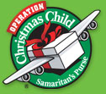

Samaritan’s Purse Operation Christmas Child
Shoebox Collection Week
November 14 – 21, 2016
Collection Site: Bethlehem Baptist Church
Goal for Site: 1,600 Shoeboxes
Monday – Friday, Novermber 14 – 18: 4:00 – 6:00 PM
Saturay & Sunday, November 19 – 20: 2:00 – 6:00 PM
Monday, November 21: 9:00 – 11:00 AM
As a point of interest: In 2009 this site collected 707 shoeboxes. In 2014, the total was 1,231 shoeboxes!
Let’s keep up the good work!
DON’T FORGET: NO TOOTHPASTE OR CANDY IN SHOEBOXES INI 2016.

November 14 – 16 193rd Annual Meeting of the Baptist General Association of Virginia
Location: Bonsack Baptist Church, Roanoke, VA
Theme: The New Way (John 13:33-35)
Keynote Speaker: Gabe Lyons, Founder of Q Ideas, a learning community that mobilizes Christians to advance the common good in society and well-known arthur of several books on Chrisianity in today’s world.
Other Speakers: Chris Cadenhead, Pastor, Bonsack Baptist Church, and Dr. John Upton, BGAV Executive Director
Online registration opens on September 6 at www.bgav.org/meeting.
Special rates are availabe for lodging at several area hotels. View the hotel options online at the above address.
Note that the schedule is somewhat different this year: Ther will be breakout sessions available on Monday afternoon at 4:00 PM. Dinner on-site will be available for purchase Monday and Tuesday nights, as well as lunch on Tuesday.
Gathering I will be Monday night at 7:00 PM. Tuesday will include Business Session I, Gathering II, Regional Meetings, Breakouts, and Gathering III(7:00 PM), followed by a dessert fellowship. Wednesday will include the second Business Session
and Gathering IV.

5

JRBA REACHES OUT>>>

V.B.S. REPORTS
Antioch Union held its VBS July 13 – 16. They enrolled 40 with 17 faculty and 23 students, from preschool through adults. Their average daily attendance was 32. They used Barnyard Roundup by Concordia. They collected $150 for Hope Tree Family Services.

First Baptist Dillwyn held Children’s VBS June 27 – July 1 with 87 enrolled. They had 42 workers and 45 students. Their average attendance was 83 and they used Cave Quest: Following Jesus, The Light of the World curriculum. Directors were Melissa Wood and Christy Jamerson. $245 was collected for Samaritan’s Purse. FBC also conducted Youth VBS on July 17 – 21. They had 19 youth and 14 leaders enrolled with an average attendance of 26. Melissa Wood was the Director.
They collected school supplies for an orphanage through the SEEDS Ministry. They studied LifeWay’s Submerged: Finding Truths Below the Surface.

Tar Wallet’s VBS was held August 1 – 5 with 18 workers and 23 students. 21 students had perfect attendance! They used
LifeWay’s Submerged curriculum. The children collected 55 pounds of coins, equalling $308 for Operation Christmas Child.

MISSIONS COMMITTEE REPORT

- Our Hispanic Fellowship Event was held at Arvon Bapitst Church on Sunday, August 21, with 19 Anglos and 9 Hispanics . Adults from Arvon, Buckingham, First Baptist Dillwyn, Mt. Zion, and Mulberry Grove were in attendance. It was a great time of fun, food, and fellowship. After playing some competitive corn hole and a devotion led by Rev. Michael Khol, the group enjoyed a wonderful meal of grilled chicken, hot dogs, rice, fruit, salads,and desserts. Thanks to Adán for taking on the job of grilling and thanks to Arvon for hosting the event.
Let us all work diligently to enlist our Hispanic friends in the Bi-Lingual Bible Studies taugh by Michael. Hopefully, we can also enlist many of them in our regular church activities as many of them do speak English.
- Stop Hunger Now – Sincre thanks to Gladstone Baptist Church for sending a generaous check to our association office during July. We are also very pleased that First Baptist Dillwyn and Tar Wallet contributed to this effort in August. As all 18 of our churches give generously to Stop Hunger Now throughout the year we will have at least $9,500 avalable by April 20,2016, to package more food packages than ever before. Thanks for your continued support of Stop Hunger Now!
- The Operation InAsMuch Missions Blitz , to be held on Saturday, September 24, is a great time for all 18 of our churches to carry out mission projects that will bless many persons in the name and spirit of Jesus. So, line up your projects, enlist your volunteers, and carry out your projects in the best possible way.
- Disaster Relief needs still abound so let us all help by sending Disaster Relief gifts to the Baptist General Association of Virginia, Disaster Relief, and by volunteering to help wherever we are needed.
- Our Blue Ridge Food Ministry continues to give out hundreds of bags of food to needy persons on the 2nd and 4th Friday of each month at
9:30 AM at the Crystal Cathedral, Dillwyn. Your help will be greatly appreciated.
In Christ’s Love,
Jimmy
Rev. Jimmy Dunn, Co-Chair

CHURCH OUTREACH

Cedar’s Choir and others from the church family were blessed on Wednesday, August 24, to go to Heritage Hall and share songs of praise and fellowship with the residents there.

Chestnut Grove just finished collecting school supplies for Buckingham County and are collecting money for the Alma Hunt Offering throughout September.

Pastor Tuttle, Jones Chapel, was invited to hold a prayer breakfast at CumberlandCounty Public Schools on August 4. Over 60 teachers, administrators, and students were in attendance. Afterwards, Pastor Tuttle was asked to become the Chaplain for the High School Football Team to conduct devotions and prayer each Friday night prior to games. Pray that these opportunities continue to open up as Pastor Tuttle ministers to the school.

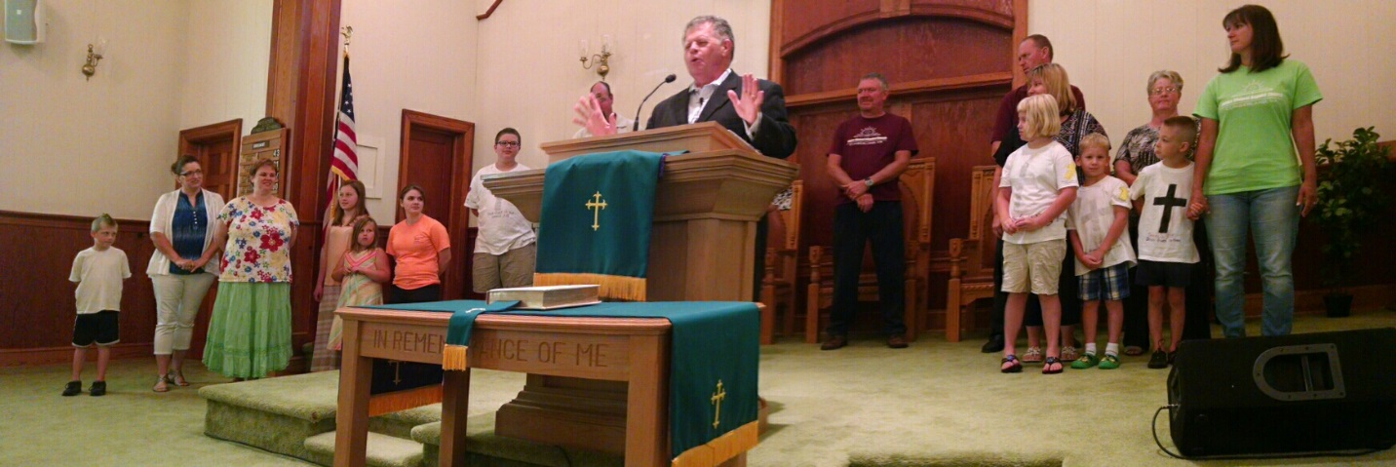

Jones Chapel’s Mission Team gave a report to the church on Sunday, August 7. They each gave brief comments on how the trip
impacted them and how they ministered to the children and community in WV.

On September 4, Jones Chapel will take a special offering to go to the flood victims in Louisiana. Our hearts go out to them and the families who have lost so much. During the month of September, they will also be receiving the Alma Hunt Offering.

6

Mt. Zion WMU donated to the Operation InAsMuch Roofing Project.

Mulberry Grove is in the midst of planning for the Operation InAsMuch event on September 24. A mission group from Virginia Beach visited the Khols in August and worked with church members to take down a dead tree at the church and deliver firewood. Members continue to work with ongoing ministries at the weekly Hispanic Bi-Lingual Bible Study, the bi-monthly food distribution at the Crystal Cathedral, and reach out to the sick and homebound. An additional focus in September will be the Alma Hunt Offering for state missions.

The congregation of Sharon contributed numerous school supplies for chldren in Buckingham County schools. Rose of Sharon WMU continues visiting with, and delivering meals to, those who are sick or homebound.

Tar Wallet’s WMU made a donation to Project Ruth for their August project. The September project will be to promote the Alma Hunt Offering.

LEARNS AND GROWS>>>

On Saturday, August 20, the Children in Action from Buckingham went to the Science Museum of Virgnia in Richmond. A total of 12 children and adults enjoyed a hands-on experience that was truly wonderful. There were two rats playing basketball, a hive of honey bees working and feeding the queen, many games to test skills and knowledge, and, to climax the evnt, a viewing at the IMAAX theater of the National Geographic production of the emergence of the National Park system under President Theodore Roosevelt. The chldren saw many small animals and insects in glass cages. The group took a picnic lunch which they enjoyed in a room of the museum. The museum was totally user-friendly. The adults and children alike were involved in the program and will consider doing this again. One of the boys wanted to know when they were going back!

Goshen will have the following speakers during the month of September: Slim Christian (Sept. 4), Anthony Clore (Sept. 11), Dr. Jeff Cranford (Sept. 18), and Jake Stewart (Sept. 25).

JRBA PASTORS’ HUDDLE

It was a pleasure to continue to meet with the pastors of our association. Last month we had six men representing three JRBA churches. It was a blessing to welcome our brother in Christ, Wesley Yoder, Maysville Baptist Church, to our fellowship. Our next scheduled meeting is September 21,
at noon at First Baptist Dillwyn. Pastors, hope to see you there.
Michael Khol

OTHER EVENTS>>>

Due to conflicts and hot weather, the Jones Chapel cookout at Bear Creeek Lake was rescheduled and was held at the church on August 27. It was hot again that day, but they had a great time, eating hamburgers and hotdogs, laughing together, and playing games. After eating, a partially-shady spot was found to have a wiffle ball game – men vs. chldren. It was fun to play and even more fun to watch them have a good time together!

Sharon’s Homecoming and Revival services were well attended, and all were blessed by inspriational messges from the guest speakers, Mr. Anthony Clore, Rev. Lewis Brandt, and Rev. Jimmy Dunn. The music by Anthony, Autumn Helms, County Line, the Griffin Girls, Jennifer Farrish, and the Sharon Church Choir was also a blessing. Sharon appreciates all who shared in this wonderful time of fellowship.


JRBA CELEBRATES>>>

Cedar has been blessed greatly recently with several new members. Chris Taylor, Vance Leighty, Tyler LeSueur, Grace Dodson, and Christin Midkiff all joined through a profession of faith. Also, Kimberly Thompson, Craig Dodson, Jamie Dodson, Thomas Midkiff, Karly Midkiff, and Jackie Davenport came through transfer of letters. On Sunday, August 14, Camden Allen and Chris Taylor were baptized at Allen’s Lake.

On Sunday, August 28, Jones Chapel celebrated the Ordinance of Baptism. Hosten McCollom, Hannah Lenz, MarkTuttle, and Mark Chambliss were baptized by Pastor Richard Tuttle in the James River, at Cartersville Baot Landing. Jones Chapel was overjoyed for the professions of faith and welcomed each one into church membership. Pictured below are Pastor Tuttle and Mark Chambliss.

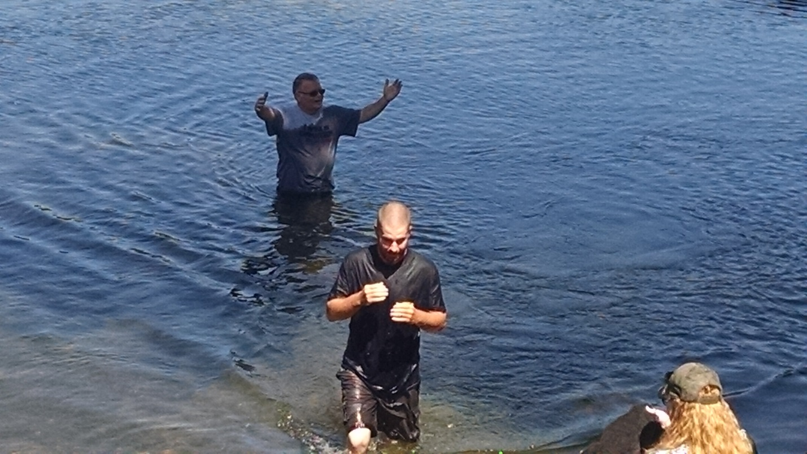

7
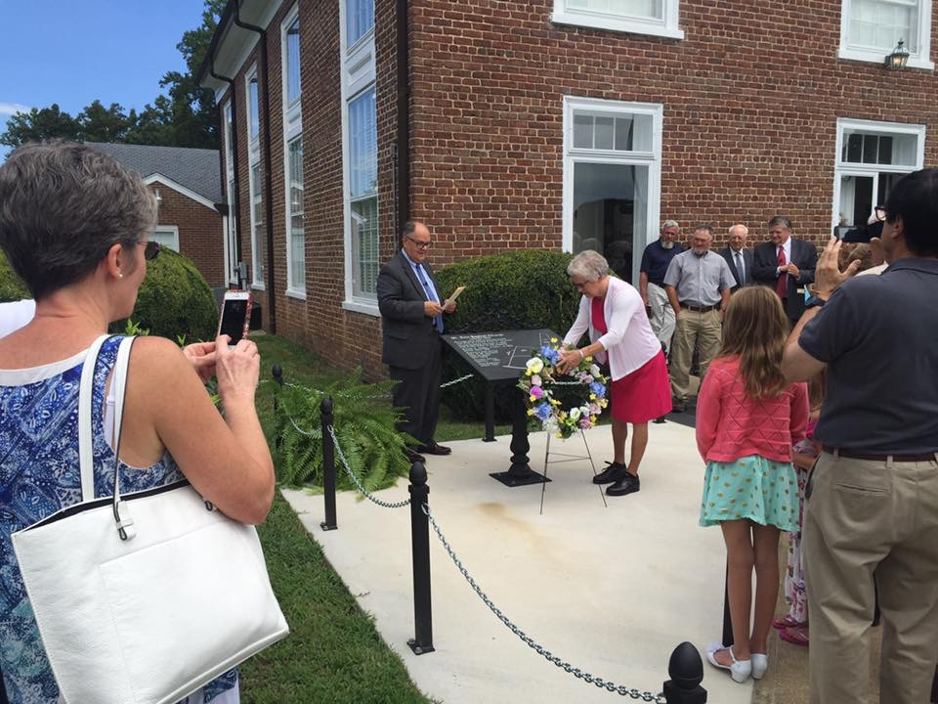
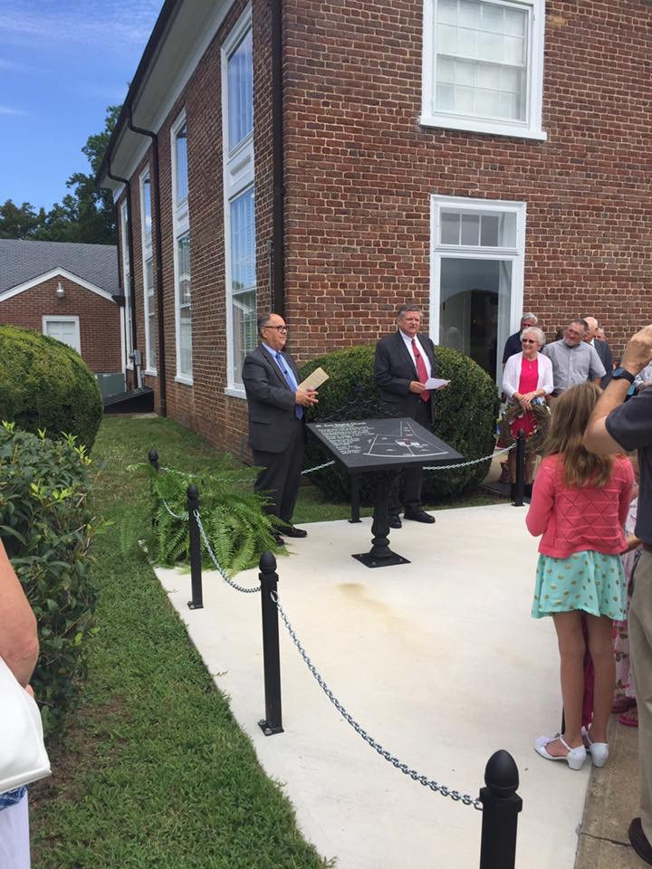

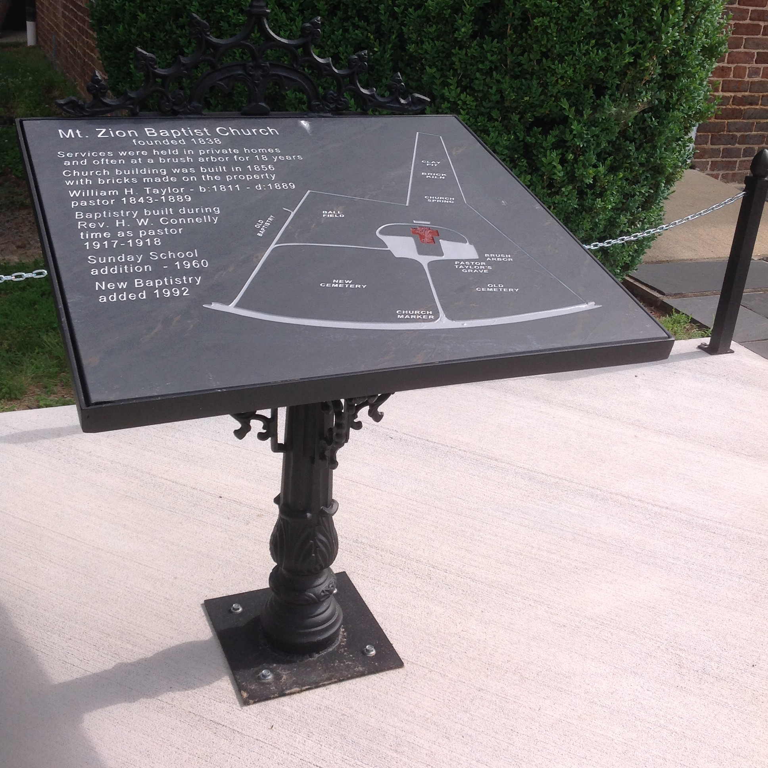
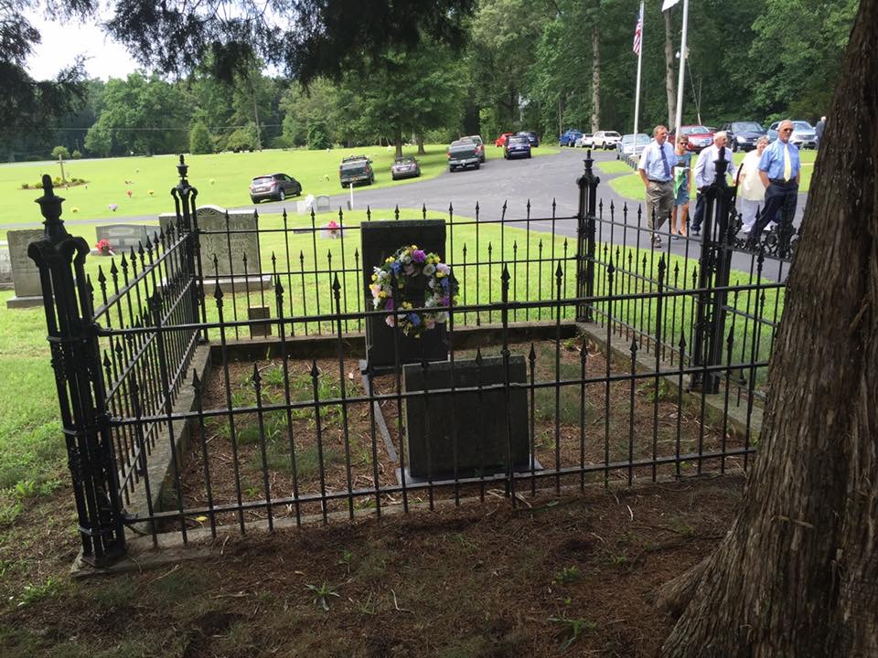

On Sunday, August 7, Dr. Fred Anderson spoke at the morning service at Mt. Zion and had the dedication of the Historical markers. Those who had made it happen were recognized: Kathleen Jones , Troy Jones, Wayne Apperson, and Jim Cook. Mt. Zion had a wonderful Homeocoming and Revival with over 100 in attendance on Sunday, August 7, and an average of 50 each night of revival. Each speaker gave them something to think aobut and meditate on.

On his way home, Dr. Anderson went by the Oak Grove Chapel that has been painted inside and out now and noted how nicely the grounds are cared for. Thanks to the members of Mt. Zion that worked so hard in the 90+ degree weather to prepare the Chapel for next year when they will celebrate 100 years!

FOR YOUR INFORMATION>>>

- ATTENTION CHURCH CLERKS: Hopefully, all of you have received my recent email regarding the 2016 Annual Church Profile. I have still not received the “official” profile forms, but you should have in hand a facsimlie to utilize and record the needed information. There are no changes to the form for this year, but if you have questions, be sure to call. I think that it will be best if everyone just plans to send me a hard copy this year since the new network is not yet completely functional. When it is, I will enter the information online and we can plan to meet before next year for a training on the new system. I appreciate your understanding and hard work! I look forward to again having 100% of our churches reporting. The deadline for reporting to me is October 20.
- ATTENTION YOUTH LEADERS: Danny Quirin is the new Youth Minister in Residence for the BGAV. In this position he will serve as an ambassador to BGAV church in their youth ministry-related matters; respond to inquiries and requests from BGAV churches and staff related to youth ministry; and coordinate the BGAV annual youth ministry training event, which will be in May. You can reach him by email at danny.quirin@bgav.org. or by phone at 540-580-4476, or on Facebook. Contact him whenever you have youth-related questions.
- BGAV has scholarships available for students from cooperating churches of the BGAV who need aid in financing their education at one of the BGAV-partnering Academies (Fork Union Military Academy, Hargrave Military Academy, or Oak Hill Academy.
8
- Southwestern Baptist Theological Seminary is preparing for “Revive This Nation 2017, an evangelistic program design to serve Southern Baptists as a catalyst for revival. If a church would like to participate in this initiative, you will need to complete the Church Application Form, available online at http://www.swbts.edu/rtn. The basic features of the Revive This Nation Program are as follows:
- Southwestern Seminary recruits churches to hold revival meetings in the spring and pays for the roundtrip transportation for preachers to these churches.
- The host church provides meals, lodging, and local transportation for the preacher while they are on the ground
- Revival meetings generally begin on Sunday morning and end on Wednesday evening, March 12 – 15, 2017, although alternative formats are available if this schedule is not an option.
- The preacher partners with the host church to engage lost people from the lcoal community through evangelism during the weekdays.
If you would like to speak to someone about this program, please contact Mr. Daniel Dickard in the Office of Church Ministry at 817-923-1921, Ext. 6331.
- Disaster Relief Responses:
- A BGAV team arrived in Baton Rough on Sunday, August 21, to begin cleanup efforts. Additional teams are being assembled and will be going. When teams enter a home, they must remove every wet item which cannot be cleaned, including wall board, insulation, flooring, furniture, clothing, and personal effects. The emotional burden on the homeowner is significant, as neighbor by neighbor piles debris out by the road for disposal. You and your church can contribute to Louisiana flood relief through the BGAV. Donations will be used to assist our Baptist partners and volunteers on the ground with the cleanup and rebuilding efforts. Make checks payable to BGAV with “Disaster Response – Louisiana” on the memo line. Mail to Disaster Response, Virginia Baptist Resource Center, 2828 Emerywood Parkway, Richmond, VA 23294.
- Cooperative Baptist Fellowship Global has a team on the ground in Louisiana and other volunteer teams are preparing to go and help. The people of Louisiana going back to their homes need physical, moral, and spiritual support. If you would like to donate to this effort, make your check payable to CBF with “Accdt. 17006” on the memo line. Mail to Cooperative Baptist Fellowship, P. O. box 102972, Atlanta, GA 30368-2972
- JRBA Guidelines for Magazines & Literature for Hope Aglow Prison Ministry
- Always remove your mailing label from the magazines. (Also any church shipping invoices that may contain account numbers.)
- Secular magazines or books, hardback books, calendars, or catalogs are NOT allowed.
- If you have Teachers’ Editions that go with Sunday School books, it would be helpful to put them together by quarter.
- It is best if you put your magazines/books/literature in plastic ghrocery bags, tied with a bow or slip know, or in SMALL boxes.
Thank you for your continued support of the prison ministry and for following the guidelines when donating materials. Through your efforts we are able to supply inspirational reading material to thousands of inmates each year. Your magazines and literature can be brought to the JRBA Office on Mondays and Wednesdays from 8:30 AM to 2:30 PM.

JRBA CHURCH WEB SITES

ANTIOCH (Scottsville) – www.antiochva.org

CEDAR – www.cedarbaptistchurch.org

ENON – www.enonchurch.net

FIRST BAPTIST DILLWYN – www.fbcdillwyn.com

JONES CHAPEL – www.joneschapelbaptistchurch.com

MULBERRY GROVE – www.mulberrygrovebaptistchurch.com

The following churches have Facebook pages:
Antioch Baptist Church, Antioch Union Baptist Church, Arvon Baptist Church, Buckingham Baptist, Chestnut Grove Baptist, First Baptist Church Dillwyn, Fitzgerald Memorial Baptist Church, Goshen Baptist Church, Jones Chapel Baptist Church, Mount Tabor Baptist Church, Mt. Zion Baptist Church, Mulberry Grove Baptist Church, Sharon Baptist Church, and Tar Wallet Baptist Church.

It is good to see that so many of our churches have a social media presence as we continue to reach out to others.

STAFF CHANGE
Mt. Zion has called Rev. Woody Moore to their pastorate. He will start on September 1.
Rev. Woody Moore
11400 Winterpock Road, Chesterfield, VA 23838
Phone 804-382-7954
Email n2preaching@comcast.net
JRBA welcomes Rev.Moore and looks forward to working with him.

FROM YOUR MODERATOR>>>

I really enjoyed the Hispanic Fun Day at Arvon, playing corn hole, and lots of good food! Thanks, Michael, for all you do, encouraging churches to be “united to serve, committed to making a difference”. Thank you to all for participating in association endeavors. Thanks to all who purchased flood buckets, food, and to Rev. Beale, Antioch Union, for delivering the food to WV victims. Valeria Breault is working to get us ready for another Operation InAsMuch in a few weeks. Another opportunity to serve together is the OIAM Roofing Project. We also have an opportunity to worship together at the Mt. Zion OIAM Rally on Friday, September 23, at 7 PM, prayers on Saturday morning, and a Closing Service on Saturday night. Mt. Zion’s Fall Festival starts at 3:00 PM…after your OIAM event, join us for music, hotdogs, and stew. There will be special music from 5:00 – 6:00 PM and Wesley Yoder will be preaching at 6:00 PM. Please try to come and invite others.
Marilyn
9


JRBA Executive Board Summary
July 11, 2016

Moderator, Marilyn Snoddy, opened the meeting with devotional thoughts based on Luke 15:10: “ In the same way, I tell you, there is rejoicing in the presence of the angels of God over one sinner who repents.” Jesus spoke these words in his parable of the Lost Sheep when he talked about searching for the one lost sheep. Marilyn shared the advise of Pat Wright, WMUV President, that every church should have a GA group, even if there is only one girl. She was that one girl in her church and now she is the WMUV President! Marilyn shared that she started a GA group at Mt. Zion only thinking that there might be one girl, but now there are six girls attending. She reminded us that we need to be faithful in order to be fruitful. If we “do our best, God will do the rest.” She then offered a prayer of gratitude and willingness to follow God’s direction for the association.

The meeting was called to order and Frank Breault, Clerk, had the roll call of churches. There were 19 in attendance, representing nine member churches. The minutes of the April Executive Board Meeting were presented and approved. The minutes of the Spring Meeting were presented and approved. The Treasurer’s Report was presented and approved. As of June 30, 2016, the Checking Account had a balance of $26,744.42. This balance includes the following designated monies: Additional Missions Fund - $278, Youth Encounter - $400, Local Missions & Impact VA Fund - $70.04, and Hispanic Ministry - $611.46. Total receipts for the quarter were $7,541.83. Total Disbursements were $15,372.53, including $700 to Mission Trip participants, $218.24 to Hispanic Ministry, $9,591.14 to Stop Hunger Now, and $550 to BGAV More Than Nets (Spring Meeting Offering). The Savings Account Balance stands at $4,145.17.

Mrs. Betty Toney presented the John E. Mann, Sr. Benevolence Fund Report. From April 1 – June 30, the fund assisted 2 stranded motorists with one night’s lodging and made a donation to a family who lost everything in a house fire. Total disbursements were $210.00. There were no contributions from the churches during this quarter. The checking account balance on June 30 was $3,208.91. The report was approved as presented.

Marilyn then introduced Rev. Jimmie Beale, Interim Pastor at Antioch Union, and Jimmy Dunn extended a warm welcome to him. Marilyn mentioned the upcoming VBS, Homecomings, and Revivals. She also told about the BGAV effort to make and distribute Flood Buckets to the victims of the West Virginia Flooding. The cost of purchasing the items for a bucket is $75.00, but through a BGAV partnership with Home Depot, for every $150 contributed, they can assemble three buckets. A motion was made, seconded, and approved for JRBA to send $150 to this effort. Marilyn reminded everyone of the JRBA Annual Fall Meeting scheduled for Thursday, October 20, at Arvon Bapttist.

There were no other Officers’ Reports so Marilyn called for Committee Reports. Representing the Missions Committee, Rev. Jimmy Dunn praised everyone for the generous giving to our May Stop Hunger Now Meal Packing effort. Our churches raised over $9,000 and BGAV supplemented this with an additional $500. Jimmy encouraged everyone to begin now to save contributions for our next meal packing event. He also expressed his excitement and appreciation for all the groups and individuals who are involved in summer missions trips. It was noted that Jones Chapel currently has a team of 19 adults and youth on mission in West Virginia. Buckingham Baptist will be sending a team to Impact VA, Saluda, at the end of the month. Jimmy then noted that we have three opportunities to assist our neighbors in West Virginia who have been impacted by the recent flooding. First we can donate to the BGAV Flood Bucket project (as previously approved). Another opportunity is available through First Baptist Dillwyn. White Sulphur Springs, an area hit hard by the flooding, is in need of lime. FBC is collecting money for this cause. Rev. Jimmie Beale announced that Antioch Union has already collected a trailer load of items and sent them to WV. They are still collecting through July 18 - items can be dropped off at Pearson Construction on Route 24. (A list of items needed has been emailed to each church.) They are working with a church in Lexington and their goal is to reach folks in isolated areas that may not benefit from other donations.

Rev. Michael Khol noted that the Hispanic Ministry has hit somewhat of a lull. In an effort to further encourage our Hispanic neighbors, a Picnic/Game Day is being planned for Sunday, August 21, at Arvon , at 4:00 PM. He asked that everyone continue to pray for our Hispanic Outreach. Michael also noted that the Associational Picnic held on June 25 was a great time of fellowship for the 34 in attendance representing seven of our churches. Rather than play softball, quite a few of the attendees engaged in a rousing game of Kickball. The hotdogs and hamburgers, along with other dishes, were enjoyed by all. Michael is hoping to have another fellowship event later in the fall.

Mrs. Valeria Brault, Operation InAsMuch Committee Chair, reminded everyone of the date for the JRBA Missions Blitz: September 24. She noted that she needs a contact person’s name and contact info for each church – she currently has heard from 10 churches and needs the rest as soon as possible. She will plan a meeting in August to meet with the contact individuals. At that time she will distribute a list of possible activities for the churches. Additionally, each church can be thinking of activities they may want to do in their communities to reach out and show the love of Jesus. Our goal is to involve all of our churches and as many members as possible. Folks are again being asked to wear red shirts and name tags will be provided. There will be a Pre-Event Rally on Friday, September 23, at Mt. Zion at 7:00 PM. This will be an opportunity to meet for inspiration and prayer before the outreach on Saturday.

There was no Old Business. Phyllis announced that the landlord, Mr. James Snoddy, had the office exterminated and she has thoroughly cleaned it. Mr. Snoddy has mentioned the possibility of replacing the carpeting with new flooring. There was no New Business. Marilyn asked if there were any additional announcements. Betty Toney commented on the success of the Splash Event held at Buckingham Baptist. Kathleen Jones made a motion to adjourn and the meeting was closed in prayer by Rev. Perry Clore.

10

ASSOCIATION FINANCES
2015 – 2016

REGULAR BUDGET RECEIPTS
Church | August | Year-to-Date
Antioch(Scottsville) | $ 300.00 | $ 900.00
Antioch Union |  | $ 500.00
Arvon |  | $ 1,362.00
Buckingham |  | $ 1,368.47
Cedar |  | $ 2,000.00
Chestnut Grove |  | $ 500.00
Enon |  | $ 700.00
First Baptist Dillwyn |  | $2,000.00
Fitzgerald Memorial |  | $ 550.00
Fork of Willis |  | $ 429.00
Gladstone Memorial |  | $1,325.00
Goshen |  | $1,257.00
Jones Chapel | $ 126.81 | $ 1,338.61
Mt. Tabor |  | $ 730.00
Mt. Zion |  | $1,800.00
Mulberry Grove |  | $2,300.00
Sharon | $ 391.00 | $1,564.00
Tar Wallet | $ 500.00 | $ 500.00
Individuals | $2,500.00 | $2,600.00
VBMB – Alma Hunt |  | $ 169.30
TOTAL | $3,817.81 | $23,893.38
Approved Budget for 2014 – 2015: $24,671.00

TREASURERS: Please note that unless a specific ministry or project is designated on the memo line of the check or in an accompanying note, the contribution will appear in the regular budget receipts.

OPERATION INASMUCH ROOFING PROJECT
Mt. Zion - $ 200.00

ADDITIONAL MISSIONS FUND
No contributions or expenditures in August.
Earlier individual contribution: $100 (More Than Nets)
Earlier expenditures: BGAV More Than Nets - $400
BGAV Carolina Flooding - $300
Antioch Flint Water Project - $100
BGAV –WV Flood Buckets $150.00
Balance: $128.00

YOUTH ENCOUNTER
Carryover: $400.00
No contributions or expenditures in August.



JRBA Meal Packing Event Expenditure
May - $9,591.14

STARTING OVER
Church | August | Total-to-Date
First Baptist Dillwyn | $ 120.00 | $ 120.00
Gladstone Memorial |  | $ 167.00
Tar Wallet | $ 100.00 | $ 100.00
TOTAL | $ 220.00 | $ 387.00

LOCAL MISSIONS PROJECTS/IMPACT VA FUND
Carryover: $258.04
No Contributions or Expenditures in August.
Earlier Contributions: ½ Fall Meeting Plate Offering - $212.00
Individual - $100.00
Earlier Expenditures: BGAV Disaster Response- Appomattox $400.
Buckingham Youth to Impact VA - $100
Balance: $ 70.04
BGAV SYRIAN REFUGEE CRISIS
½ Fall Meeting Plate Offering: $212.00
October Expenditure $212.00
BGAV MORE THAN NETS
Spring Meeting Offering - $550.00
BGAV More Than Nets - $550.00

JRBA Hispanic Ministry

Church | August | Total-to-Date
Carryover (2014-2015) |  | $ 850.82
Buckingham |  | $ 200.00
Enon |  | $ 100.00
First Baptist Dillwyn | $ 100.00 | $ 100.00
Mulberry Grove |  | $ 100.00
TOTAL | $ 100.00 | $ 500.00
No expenditures in August
Balance: $ 659.62

John E. Mann, Sr. Benevolence Fund

Church | August | Total-to-Date
Buckingham |  | $ 400.00
Cedar |  | $ 300.00
Enon |  | $ 186.52
First Baptist Dillwyn |  | $ 500.00
Mt. Zion |  | $ 100.00
Goshen |  | $ 250.00
Mulberry Grove |  | $ 300.00
Sharon |  | $ 200.00
TOTAL |  | $2,236.52
August Disbursements: $50.00
Balance on Hand – 7/31/16: $3,233.91

KEEP IN PRAYER>>>
- Those who are lost and need to know the Savior
- Churches without a Pastor : Antioch Union (Rev. Jimmy Beale, Interim), Buckingham, Chestnut Grove, Fitzgerald Memorial, Goshen, and Mt. Tabor
- JRBA Hispanic Ministry
- September 24: JRBA Operation InAsMuch Missions Blitz
- JRBA Pastors’ Huddle
- Upcoming Homecomings & Revivals
- Victorita Gina Vasile, JRBA WMU Project Ruth adoptee
- Local family serving IMB
- All those in our congregation who are ill or have lost loved ones.

…the prayers of the righteous please Him.
Psalm 15:8b

11

