 THE SERVANT LINK
CHURCHES UNITED TO SERVE -
COMMITTED TO MAKING A DIFFERENCE
James River Baptist Association
P. O. Box 1219, Dillwyn, VA 23936
Mrs. Marilyn Snoddy – Moderator
www.jamesriverbaptistassociation.com
Tel: 434-983-7385 Email: jrba@embarqmail.com
Hours: Monday & Wednesday 8:30 AM – 2:30 PM
____________________________________________________________________________________________________________
Volume XV November 2016 Edition XI

EVENTS DETAILS

November 2 Prayer Meeting at Goshen 7:00 PM
Wednesdays: 2, 16, 23, & 30


WMUV Women’s Get-Away
November 4 – 5 or 5 – 6, 2016*
Featured Speaker: Morgan McCoy
Worship Leader: Keith Tan

WMUV Annual Meeting
Saturday, Nov. 5 (Between Sessions)
2:00 – 3:30 PM
Followed by Reception

Over 20 Breakouts, Music, Fellowship, & More!
*Each session starts with Dinner at 5 PM and
ends with lunch on the following day.

November 5 Harvest Festival at Mulberry Grove 1:00 – 3:00 PM

November 6 Missions Presentation at Chestnut Grove 11:00 AM
Donielle Yoder, former missionary to Sri Lanka, will speak during the Worship Service about her experiences
on the mission field.

Personal Finance Class at Antioch (Scottsville) 5:45 PM
Taught by Eric Oliphant, Bank Examiner for the Federal Government

November 7 Youth OCC Shoebox Packing Party at Cedar 6:00 PM
The Women on Mission look forward to sponsoring the packing party for the youth.

Baptist Women’s World Day of Prayer Service at First Baptist Dillwyn 7:00 PM
Theme – ARISE, SHINE: Arise, Jerusalem! Let your light shine for all to see. For the glory of the LORD
rises to shine on you.
Special Guest: Representative from Madeline’s House, Farmville
The offering will be divided between the Women’s Department of the Baptist World Alliance and Madeline’s House.
Each church is asked to make a donation to this offering and to send representatives to this evening focused on prayer.

November 8 ELECTION DAY
Exercise your right to vote!

November 9 Senior Citizens Fellowship at Mulberry Grove 11:00 AM
Bluegrass/Gospel Music and Covered Dish Fellowship Lunch

NOVEMBER 9, 2016 HYGIENE KITS FOR THE PRISON MINISTRY ARE
DUE TODAY BY 2:30 PM AT THE JRBA OFFICE.

November 10 Veterans Day Service at Buckingham Correctional Center
The Adult Choir of First Baptist Dillwyn will be sharing during this special service.

November 11 VETERANS DAY
1

November 11 & 25 Blue Ridge Food Services Food Distribution at Crystal Cathedral
Volunteers needed at 9:30 AM.

November 13 Antioch (Scottsville) Boomer Class Fundraiser – Soup/Chili Meal Noon
Donations go to the Boomer Fund.

Chris Lewis in Concert at Enon 3:00 PM
Followed by refreshments in the fellowship hall.

Youth Group at Goshen 5:00 PM

November 14 – 16 193rd Annual Meeting of the Baptist General Association of Virginia
Location: Bonsack Baptist Church, Roanoke, VA
Theme: The New Way (John 13:33-35)
Keynote Speaker: Gabe Lyons, Founder of Q Ideas, a learning community that mobilizes Christians to advance the common good in society and well-known authur of several books on Christianity in today’s world.
Other Speakers: Chris Cadenhead, Pastor, Bonsack Baptist Church, and Dr. John Upton, BGAV Executive Director
Online registration is now open at www.bgav.org/meeting.
Special rates are availabe for lodging at several area hotels. View the hotel options online at the above address.
Note that the schedule is somewhat different this year: There will be breakout sessions available on Monday afternoon at 4:00 PM. Dinner on-site will be available for purchase Monday and Tuesday nights, as well as lunch on Tuesday.
Gathering I will be Monday night at 7:00 PM. Tuesday will include Business Session I, Gathering II, Regional Meetings, Breakouts, and Gathering III(7:00 PM), followed by a dessert fellowship. Wednesday will include the second Business Session and Gathering IV.
Registration packets have been mailed to churches. Don’t forget to approve your messengers at a church business meeting.

THE JRBA OFFICE WILL BE CLOSED ON MONDAY, NOVEMBER 14,
AND WEDNESDAY, NOVEMBER 16.

Samaritan’s Purse Operation Christmas Child

Shoebox Collection Week
November 14 – 21, 2016
Collection Site: Bethlehem Baptist Church

Monday – Friday, Novermber 14 – 18: 4:00 – 6:00 PM
Saturday & Sunday, November 19 – 20: 2:00 – 6:00 PM
Monday, November 21: 9:00 – 11:00 AM
As a point of interest: In 2009 this site collected 707 shoeboxes. In 2014, the total was 1,231 shoeboxes!
2016 Goal for this site: 1,600
South Central Virginia Goal: 16,600
Let’s do our part to make these goals a reality!
DON’T FORGET: NO TOOTHPASTE, CANDY, OR GUM IN SHOEBOXES IN 2016.

November 19 5 Loaves & 2 Fish Ministry Meal at Antioch (Scottsville) 11:00 AM – 1:00 PM
Volunteers at 8:00 AM.

Fall Festival at Antioch (Scottsville) 11:00 AM – 4:00 PM
Theme: Fall in Love with Jesus
Community Outreach with Brunswick Stew, Horse and Wagon Rides, Bounce House, Face Painting, Cake Walk,
and lots more fun!


NOVEMBER 20

Thanksgiving Meal at Enon Noon

Covered Dish Thanksgiving Lunch at Buckingham Noon

Antioch Union’s Community Thanksgiving Pot Luck Meal at Toga Fire Department 5:00 PM
Thanksgiving Service to follow the Meal 6:15 PM

Thanksgiving Dinner at Chestnut Grove 5:30 PM
Covered dish dinner followed by special music by Michael Wayne Smith. All are welcome.

2

November 24, 2016 – Thanksgiving Day
Give thanks to the Lord, for He is good; His love endures forever.
Psalm 107:1

November 26 Hanging of the Greens at Tar Wallet
Church members will gather to decorate the church and Christmas tree.

November 28 Information is due TODAY by 9:00 AM for the December newsletter.
Be sure to include dates and times for all Christmas activities and New Year’s Eve Watch Services.

November 29 WMU Meeting at Chestnut Grove 7:30 PM
Featuring presentation by Ruth Wallace on her recent trip to Senegal, Africa.

LOOKING AHEAD>>>

December 2 Very Merry Joyful Noise Gospel Sing at Antioch (Scottsville) 7:00 PM
Sponsored by the Boomer Class

LOTTIE MOON CHRISTMAS OFFERING
Week of Prayer for International Missions
December 4 – 11, 2016
Theme: the gospel resounds
100% of your gift helps send and sustain IMB missionaries.

December 4 International Mission Study at Mt. Zion 2:00 PM
Donielle Yoder will be speaking on her experience as an interational missionary and the
Lottie Moon Christmas Offering.

Christmas Cantata at Sharon 7:30 PM
The choir will perform Celebrate the Gift. All are invited to joinin this special time of celebration;
refreshments and fellowship will follow the performance.

December 5 Annual Christmas Dinner at Tar Wallet 5:00 PM

JRBA Hispanic Christmas Fiesta at Buckingham 6:00 PM
Invite your Hispanic friends to come out and enjoy a time of celebrating our Savior’s birth and
enjoying a meal together. Bring a side dish.

January 22, 2017 Just Us in Concert at Mt. Zion 6:00 PM
Just Us,hails from Powhatan. Some of you will remember Rev. Ron Wyatt, a former pastor of Fitzgerald
Memorial, Cumberland, who is part of this group.

JRBA REACHES OUT>>>

MISSIONS COMMITTEE REPORT

- Stop Hunger Now: We are now halfway between our last Stop Hunger Now packaging project and our next event to be held on May 7, 2017.
Therefore, it is urgent that we set aside money each day or week and turn it in to our churches and association regularly so that we will have
money available for our biggest Stop Hunger Now packaging project ever.
- Our Disaster Relief offering of $756, taken at our Annual Fall Meeting, will be a great help to our Virginia Baptist Relief work. I pray each of
our churches will continue to help BGAV Disaster Response work through our prayers, gifts, and volunteering to go when opportunities arise.
- Operation InAsMuch: Our churches continue to have opportunities to carry out Operation InAsMuch-type mission projects as people all
around us need food, home reparis, and so many things we can help with. So, let us regularly carry out these mission endeavors in the name
and spirit of Jesus.
- Missions Everywhere: Let us all be on mission for Jesus in our schools, businesses, communities, and everywhere we are as we serve others in His name through kindness, prayers, gifts, deeds of love, and words of witness.

In Christ’s Love,
Jimmy
Rev. Jimmy Dunn, Co-Chair
3


JRBA MISSIONS BLITZ
SEPTEMBER 24, 2016
Follow Up

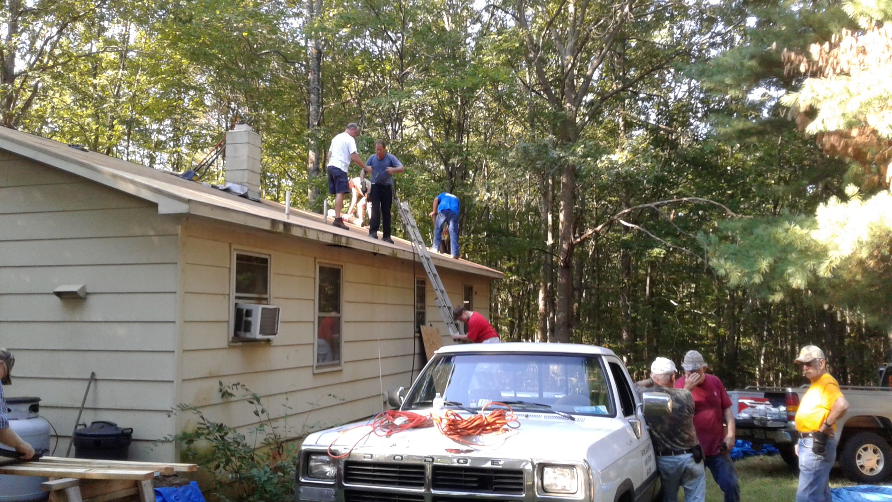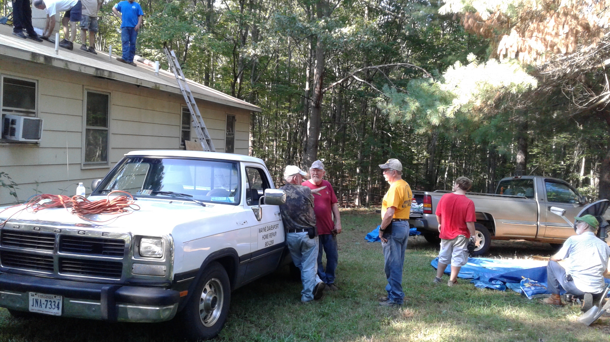

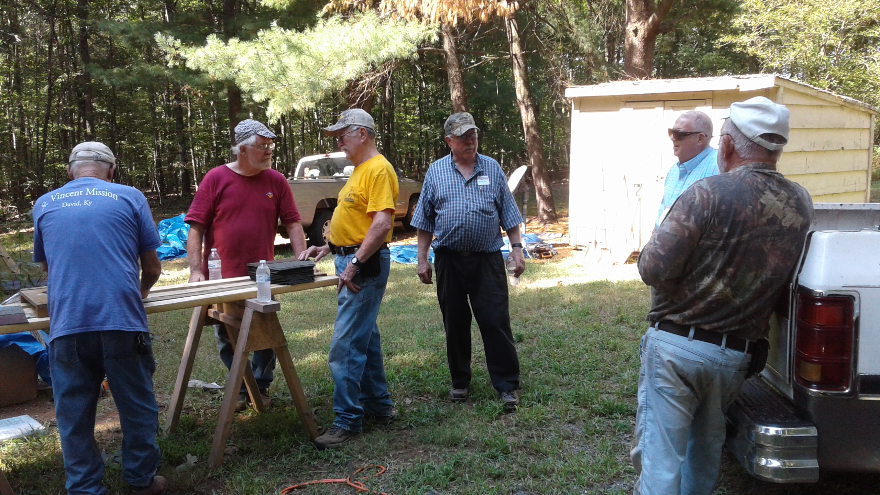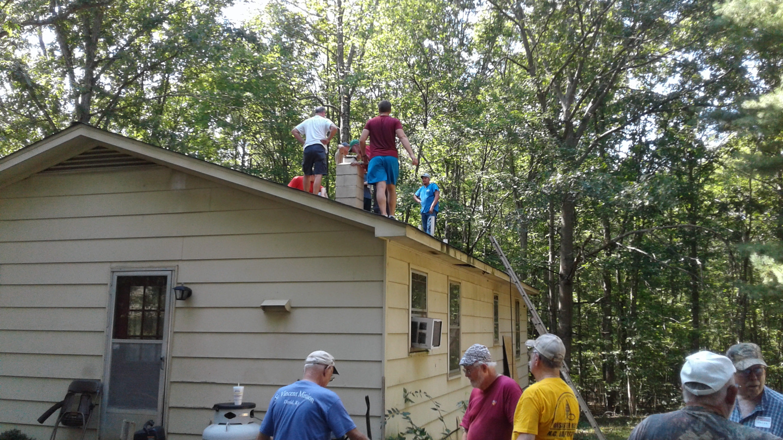

JRBA ROOFING PROJECT

I just wanted to send a final “Thank You” for the OIAM Roofing Project. We originally had intended on replacing half of the roof, but due to the generous contributions of our association as well as the enthusiasm of the volunteers, we were able to complete the second half of the roof on Ocboer 15. It was a real blessing to work along side so many of you to complete this project. No one could have done it alone, but together we were able to accomplish more. Thank you so much to all who were involved!
Love in Christ,
Rev. Michael Khol

ADDITIONAL CHURCH OIAM PROJECTS

ARVON: A Fall Festival was held with 30 people participating. They collected 18 units of blood. They had over 50 cards signed for military men and women for Christmas. They filled a huge box with food for the Backpack Ministry and another large box was filled with items for the food bank. AWARE had a great talk with the kids about online predators and the dangers of social media. The Pregnanacy Center received a huge box of donated new newborn clothes, homemade baby blankets, diapers, wipes, and money to purchase Bibles. The day was a huge success!

ENON: Members visited Heritage Hall and delivered snacks to the volunteers on the Roofing Project.

GLADSTONE MEMORIAL: Members sent cards to shut-ins and had a pancake breakfast for law enforcement rescue squads, and volunteer fire departments in Nelson County.

TAR WALLET: Additional projects not reported last month included providing snacks for the Cumberland volleyball team, donations of Bibles, hygiene items and food to Good Samaritan Ministries, providing coupons for Cumberland Clothes Closet, making Christmas ornaments for shut-ins and nursing home residents, returning shopping carts at local businesses, providing snacks for Cumberland Sheriff’s Office, and delivering medicines to shut-ins.

4
UPDATE ON ANTIOCH UNION’S OIAM PROJECT: On Saturday, October 1, members met at the home of a neighbor who had recently fallen and broken a hip. They removed an old porch and replaced it with a new porch and handicapped ramp. Eight folks did the construction, one person provided coffee set up, one person made and sent ham biscuits for “breakfast”, two peole prepared burgers and dogs for lunch for all workers at the conclusion of the construction.

PICTURES FROM ANTIOCH (SCOTTSVILLE) FOOD MINISTRY DISTRIBUTION

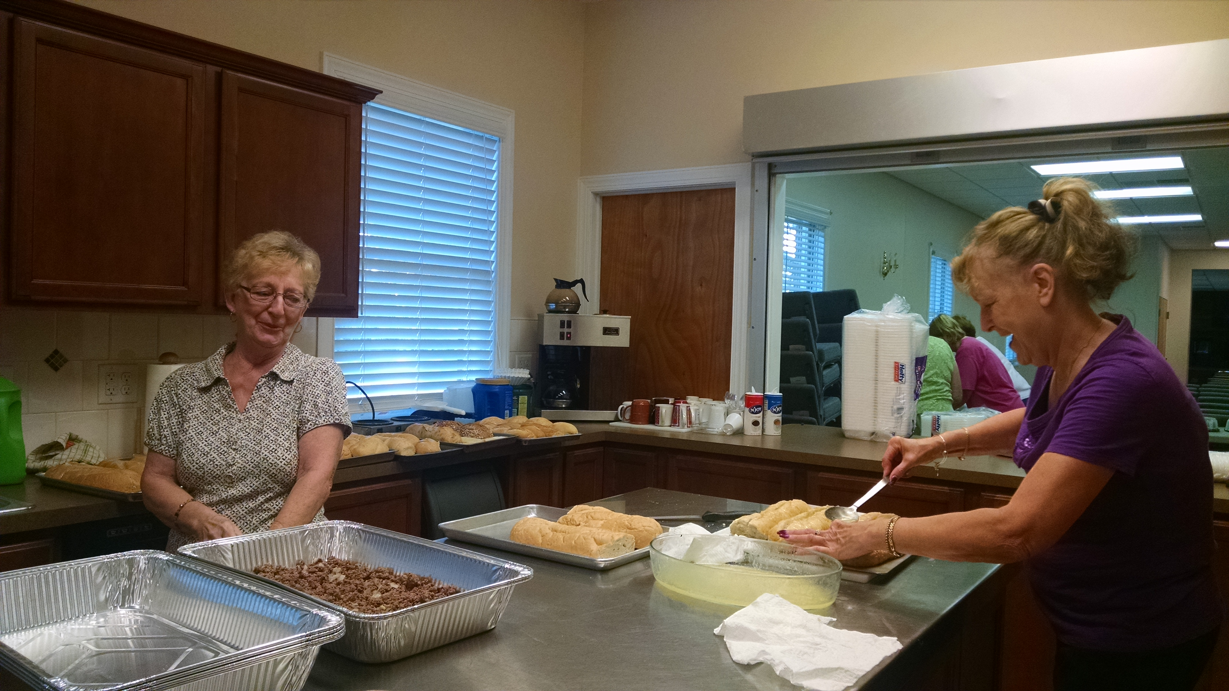

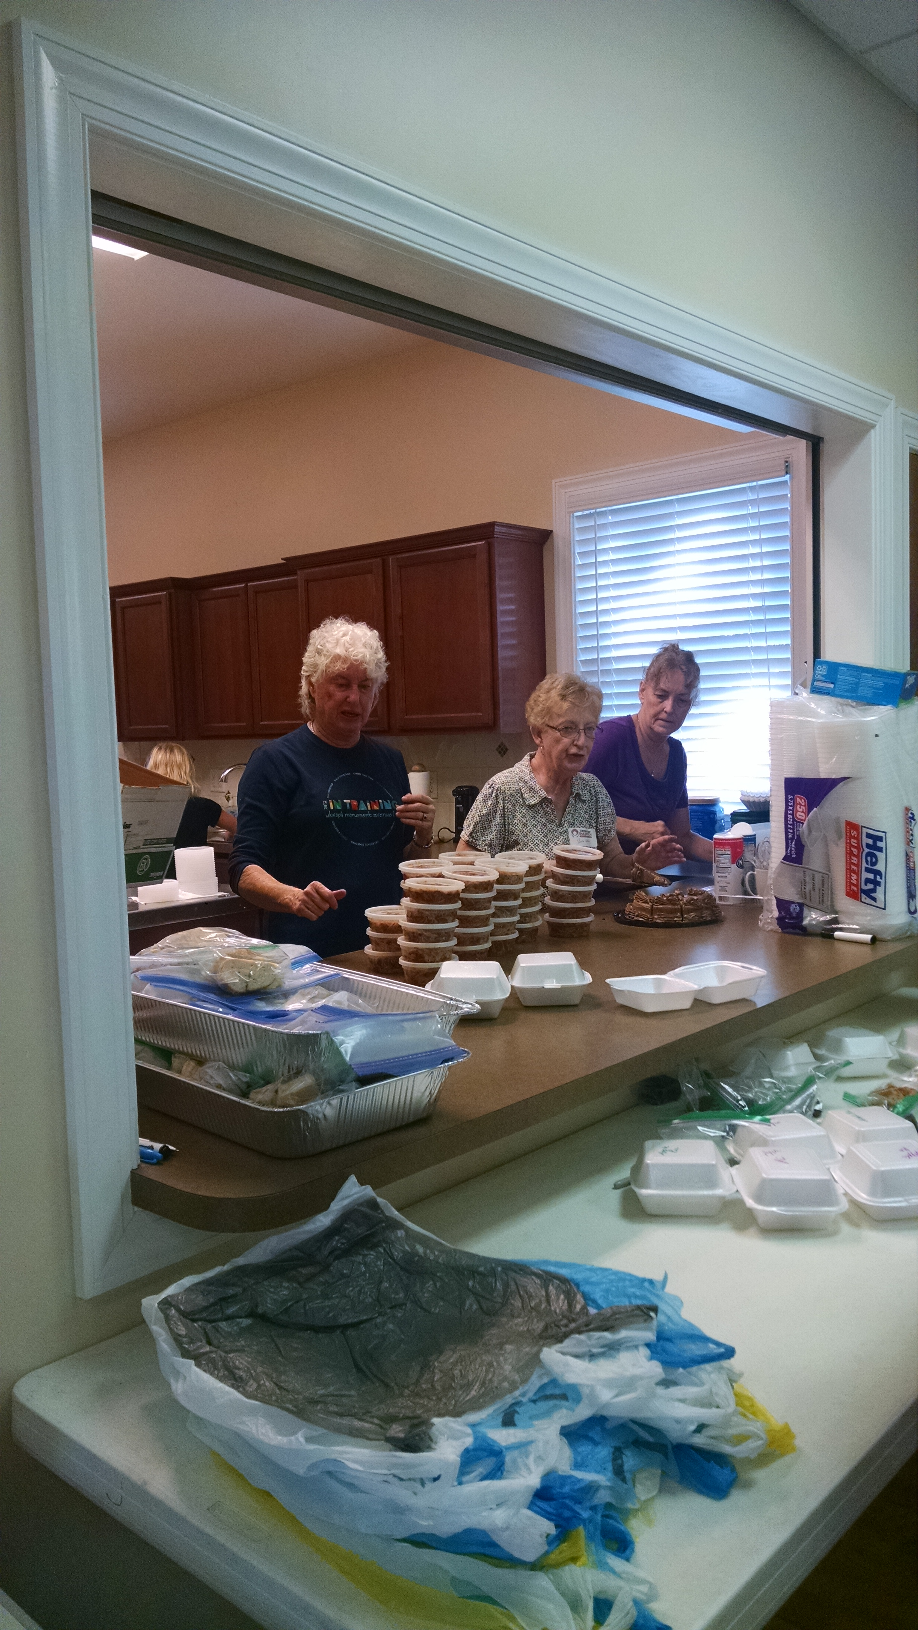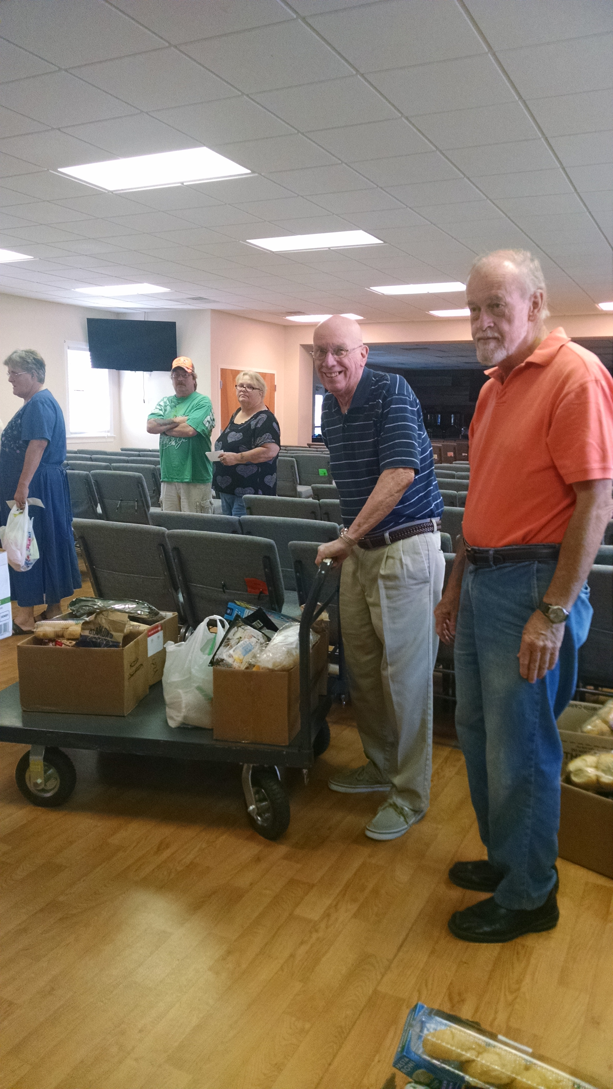

Antioch’s Five Loaves and Two Fish Meal Ministry served 143 meals and distributed 88 boxes of food. They had several new families come in. One blessing of the day was when two little boys (with one of the new families) asked for Bibles and little goodies they had to hand out. They invited the boys to church. The boys seemed excited about that and said they would ask their parents to bring them. Please pray that they will be in attendance soon!

PICTURE FROM MULBERRY GROVE’S MUFFIN DELIVERY
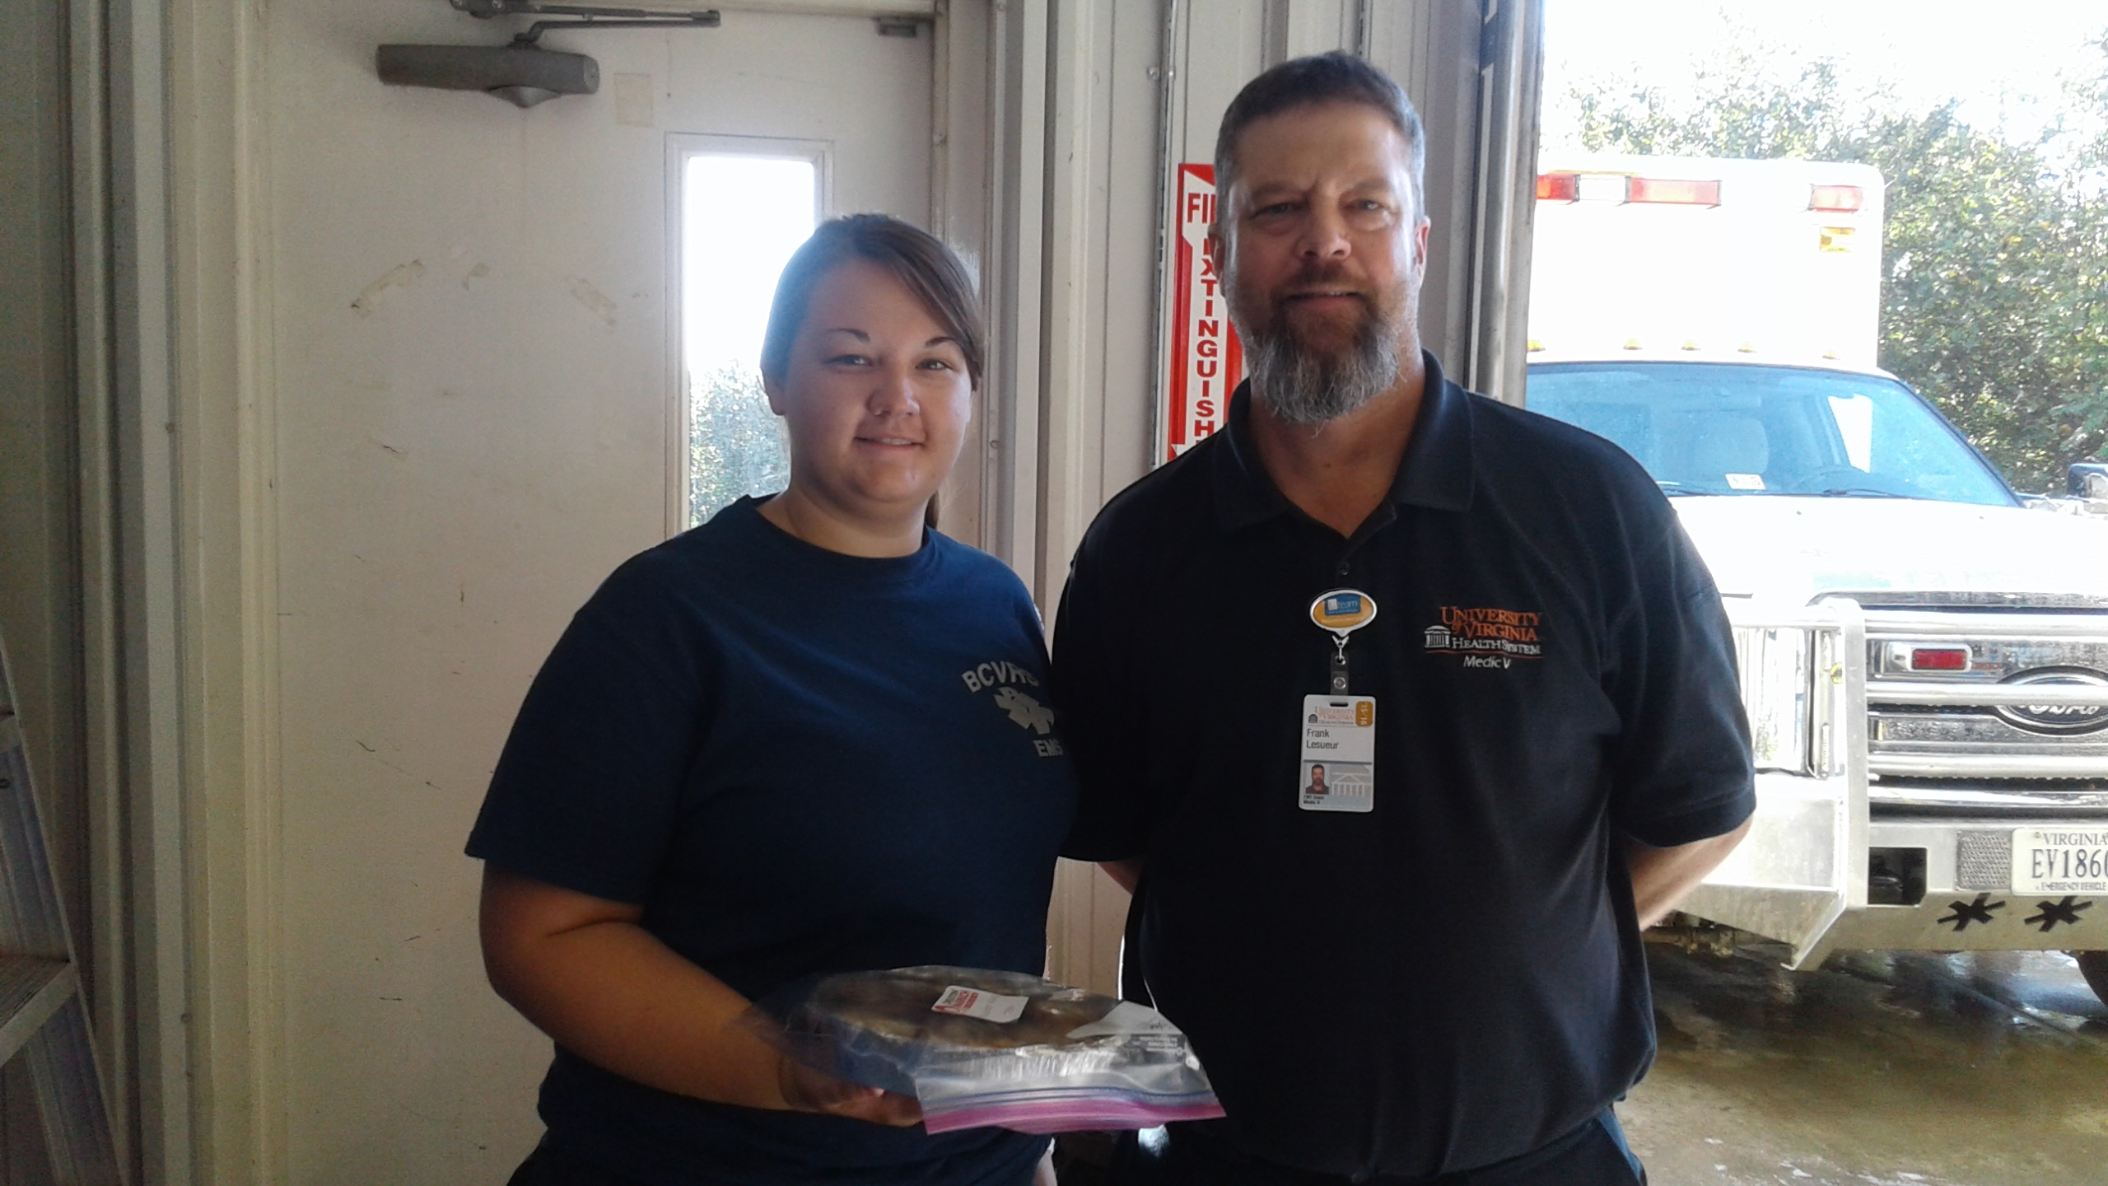

UPDATE ON SHARON’S PARTICIPATION IN ROOFING PROJECT: The ladies of Sharon provided so many home-baked desserts fr the roofing team’s initial workday that there were plenty of extras to be frozen,and then made available to volunteers during the second phase of the project!

5

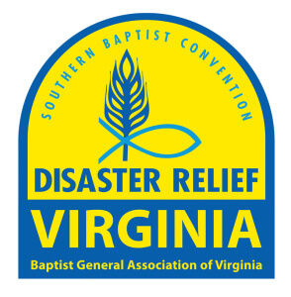
VIRGINIA BAPTIST DISASTER RELIEF

On Monday, October 10, the call came out asking for volunteers to go to Rocky Mount, NC, to leave that day or Tuesday. Gayle Noble and I cleared it with our employoers on Monday and went home to pack. We left Bucknigham about 6:30 AM Tuesday morning and headed to Rocky Mount, NC, and reported in to the Feeding Unit. Gayle was assigned to work the ovens and I was assigned to assist with the administrative duties. We were blessed to stay at the Englewood Baptist Church and volunteer with a NC Baptist Men’s Group. We served until Friday morning, October 14, when the two kitchens were moved to Wallace, NC. 35,000 meals were served through Wednesday, October 19, and the kitchens closed on Friday, October 21.

BGAV Disaster Relief sent a call out last week for volunteers for the mud out and clean up and they also will be staying in Rocky Mount. These volunteers will assist the home owners in salvaging whatever they can of what is left of their homes. Most often the homeowners do not have flood insurance because of living in a flood prone area.

The majority of the volunteers are retired, one gentleman celebrated his 88th birthday and his wife is 87. Don’t ever think you are too old to serve. Remember God does not call the equipped, he equips the called!

Training for Disaster Relief occurs in the spring. Please get the training as it is never a matter of “if” it happens to us, it is a matter of “when” a disaster will occur in our area. When it does happen we want to have encough volunteers to be able to help our neighbors during a time of need.
Thank you.
Liz Steger

ALMA HUNT OFFERING FOR VIRGINIA MISSIONS


CHURCH | CONTRIBUTION
Antioch (Scottsville) | $1,482.00
Buckingham | $1,500.00
Chestnut Grove | $ 445.00
Fitzgerald Memorial | $ 538.00
Goshen | $ 975.00
Jones Chapel | $ 225.00
Mt. Zion | $1,286.00
Mulberry Grove | $ 355.00
Tar Wallet | $ 350.00

OTHER CHURCH OUTREACH FOR OCTOBER

Buckingham held a benefit for Rose Mangelletti Rea on October 15 to help with her bills from chemo for breast cancer. Chris Lewis, Noah and Sandra Hickman, Sharon Hickman, and the Roger Woodson Family and Friends provided the music. Brunswick Stew and BBQ chicken dinners were available for a donation. About $3,500 was received from the event. Rose and Shelia Mozingo would like to thank everyone who helped in any way.

Chestnut Grove will pay for putting “In God We Trust” decals on all Buckingham County Sheriff Department vehicles. They are currently collecting shoeboxes for Operation Christmas Child.

First Baptist Dillwyn is seeking to continue to carry out Operation InAsMuch throughout the year by serving others in Jesus’ name. Lewis Brandt’s SS Class is continuing to provide food for a needy family served through OIAM. FBC continues to visit residents of Heritage Hall and conduct services there on the 4th Sunday of each month. FBC will prepare and deliver over 100 meals to shut-ins of the area on Sunday, November 20.

Goshen will also prepare and deliver Thanksgiving meals to the elderly and shut-ins on Sunday, November 20. Members continue to collect for the prison ministry and Operation Christmas Child shoe boxes.

Mulberry Grove worked on several projects in October, and these will continue into November. Members are contributing items for the Harvest Festival Brunswick stew and cake walk. In addition, individuals are donating non-perishable food items, baby items, and paper products, gift cards ,and school supplies for a family that lost everything in the flooding in Louisiana. The family has relocated to Buckingham. The church is working on the Operation Christmas Child shoeboxes and hygiene kits for the Fluvanna Women’s Correctional Facility. The pastor and several members worked on the second phase of the OIAM Roofing Project. Others volunteered at the bi-monthly food distribution at Crystal Cathedral. Ongoing outreach ministries continue.

The congregation of Sharon contributed 94 dozen home-baked cookies to the Kairos Prison Ministry for their recent weekend within the Buckingham Correctional facilities. Sharon appreciated and enjoyed the opportunity to join Arvon Baptist for “Trunk or Treat” festivities on Saturday evening, October 29. In conjunction with the Women’s Get Away at Eagle Eyrie, Rose of Sharon members are also contributing: 1) Shoes for Hope: gently-used shoes with proceeds funding food, housing, and education for orphans in the Democratic Republic of Congo; and 2) Christmas gifts for Standing Rock (toys, winter hats, gloves, scarves, hygiene items, school supplies, etc.). Rose of Sharon WMU continues visiting with and delivering meals to those who are sick or home-bound.

6
HYGIENE KITS FOR FLUVANNA WOMEN’S PRISON
Church | Hygiene Kits | + Stamps/Stationery
Mt. Zion | 8 | 10
Tar Wallet | 71 | + Stamps

JRBA LEARNS AND GROWS>>>

JRBA Pastors’ Huddle

Last month, our pastors were blessed with a presentation from Bill Cosgrove, who is a church planting missionary in NE Asia. We were presented with ways to partner and pray for the Lord’s work in planting churches there. Due to the fact that the BGAV is having the annual meeting during our next scheduled Huddle time, we will NOT plan to meet in November. Also, due to the holidays, we will probably not have a Huddle in December. We will plan to resume on the 3rd Wednesdays, starting in January. Thank you all for your ongoing work and faithful support.
Michael
Rev. Michael Khol

Decision America Prayer Rally*

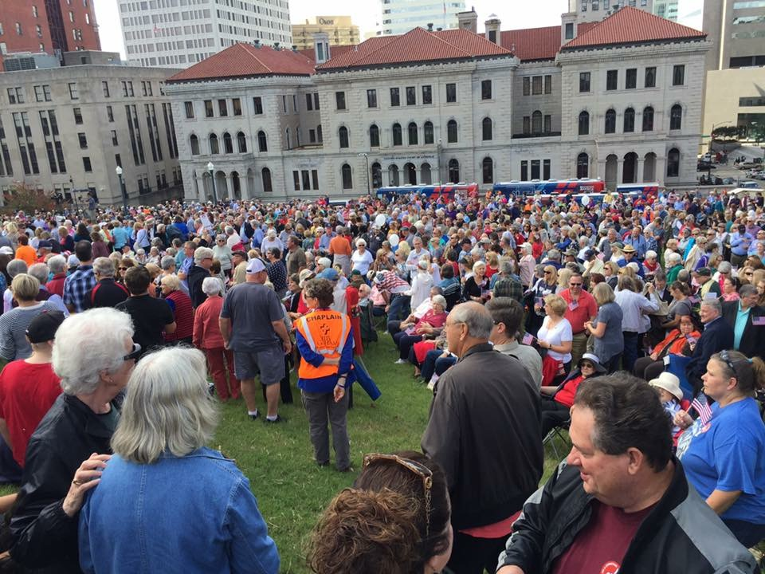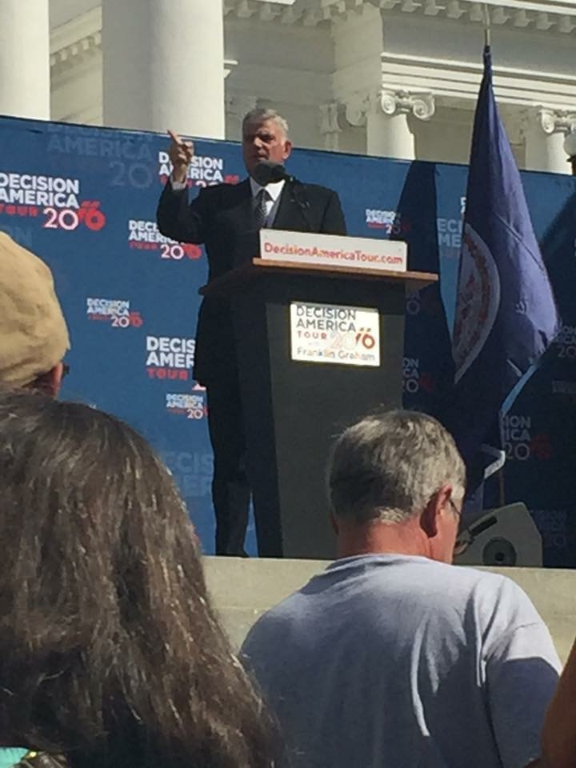

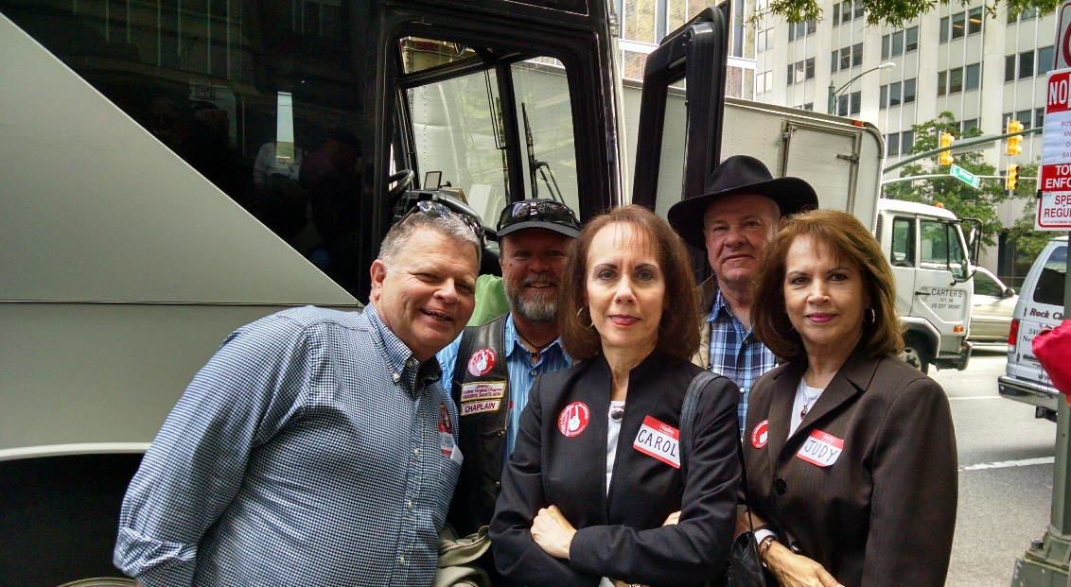

On Wednesday, October 12, Rev. Jimmie Beale (Antioch Union), along with his wife, Adele, led a group to the State Capitol in Richmond to gather with others for the Franklin Graham Decision America Tour Prayer Rally. A Total of 46 people made the trip. Rev. Beale drove the bus and Adele hosted the group by providing snacks, water, and instructions for getting to the site and back to the pick-up location. JRBA and all those who took the bus trip wish to extend our thanks to Jimmie and Adele for organizing the trip and making sure the ride to and from the event was so enjoyable.

Among those attending from JRBA were Rev. Jimmie Beale and his wife, Adele, and Peggy Agee (Antioch Union), Joe and Anne Jones, Harry and Shelia Mozingo, and Betty Toney (Buckingham), Rev. Tommy and Margaret Armstrong, Irvin and Sandra Poe, Richard and Barbara Carner, Kathleen Llewellyn, Dana Ballowe, Lee and Nancy Davis (Cedar), Rita Harris (Chestnut Grove), Rev. John Moxley, Rev. Jimmy Dunn, and Dottie Shumaker (First Baptist Dillwyn), Rev. Richard Tuttle, Jimmy Barden, Gene Bradbury, Carol Ownby, and Judy Ownby (Jones Chapel), Dorris Roberts, Junior Roberts, and Dorothy Davis (Mt. Zion), and Genie Bradshaw and Audrey Ragland (Sharon). Rev. Woody Moore, and his wife, Janice, and Brenda McAllister (Mt. Zion) also attended, but didn’t go on the bus. Shannon and Elizabeth Tomlin (First Baptist Dillwyn) also went with the group from the Central Virginia Christian School.

Over 8,200 were in attendance at this event. There was a time of worship as the group was led in singing praises to God. At noon, Rev. Graham preached from the book of Nehemiah and talked about the condition of our nation. He asked everyone to pray aloud and ask forgiveness of our sins and the sins of our fathers through the generations. Rev. Graham then asked the group to join hands and pray for our military, police, our local, state, and national government officials, and the upcoming election. It was a very moving experience to be in worship and prayer with so many others and to be led by Rev. Graham on the steps of our state capitol building. Let us continue in prayer for our nation as we near the election date.
*(Information submitted by Betty Toney, Pat Allen, Judy Ownby, Dorothy Davis, Rev. Jimmy Dunn, and Marilyn Snoddy)

7
JRBA WMU Fall Workshop
The WMU Fall Workshop was held at Buckingham on October 30. There were 25 in attendance from seven JRBA churches. Lynn Litchfield from GraceInside was the guest speaker and she shared “Hope’s Story”. She shared how GraceInside provides chaplains to Virginia prisons and ways we can help this ministry. It was very informative and heart-wrenching to hear the stories. Her message truly blessed those in attendance.

Churches Learn and Grow>>>

Pastor Dave Vogt, Antioch (Scottsville), is teaching a New Member Class on Sunday morning during the Sunday School hour. He has 19 people enrolled in the class.

Gladstone Memorial will be having a November to Remember. It will be a time during which the church will request and revisit some of Pastor Fetty’s sermons from throughout the year.

OTHER EVENTS>>>

Antioch (Scottsville) had 68 families who came for their photograph session with Life Touch. They are building a Church Pictorial Directory. The church will be used as a polling place on November 8.

Cedar’s Youth Committee took a group of youth to the “Scare Mare” in Lynchburg on Friday, October 21, followed by dinner at Golden Corral.

On Sunday, October 2, Jones Chapel enjoyed a wonderful Homecoming with special music by the Taylors and a message about “Heaven” by Pastor Richard Tuttle. They had a good time of fellowship and food after the service. Revival services were held October 3 – 5. They were led by Pastor Tuttle each night and the Hatcher Trio (Pam Anderson, Lauren Haislip, and Lynn Cloud) sang on Monday night and Percy Abell sang on Tuesday night. Linda Melvin, Jones Chapel, sang on Wednesday night.
Jones Chapel’s Annual Family Fun Festival

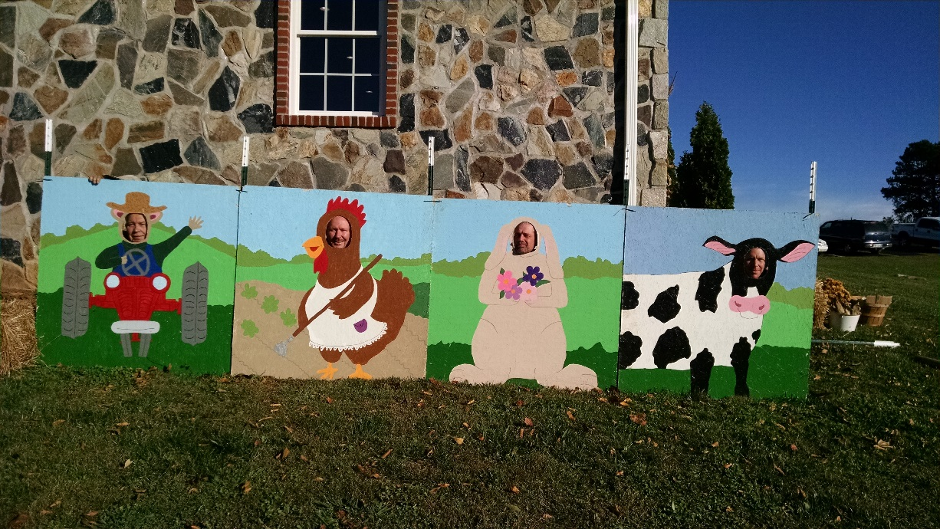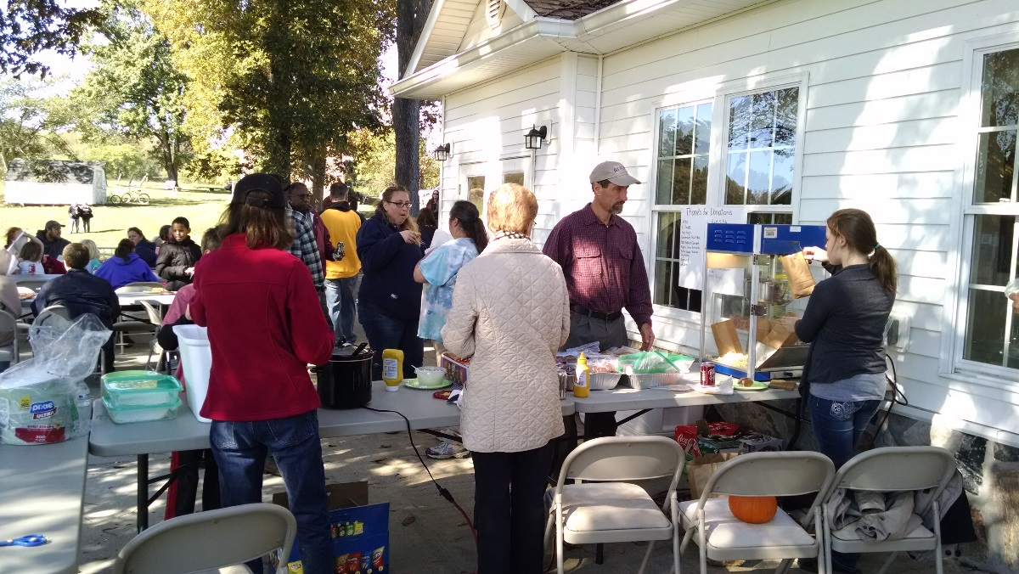

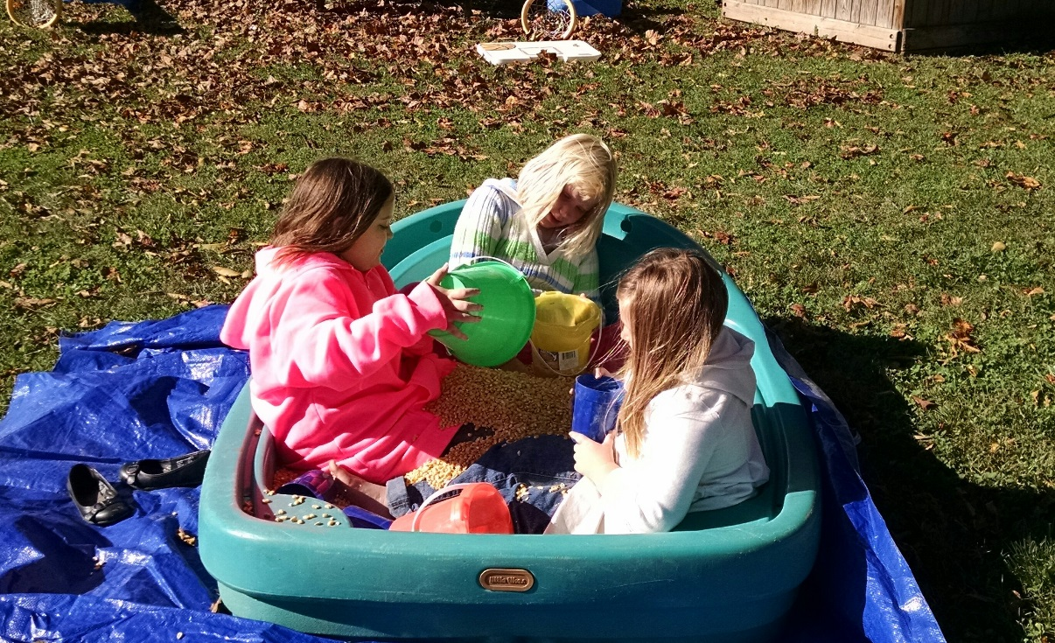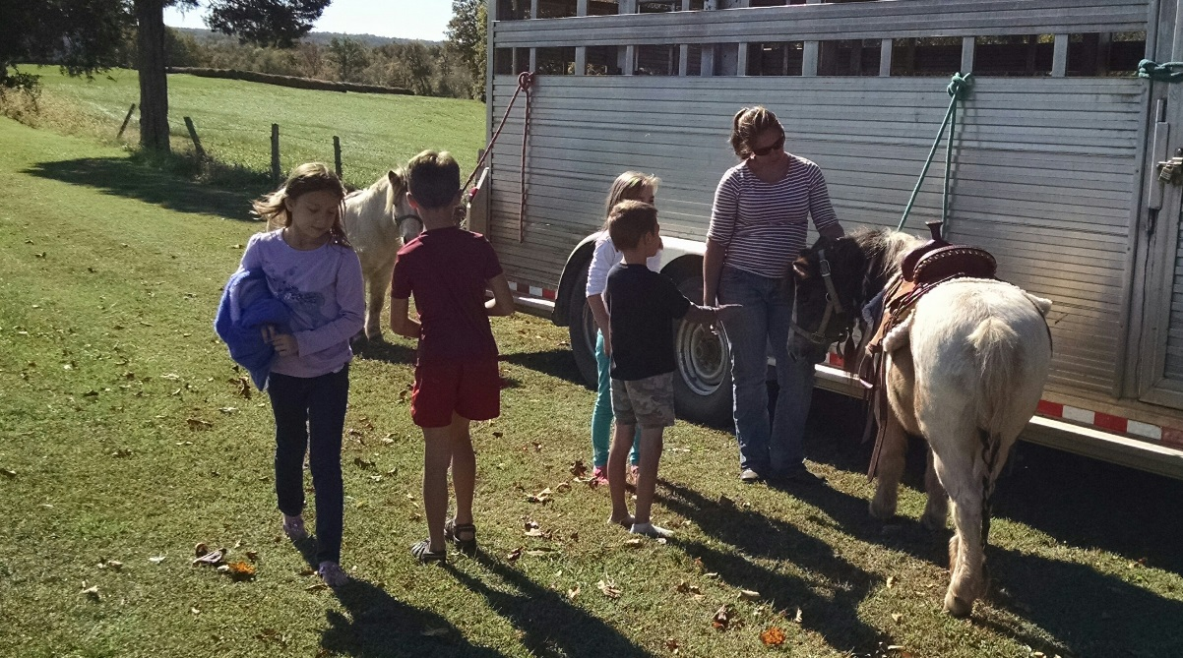

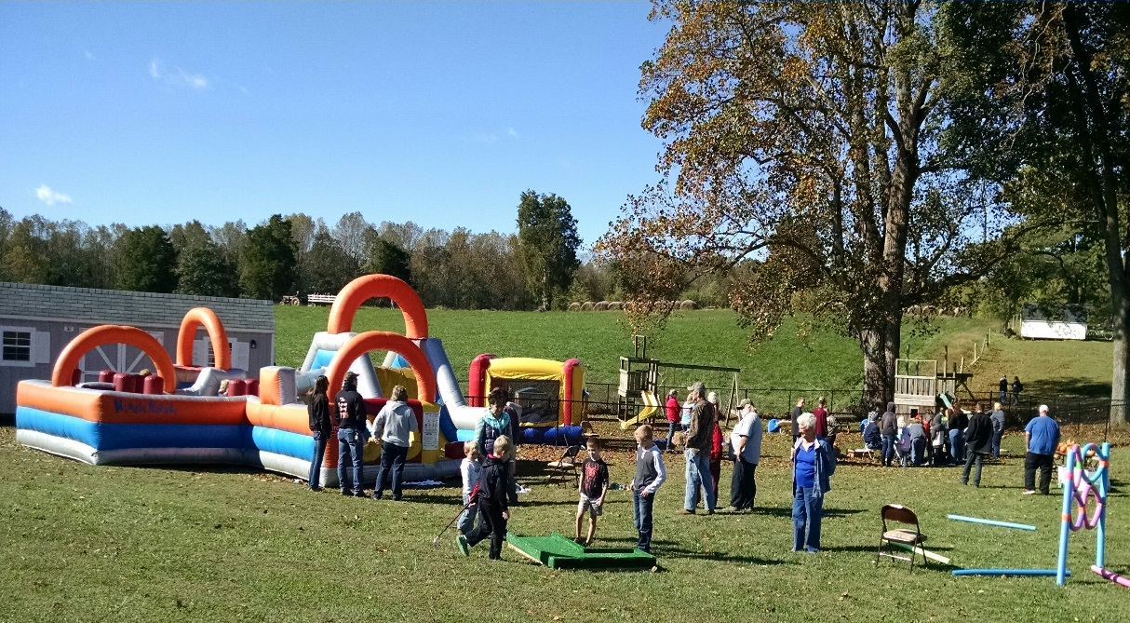

On Saturday, Oct. 22, the Jones Chapel Annual Family Fun Festival was held, with many activities, games, vendors, free food, pony rides, and door prizes. They also held a huge Yard Sale to help offset the cost of the event. They had a bigger crowd than last year and everyone had a wonderful time. Items not sold at the yard sale were donated to the Christian Outreach Pregnancy Center in Dillwyn. Faces in the cutouts are four of the deacons! Other photos show visitors and members enjoying the food, kids playing in the “pool” of loose corn, ponies provided by Frankie and Sarah Large, and two inflatable Bouncies.

8
On Saturday, October 29, Jones Chapel held “Trunk-or-Treat” in the parking lot of the church. Trunks of cars were decorated and filled with candy. The children went from trunk to trunk filling their bags. There were a lot of cute costumes on the kids and so many football jerseys and painted faces on the adults! Pastor Richard and church members use these types of activities and events as an opportunity to reach out to the un-churched in the community.

Mt. Zion would like to thank the choir of First Baptist Church of Dillwyn and their always-smiling piano player, Cody Moss, plus their very talented director, Kristye Moxley, for coming to Mt. Zion on Sunday, October 23 for an hour of beautiful music. The choir sang, two ladies offered solos, and Cody and his magic fingers livened up the sanctuary to the delight of all in attendance.

Tar Wallet’s Fall Fest on Saturday, October 29, was a huge success with lots of children attending.


JRBA CELEBRATES>>>

On October 23, Antioch (Scottsville) received into membership Charles and Debbie Rittenhouse and Peyton and Ivanna Townsend .

Cedar welcomes into their church family Steven Taylor, Jr., Ed Kelly, and Vikki Kelly through a profession of faith to be followed by baptism in the near future.

A Baptismal service was conducted at Mulberry Grove on October 3. Baptismal candidates were Carly Jones, daughter of Jay and Stephani Jones, and Abby and Jacob Palmore, children of Freddie and Misty Palmore. The service was followed by a fellowship meal. It was a great day of worship and fellowship.

On Sunday, October 23, the congregation of Sharon expressed love and appreciation for the dedicated ministry of Rev. and Mrs. Perry Clore with an old-fashioned “pounding”! Happily, Perry and Shari received no physical injuries from their “pounding” – only pounds of love by way of groceries, goodies, gift cards, and notes of love and appreciation.

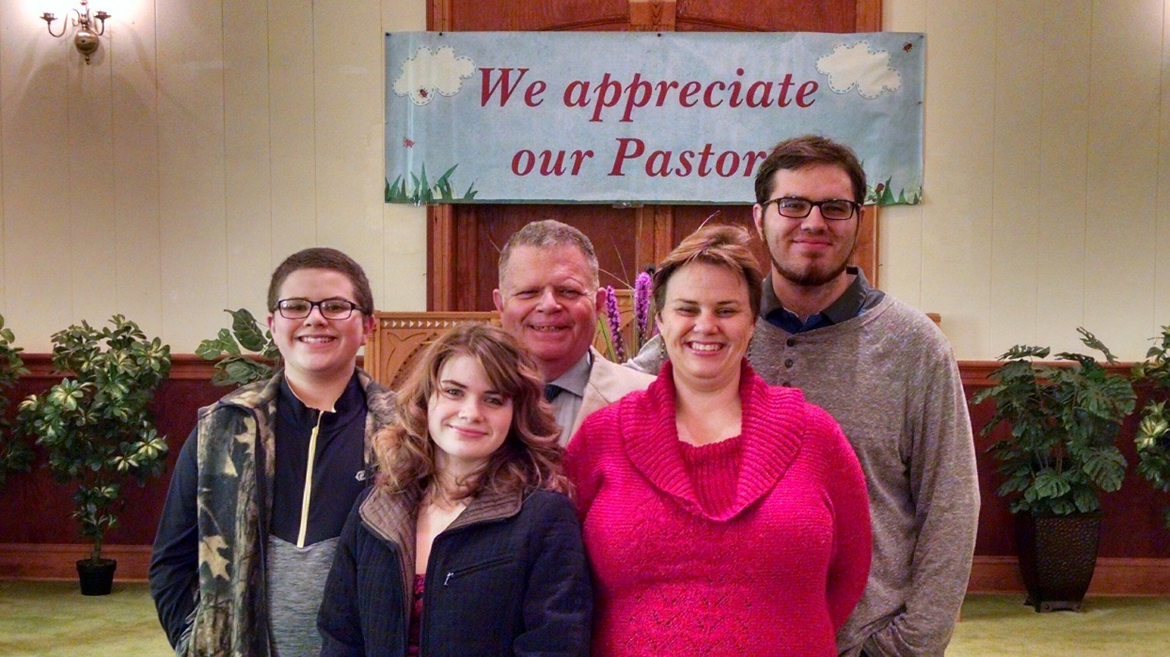
On October 9, Jones Chapel celebrated Pastor Appreciation Sunday. The week prior, members mailed notes of thanks and appreciation to Pastor Richard and Michelle so that they were receiving mail all week long. On Sunday, a banner was hung on the church’s sign expressing the congregation’s appreciation. A special song, Because You Gave, was played for them during the service. Afterwards, a card with donations from many church members was presented to Pastor Richard and Michelle by Deacon Chairman, Gene Bradbury, along with a bouquet of flowers for Michelle. A slide presentation was then shown of pictures that had been taken of Pastor Richard at various events (baptism, VBS, preaching, Heroes Banquet, talking with children, etc.) and words and phrases that the congregation had used to describe him. Jones Chapel would like for all of JRBA to know that they are so blessed to have Richard D. Tuttle as their pastor – he has a passion for preaching about Jesus and reaching out to the lost, the sick, and all of God’s people. Thank you, Pastor Richard and Michelle, and your family, for being a part of Jones
Chapel Baptist.

Antioch (Scottsville) – Tent Revival

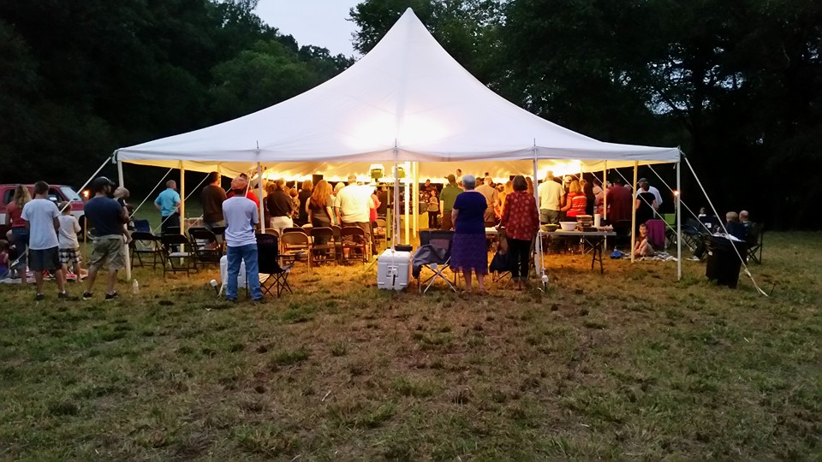

September 22 – 25, 2016

9
Antioch (Scottsville) – River Baptisms
September 25, 2016
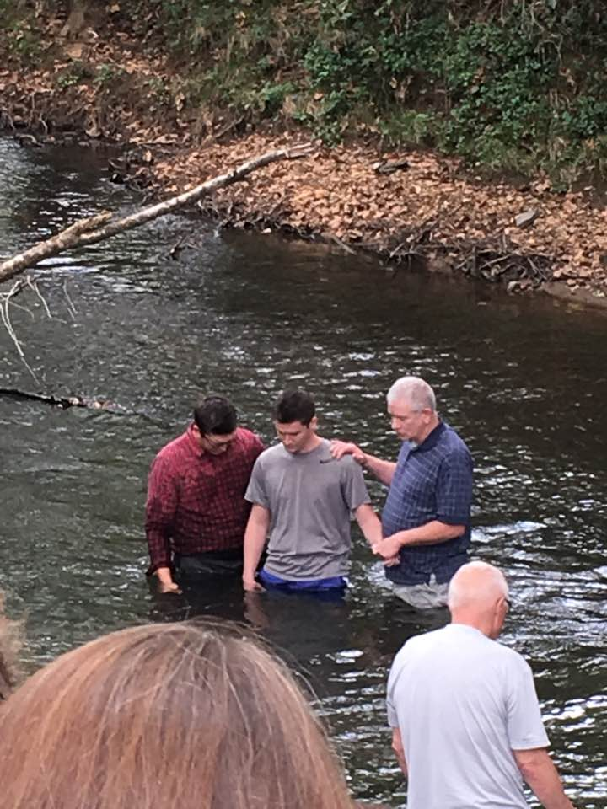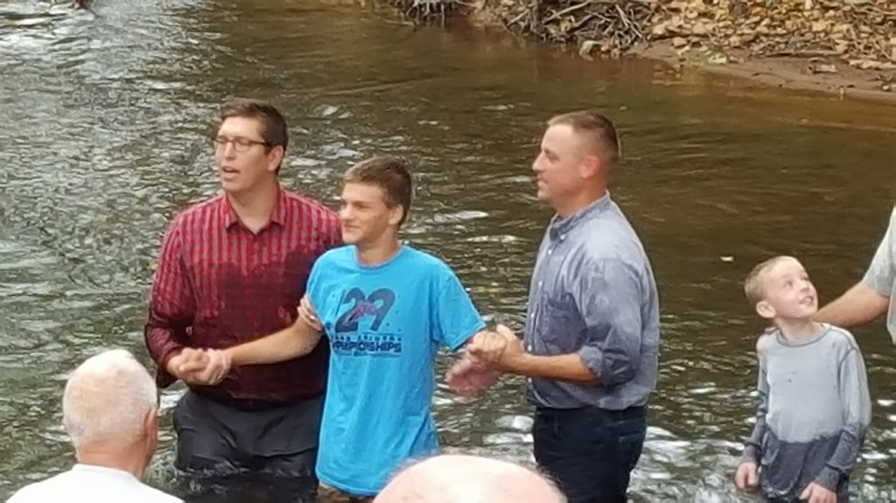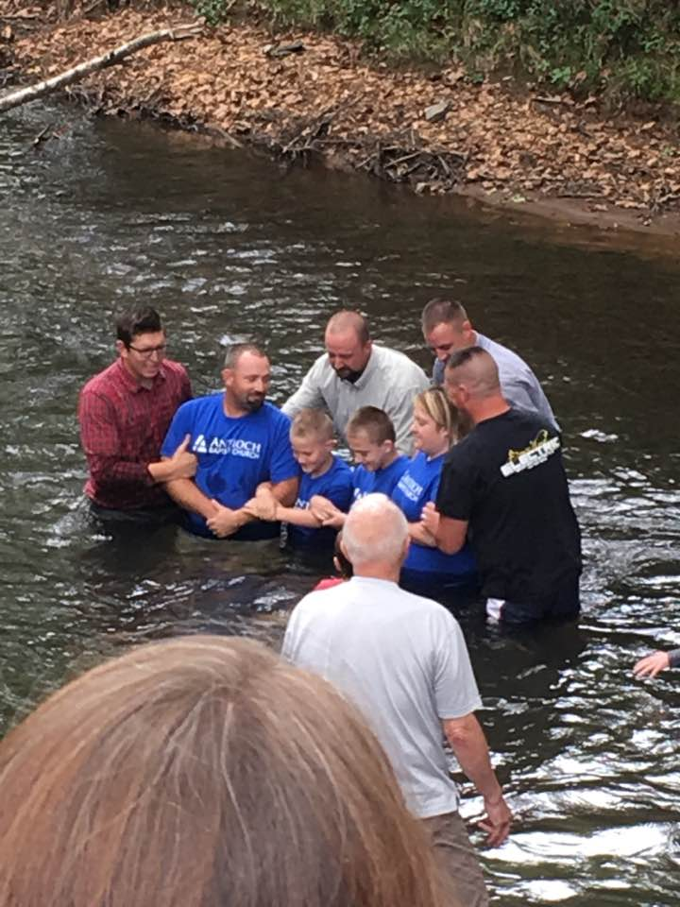

Justin Holdgreiwe Andrew Tamberino Palmer Family

IN LOVING MEMORY>>>

Dan Coleman, Antioch (Scottsville), went home to be with the Lord on Thursday, October 27. His memorial service was held on November 2. Please remember his wife, Carol, and his family in your prayers.

Cedar extends sympathy to the family of Sherry Scott who passed recently and, especially, to her husband, James, who had taken such wonderful care of her during her many months of illness. Sherry’s smiling face and always cheerful attitude will be greatly missed at Cedar. Her celebration of life was held at Cedar on Saturday, October 15.

Jones Chapel is saddened to lose long-time member and beloved Deacon of the church, Billy “Bill” Ken England, who passed away on September 30, 2016. Sincere sympathy is extended to his wife, Carolyn, and all the family. He will be missed. Jones Chapel also extends sympathy and love to the family of Mrs. Annie May Parker who passed away on October 15. Her sons, Michael and Dennis, and their families, are members of Jones Chapel. When Mrs. Parker was able, the family brought her to church with them and members came to know and love her.

IN APPRECIATION>>>

Dear Friends,

Thank you so much for the check we received from you.* Your gift enables us to provide ministries and Christian leadership skills to our college students. Also, it is greatly used for our mission projects. It is greatly appreciated!
Janice Kiehm
Baptist Campus Ministries
Hampden-Sydney College & Longwood University
*Regular Budget Line Item - $500

Straight Street News>>>

Straight Street sponsored See You At the Pole on September 28. There were forty-four people in attendance which included pastors, teachers, two school board members, and students. The student prayer group at Buckingham High School has grown and is meeting regularly every two weeks. They meet during their lunch shifts in different teachers’ rooms and they alternate either bringing a brownbag lunch or having a meal provided. Watch the newsletter for future events sponsored by Straight Street.
Anita Adams
Straight Street – Buckingham, Inc.

FROM OUR MODERATOR>>>

I would like to thank Arvon for hosting our Annual Fall Meeting, and for providing the heartfelt music, and good food. I appreciate everyone that took part before with getting everything ready, and during the meeting. It took all hands working together to make it an informative and enjoyable time.

I’m still meditating on the word Dr. Don Campbell brought to us, and his words of encouragement for JRBA. I am sure that while he is sitting on his porch watching the rockets, he is praying for us. May we always follow the Good Shepherd and each of our “under-shepherds” so that none will be weak or left behind because of their “bleating”. Let’s accomplish the task before us, together, sharing the Good News of Jesus Christ.
In the Love of Jesus,
Marilyn
Marilyn Snoddy

10

FOR YOUR INFORMATION>>>

- A Samaritan’s Purse film, Facing Darkness, is coming to theaters on Thursday, March 30, 2017. As the Ebola pandemic was sweeping across West Africa in the spring of 2014, one organization provided comfort, compassion, and care to the sick and suffering…all in the name of Jesus Christ. When the deadly virus infected its own team, including Dr. Ken Brantly, the crisis took another challenging turn for Samaritan’s Purse and its president Franklin Graham. Facing Darkness tells an incredible story of faith, determination, and prayer. A preliminary list of theaters is already up and tickets can be purchased. Go to www.facingdarknessmovie.com for more information.
- In theaters across the nation on December 2, 2016, comes Believe, a film for the whole family chronicling the power of faith in the face of insurmountable hardships. In a small town going through tough economic times, business owner Matthew Peyton struggles between his desire for financial success and the responsibility of funding the annual Christmas pageant. But when Matthew meets Clarence, a joyful boy who believes in miracles, he must make a choice: do what’s best for himself or give faith a chance by opening his heart to help his new friend and his community. Visit www.Believe.Film to meet the full cast, get information on theaters and sign up for their newsletter.
- Southwestern Baptist Theological Seminary would like to partner with churches for a spring revival. Go to www.swbts.edu/rtn for more information and to register your church. This is part of the seminary’s Revive the Nation Program through which SWBTS recruits churches to hold revival meetings and pays for the transportation of the student revival preacher. The host church provides meals, lodging, and local transportation for the preacher. Revival meetings generally begin on Sunday morning and end on Wednesday evening, March 12 – 15, 2017, although alternative formats are available. The preacher partners with the host church to engage lost people in evangelism efforts during the week. If you would like to speak with someone about Revive The Nation, please contact the Office of Church Ministry at 817-923-1921, Ext. 6331.
- Southside Virginia Community College has requested the support of JRBA in getting the word out that they will be providing GED classes for those who need a GED or wish to improve their basic skills. All the prospective student has to do is simply call Dean Harris at 804-387-0739 or Lois Hicks at 434-736-2048 to begin the process. The Adult Education/GED classes are FREE and will be held at Ellis Acres, Dillwyn, VA, on Tuesday and Thursday from 9:00 AM – 12:00 Noon and on Monday and Wednesday from 5:30 -8:30 PM.
- Patrick Henry Family Services ministry, Safe Families for Children, is hosting the 2016 Foster Hope Conference on November 12, 2016, at the Blue Ridge Community Church from 9:00 AM – 3:00 PM. The Keynote Speaker is Chadwick Sapenter, a former foster child turned entrepreneur, best selling author, and motivational speaker. He will address issues related to foster care, adoption, child abuse, and more. There will be educational workshops, experienced foster/adoptive parents for Q & A, dynamic discussions, vendors, and agency/church resources. Whether you are just beginning your foster/adoption journey, or have years of experience under your belt, there will be something for you. Guest speakers will discuss some of the most challenging issues facing foster and adoptive families. Blue Ridge Community Church is located at 2361 New London Road, Forest, VA. For more information, contact Henry Carter at 434-376-2006, Ext. 2013.
- AVAILABLE BIBLE STUDIES: First Baptist Dillwyn has several Bible studies available for loan:
Daniel: Lives of Integrity, Words of Prophecy (Beth Moore) – 12 sessions – 6 DVDs
David: Seeking a Heart Like His (Beth Moore) – 11 sessions – 6 DVDs, Leader Guide, Book
Esther: It’s Tough being a Woman (Beth Moore) – 10 sessions – 6 DVDs
Jonah: Navigating a Life Interrupted (Priscilla Shirer) – 7 sessions – 2 DVDs, 1 Book
Me, Myself, and Lies: A Thought Closet Makeover (Jennifer Rothschild) – 6 sessions – 2 DVDs, 2 Books
Nehemiah: A Heart Than Can Break (Kelly Minter) – 7 sessions – 2 DVDs, 2 Books
One In a Million: Journey to the Promised Land (Priscilla Shirer) – 7 sessions – 2 DVDs , 1 Book
To Live Is Christ: Life and Ministry of Paul (Beth Moore) – 10 sessions – 6 DVDs, Leader Guide, Book
Call the JRBA office if you are interested in borrowing one or more of these studies.
- ATTENTION CHURCH CLERKS: Thank you for your hard work on the 2016 Annual Church Profiles. 17 of our 18 churches have reported and Phyllis is slowly entering the data onto the new SBC database. Once all of the “glitches” are worked out with the new system, we will hope to have a workshop before the 2017 ACPs come out.

A Word from JRBA’s New Discipleship Director

Dear JRBA Fellow Ministers,

As the in-coming Director of Discipleship for our association, I’d like to take a few moments of your time to express a few thoughts. First, I want to say thank you for the privilege of serving in this capacity. It is a great honor to have been asked to serve. Secondly, I’d like to ask for all your help. I would like this office to be a true help and resource to our Pastors and churches. To that end, I would love it if you could take a minute to email me your ideas on discipleship in your context. I’d love to know about what is currently working for your church so that we can all benefit from your leadership. I would also love to know if you can help us avoid any pitfalls and ideas that just haven’t worked. I truly hope that we can begin a conversation about Biblical discipleship that will help all our churches to fulfill the Great Commission. Here are a few “fire starters” to begin our conversation: Is my ministry “intentional” about discipleship? If not, why not? How do I feel about “one to one” discipleship? What are my views regarding “Small Groups” to carry out discipleship? Is “Sunday School” my church’s primary venue for discipleship? How does my ministry “measure” spiritual growth?

One of the resources I hope to provide will be a monthly newsletter submission that compiles great stories from around the association regarding successes in discipleship. It’s one thing to hear of changed lives around the globe, but it’s quite another to share our personal successes! So , please send me many stories of how your church is moving people from “saved” to “trained” to “sent”! Next month, I will be sharing the story of a man named Franky who I had the privilege of discipling for seven years in NY. His story is one of hope for those that may struggle with seeing the Kingdom benefits of investing one’s life in one to one discipleship.

I truly hope that the discipleship office of the JRBA will become an important resource, help, and source of encouragement to you and your church. Please feel free to email me any thoughts and ideas that can help us reach these goals. As your fellow-laborer, I do not claim any special insight into Biblical discipleship – I have simply been asked to encourage us all to make it a priority in our churches’ lives. I hope that all our Pastors will engage in this ministry and help make it an important part of our association. Thank you!
Pastor Geoffrey Bruschi
Arvon Baptist Church
revgbb@hotmail.com
434-907-3833

11


JRBA Executive Board Meeting
October 10, 2016
Moderator, Marilyn Snoddy, called the meeting to order and presented a devotional on Isaiah 43:18-19: Forget the former things; do not dwell on the past. See, I am doing a new thing! Now it springs up; do you note perceive it?... JRBA is moving into a new year and Marilyn noted that she will continue as Moderator for her second year. Much of nature is based on repetition (ex: seasons of the year) and, as creatures of nature, it is our nature to repeat ourselves. Often in our churches, folks don’t want change, but God’s way is a way of change (I am doing a new thing!) Just as we are changed by knowing God, we need to sometimes make changes and try new things as we work to build His kingdom. In this new year, let’s take new steps and change when it is needed. We must choose to live not just in the natural, but in the supernatural! We need to keep the things that are good and take on new things as God leads. For example, our Operation InAsMuch Outreach and Michael Khol’s outreach to the churches are good things so, we will continue to do some of the same things, but we need to look at the year ahead afresh and anew. We need to walk in the newness of spirit. Marilyn then led in a prayer of seeking God’s guidance for this new year and the courage to walk in the newness of the spirit.

Frank Breault, Clerk, had the Roll Call of Churches. There were 21 in attendance, representing 11 churches. The minutes of the July 11, 2016, meeting were presented and approved. In the absence of Treasurer, Tommy Joe Steger, Jr., the Treasurer’s Quarterly Report was presented and approved . As of September 30, 2016, the checking account balance stood at $28,322.90. This balance includes the following designated monies: Additional Missions Fund - $128; Youth Encounter - $400; Local Missions + Impact VA - $70.04; Hispanic Ministry - $432.90; Stop Hunger Now - $417; and Memorial Gift for JRBA Mission Trip - $100 . Total receipts for the quarter were $6,394.90 and total disbursements were $4,761.58. Disbursements included $100 to Mission Trip(Gary Clore - Zimbahwe), Hispanic Ministry - $278.56, BGAV-WV Flood Buckets - $150, and Spreading God’s Gifts (OIAM Roofing Project) - $400. The Savings Account balance stood at $4,154.47. Phyllis Tyler then presented the Finance Committee’s Report along with the Proposed Budget for 2016-2017. She outlined the following changes to the budget:
- Under Missions Giving, the line item Local Missions will be combined with the previously designated Additional Missions Fund and will be allocated $700. (In 2015-2016, no money was transferred to either fund because carryover and designated gifts covered all expenditures.) Youth Encounter was eliminated as a line item since there has not been an event for the past two years. These changes resulted in an overall increase in Missions Giving of $200.
- Under Office Expenses, the line item for Annuals was eliminated since we have not had an annual published since 2012. The Finance Committee noted that all business information is included in the monthly newsletters so there is not need to duplicate that information. The committee directed Phyllis to compile an Associational Directory as soon as possible. The will be funded under regular office expenses (supplies + copier maintenance) and payroll. Postage was decreased from $1,100 to $1000. Supplies were increased from $900 to $1,000. The overall decrease to Office Expenses is $500.
- There will be no changes to Payroll Expenses as Phyllis requested that she not be given a raise. Since her earnings for 2015-2016 were below the budgeted amount, the current amounts set aside should cover the additional hours to do the Associational Directory.
The overall proposed budget for 2016-2017 is $24,371.00, representing a $300 total reduction. (A copy of the proposed budget can be found on page 15 of the newsletter.) In a time of discussion, Rev. Jimmy Dunn asked that Phyllis be given a raise of .05/hour, but she declined, stating that she would not want to take a raise in a time when many of our churches are experiencing struggles to meet their own budgets. She feels that JRBA has been able to do many good missions projects in the past year and has helped many people and she wants to see that continue. She is hopeful that churches will continue to fund JRBA at the same level they did last year. The Proposed Budget was approved as presented.

Marilyn then gave her report and also noted what a blessed year we have had. She noted that the BGAV Disaster Relief has called out volunteers to go to Rocky Mount, NC, to man two feeding units. Liz Steger and Gayle Noble will leave on October 11, to help. If others are interested, please contact BGAV Disaster Relief(Aaron Lee). She then introduced and welcomed Rev. Woody Moore, and his wife, Janice. Woody is the new pastor at Mt. Zion. She noted that Mt. Tabor also has a new pastor, Rev. Ron Nida. Marilyn noted that she was chosen as the new JRBA nominee to the BGAV Mission Council – new nominees will be voted on at the BGAV Annual Meeting in November. She plans to attend and is hopeful many others from JRBA plan to attend as well. She also noted that The Gathering web cast was shown at Mt. Zion on the importance of continual praying and prophesying. Rev. Moore noted that it dealt with the need for true revival – repenting and being intentional about God. He noted that what happens in America is not dependent upon whom becomes president, but on what the church does.

Mrs. Betty Toney, WMU Director, reminded us that the JRBA World Day of Prayer Observance will be on Monday, November 7, at First Baptist Dillwyn. There will be a speaker from Madeline’s House in Farmville, and ½ of the offering will go to Madeline’s House and ½ to the Women’s Department of the Baptist World Alliance. There were no other officers’ reports.

Rev. Jimmy Dunn began the Missions Committee Report by thanking everyone for their recent participation in Operation InAsMuch. He thanked Mrs. Valeria Breault for her commitment and hard work for this event. He also noted that JRBA collected over $9,000 and packed over 38,000 meals for Stop Hunger Now in 2016. Our next event will be held on May 7, at Maysville Multi-Purpose Center. He encouraged everyone to begin contributing to this cause so that we can pack even more meals in 2017. He thanked Rev. Michael Khol for his leadership with the Hispanic Bible Study and Prison Ministry. Jimmy reminded everyone of the Blue Ridge Food Distribution that takes place very 2nd and 4th Friday at the Crystal Cathedral in Dillwyn. Volunteers are needed for that ministry as they continue to distribute food to approximately 300 families each time. He commended several worthy missions endeavors carried out by various churches during 2015-2016. He encouraged everyone to continue to support BGAV Disaster Relief as they continue to reach out during times of natural disaster throughout the state, the country, and the world. He is hopeful that JRBA will continue the strong emphasis on missions next year.

Marilyn presented the report from the Program Committee, along with the program. The Program Committee recommended that the offering for the Fall Meeting be given to BGAV Disaster Relief as they will be very involved with the Hurricane Matthew cleanup as well as continuing ministry as natural disasters occur. The Program for the Annual Fall Meeting and the committee’s recommendation was approved. Valeria Breault told about the recent Operation InAsMuch Missions Blitz held on September 24. She noted that good weather graced the event this year. All 18 churches were involved in some way, contributing financially, completing projects themselves, and/or participating in the JRBA Roofing Project headed up by Michael Khol. She extended her thanks to him for being in charge of that combined effort. There were 66 projects with over 400 volunteers involved this year. Valeria also reminded everyone to get their project pictures to Michael as soon as possible for inclusion in the slide show at the Annual Meeting on October 20. Michael noted that the Roofing Project was a true blessing. The plan had been to replace half of a roof, but due to the funds contributed by JRBA and Mt. Zion, and the willingness of the volunteers, a rain date has been set to complete the other half of the roof as well. He expressed his gratitude for those who came out and worked together, and to those who furnished ample food for the workers. He said the project was a wonderful opportunity to get to know and work together with folks from other churches, but it was also a project that made a tremendous difference in the life of one family. It was truly accomplishing together what one church could not do alone. Rita Harris presented the Nominating Committee’s Report. Rev. Geoff Bruschi has agreed to serve as Discipleship Director for 2016-2017. Rev. Doug Adams’ recent relocation vacated the position. The position of Music Director is still vacant. The addition to the Slate of Officers was approved.
12

There was no Old Business. Under New Business, Marilyn noted that the JRBA Office Copier may soon need to be replaced and suggested that the recent donation of $2500 might be used for that expense. A brief discussion ensued on the possibility of leasing vs. purchasing a copier. Rev. Perry Clore made a motion that the $2,500 be earmarked for a copier (when needed). After further discussion, he amended his motion to include that Phyllis Tyler, Tommy Joe Steger, Jr. and Rev. Michael Khol serve on an Ad Hoc Copier Committee to oversee the transaction at the appropriate time. The current copier will be used as long as feasible. The motion was seconded and approved.

Marilyn then went over the printed announcements in the representatives’ packets. Additionally, Jimmy announced a Benefit for Brandi Johnson to be held at First Baptist Dillwyn on October 30. Betty Toney announced a Benefit for Rose Mageletti Rae at Buckingham on October 15. Valeria Breault reminded everyone that October is Pastor Appreciation Month. Marilyn then asked Rev. Geoff Bruschi to adjourn the meeting with prayer.

JRBA 184th Annual Fall Meeting
October 20, 2016
The 184th Annual Fall Meeting met at Arvon Baptist on Thursday, October 20, 2016. The theme for the meeting was, Then He said to his disciples, “The harvest is plentiful, but the workers are few. Ask the Lord of the harvest, therefore, to send out workers into his harvest field. Matthew 9:37-38 (NIV) As the 66 messengers and visitors registered and chatted, slides were looping of various 2016 Operaton InAsMuch projects conducted by our churches and the association. The opening hymn was Oh, How He Loves You and Me. Rev. Geoff Bruschi, Arvon, gave a heartfelt welcome and a brief devotional based on the theme. He compared the church’s job of evangelism to the promotional advertising of great commercial companies, like Coca Cola. He noted that great companies have large visions. If we as Christians and the church can get our motivation right and have a vision, we can accomplish anything. Mrs. Marilyn Snoddy, Moderator, called the meeting to order. Frank Breault, Clerk had the roll call of churches. There were 66 messengers, pastors, and visitors present from 14 churches. Mrs. Snoddy presented the Program and announced that the Executive Board approved the offering to go to BGAV Disaster Relief. The Program and recommendation was approved. Dr. Jeff Cranford brought greetings from the BGAV. He spoke briefly on the BGAV Disaster Relief involvement in NC and reminded everyone that the Central Region will have a breakout session at eh BGAV Annual meeting on November 14-16 to nominate individuals to the Mission Council. Dr. Don Campbell gave a brief report on the BGAV Stewardship Program. He noted that there is a great deal of stewardship material available to churches from the BGAV. Those wanting materials should contact BGAV Treasurer, David Washburn, at 804-915-5000. Mrs. Judy Ownby led us in remembering our deceased members for 2015-2016. She shared Philippines 1:3-6 and then read the names of the faithful members who have gone to be with the Lord. She then led the group in a prayer of remembrance.

Most of the reports were in written form in the Book of Reports for 2015-2016. Mrs. Snoddy gave the Time/Place/Preacher Report stating that the 185th Semi-Annual Spring meeting will be held on Thursday, May 11, 2017, at Buckingham Baptist, and the 185th Annuall Fall meeting will be held on Thursday, October 19, 2017, at Cedar Baptist. Mrs. Snoddy then introduced new pastors: Rev. Jimmie Beale, Interim at Antioch Union, and Rev. Woody Moore, Pastor at Mt. Zion. She also noted that Rev. Ron Nida is the new pastor at Mt. Tabor. She then gave the Moderator’s Report, mentioning the extensive mission programs the JRBA has participated in this year, including Stop Hunger Now, Disaster Relief, and mission trips to Bland County, India, Honduras, El Salvador, SE Asia, and West Virginia. She also mentioned that the BGAV has a new program, “Minister Matching” that will help Pastoral Search Committees find a new pastor. In addition, she said that Disaster Relief has called for trained volunteers to go to Wallace, NC, for 3 – 4 days to help with the feeding unit.

Mrs. Snoddy presented the Finance Committee’s Report. The proposed budget, with changes and additions, was presented and approved. (See details in the Executive Board Meeting summary. See the budget on page 15.) Mrs. Snoddy presented the Nominating Committee Report, noting that Rev. Geoff Bruschi had agreed to be the new Discipleship Director since Rev. Doug Adams has left the area. In addition, she has agreed to be a nominee for his position on the BGAV Mission Council. The Slate of Officers was approved as presented. Rev. Jimmy Dunn, Missions Co-Chair, thanked everyone for the great year of mission work. He mentioned Operation InAsMuch, commenting on the great weather and the 18 churches involved. He mentioned Stop Hunger Now, stating that the next packing event would be on May 7, 2017, at the Maysville Multipurpose Center. He also mentioned Disaster Relief and how many have gone on mission trips. In addition, he mentioned the need for volunteers for the Blue Ridge Food Distribution. He thanked everyone for all they do. The 2015-2016 Book of Reports was presented for approval. A motion was made, seconded, and approved.

Mrs. Snoddy presented the awards for JRBA’s Top Giving Church to the 2015 Lottie Moon Offering and the 2015 Annie Armstrong Offering. Both awards were presented to Buckingham Baptist.

Rev. Richard Tuttle gave a brief report on Jones Chapel’s mission trip to WV. They went to a poor community with a high rate of addiction to prescription drugs and alcohol. They found opportunities to evangelize, walking the streets telling or God and doing outreach to the children. They learned from the trip that God is a Mission God. Pastor Tuttle also pointed out that God has opened doors in the Cumberland Schools.

Mrs. Gayle Noble showed a brief video of the first morning in NC with Disaster Relief, highlighting feeding units and shower units. She said participating was an amazing experience. On Tuesday, they sent out 2,400 meals, on Wednesday 6,500 meals, and on Thursday, after lunch, they had to shut down and relocate. Mrs. Noble said it was an honor to work with the other volunteers from across Virginia and that we are never too old to help. God doesn’t call the equipped, He equips the called. She also stated that as of October 19, the food unit had served 35,000 meals.

The first session was concluded with a benediction and blessing by Rev. Geoff Bruschi. Everyone adjourned to the fellowship hall for supper.

After enjoying a delicious meal, folks reassembled in the sanctuary for worship. The service included uplifting and worshipful music and a thought provoking message. The special music was provided by the Bruschi family – Geoff, Angela, and Kelsey. The songs included Your Great Name, Revelation Song, and Glorious Day. It set a very prayerful mood for the remainder of the service.

Several prayers were offered during the service by Rev. Woody Moore, Rev. Jimmie Beale, and Rev. Geoff Bruschi. An offering benefitting BGAV Disaster Relief was received in the amount of $756.00.

The evening’s message entitled The Peril of Independence was brought by Dr. Don Campbell using scriptures, Isaiah 53:4-5 and Psalm 23:1. Dr. Campbell emphasized the importance of working together and gathering in corporate worship. He tied these ideas to the JRBA theme: Accomplishing Together What We Cannot Do Alone. Dr. Campbell noted the importance of the JRBA Pastors’ Huddle, joining together for mission emphasis projects, fellowship events, and supporting each other on a regular basis. Dr. Campbell pointed out that although the workers are few at times with much to accomplish, Jesus is there in everything we do and that we only have t o call on Him on a daily basis. The service concluded with the installation and commissioning of the 2016-2017 officers by Rev. Jimmy Dunn. He issued a challenge to the officers to be focused on the importance of their roles and encouraged all others to be supportive of them as they strive to carry out their responsibilities.

13
JRBA Slate of Officers
2016-2017

Moderator . . . . . . . . . . . . . . . . . . . . . . . . . . . . . . . . . . . . Mrs. Marilyn Snoddy
Vice Moderator . . . . . . . . . . . . . . . . . . . . . . . . . . . . . . . . . Rev. Richard Tuttle
Clerk . . . . . . . . . . . . . . . . . . . . . . . . . . . . . . . . . . . . . . . . . . . . Mr. Frank Breault
Treasurer . . . . . . . . . . . . . . . . . . . . . . . . . . . . . . . . .Mr. Tommy Joe Steger, Jr.
Reporter/Historian . . . . . . . . . . . . . . . . . . . . . . . . . . . . . . . . . Mr. Terry Towler
Sunday School Director . . . . . . . . . . . . . . . . . . . . . . . . . . . . .Rev. Perry Clore
Baptist Men’s Director . . . . . . . . . . . . . . . . . . . . . . . . . . . . . Rev. John Moxley
Discipleship Director . . . . . . . . . . . . . . . . . . . . . . . . . . . . . Rev. Geoff Bruschi
VBS Team Leaders . . . . . . . . . . . . . . . . . . . . . . . . . .Frank and Valeria Breault
Music Director . . . . . . . . . . . . . . . . . . . . . . . . . . . . . . . . . . . . . . . . . . . . VACANT
Disaster Relief Coordinator . . . . . . . . . . . . . . . . . . . . . . . . . . .Rev. David Vogt
BCM Longwood Representative . . . . . . . . . . . . . . . . . . . . . . . Mrs. Gale Moss
VA Baptist Historical Society . . . . . . . . . . . . . . . . . . . . . . . . . Mr. Terry Towler
Parliamentarian (Appointed by the Moderator) . . . . . . . . . . .Mr. Gwynn Tyler
WMU Director (Elected by WMU) . . . . . . . . . . . . . . . . . . . . . . Mrs. Betty Toney

BGAV Mission Council:
Rev. Perry Clore, Rev. Jimmy Dunn, Ms. Judy Ownby, Mr. Gwynn Tyler
BGAV Mission Council Nominee: Mrs. Marilyn Snoddy



KEEP IN PRAYER>>>

- Those who are lost and need to know the Savior
- Churches without a Pastor : Antioch Union (Rev. Jimmy Beale, Interim), Buckingham, Chestnut Grove, Enon, Fitzgerald Memorial, Goshen, and Mt. Tabor
- JRBA Hispanic Ministry
- JRBA Pastors’ Huddle
- National, State, and Local Elections
- Victorita Gina Vasile, JRBA WMU Project Ruth adoptee
- Local family serving IMB
- All those in our congregation who are ill or have lost loved ones.

…the prayers of the righteous please Him.
Psalm 15:8b

14

JRBA REGULAR BUDGET

MISSIONS 2015-2016 Expended 2016-2017 Christian Education & Training $ 200.00 $ 0.00 $ 200.00
Christian Life (Baccalaureates) $ 400.00 $ 326.13 $ 400.00
Director of Missions Expenses $ 250.00 $ 0.00 $ 250.00
Evangelism $ 250.00 $ 0.00 $ 250.00
Mission Trips (Individuals & Groups) $ 1,800.00 $1,400.00 $1,800.00
Hispanic Ministry $ 600.00 $ 917.92* $ 600.00
($0.00 from Regular Budget)
Longwood Baptist Collegiate Ministry $ 500.00 $ 500.00 $ 500.00
Local Mission Projects + Impact VA $ 300.00 $ 500.00** ----
($0.00 from Regular Budget)
Additional Missions* --- $1,912.00** $ 700.00
Operation Inasmuch $ 250.00 $ 200.00 $ 250.00
Youth Encounter (Youth Events) $ 200.00 $ 0.00 ----
VA Baptist Historical Society $ 50.00 $ 50.00 $ 50.00
Bland Ministries
(1/2 Bland Center/1/2 Bland Dental Ministry) $ 500.00 $ 500.00 $ 500.00
_______________________________________________________________________________
TOTAL MISSIONS $ 5,300.00 $2,976.13*** $5,500.00
*All Hispanic Ministry expenditures came from carryover and designated contributions. No transfer of funds from regular budget.
**For 2016-2017, combine Local Mission Projects + Impact VA Designated Fund with Additional Missions Designated Fund. (Balance will carry over to this line item from both funds.)
Local Missions expended $500 + Additional Missions expended $1,912 from carryover and designated contributions for 2015 – 2016. No transfer of funds from regular budget.
***Total Missions expended from designated funds for Hispanic Ministry, Local Missions + Additional Missions: $3,329.92.

OFFICE EXPENSES
Annuals $ 500.00 $ 0.00 ----
Bond Insurance (3 yrs. Due 10/16) $ 485.00 $ 0.00 $ 485.00
Building Insurance $ 425.00 $ 419.00 $ 425.00
Copier Maintenance $ 750.00 $ 720.00 $ 750.00
Postage (Includes P. O. Box rental) $ 1,100.00 $ 574.00 $1,000.00
Rent $ 2,400.00 $2,400.00 $2,400.00
Supplies (Includes Web Hosting) $ 900.00 $ 841.00 $1,000.00
Utilities (Water, Century Link, Gas) $ 2,800.00 $2,153.00 $2,800.00
Miscellaneous (+Speaker Stipends) $ 500.00 $ 300.00 $ 500.00
TOTAL OFFICE EXPENSES $ 9,860.00 $7,407.00 $9,360.00

PAYROLL EXPENSES
Compensation – Secretary (*See Below) $ 8,500.00 $7,664.00 $8,500.00
Contribution to Retirement $ 360.00 $ 360.00 $ 360.00
FICA Contribution $ 527.00 $ 475.00 $ 527.00
Medicare Contribution $ 124.00 $ 111.00 ____ $ 124.00__
TOTAL PAYROLL EXPENSES $ 9,511.00 $8,610.00 $9,511.00
*Hourly rate - $11.55 – remains the same.

TOTAL BUDGET $24,671.00 $18,993.13 $24,371.00

TOTAL INCOME (2015-2016): TOTAL EXPENDITURES (2015-2016):
Regular Budget Receipts $24,743.95 Regular Budget $18,993.13
Designated Receipts $11,602.14 Designated Funds $12,921.06
Benevolence Fund $ 2,236.52 Benevolence Fund $ 1,689.60
$38,582.61 $33,603.79

Checking Account Balance (9/30/16): $28,322.90
Certificate of Deposit (7/31/16): $ 4,154.47
Benevolence Balance (9/30/16): $ 3,233.91 (1 outstanding check for $100)
15

ASSOCIATION FINANCES
2016 – 2 017

REGULAR BUDGET RECEIPTS
Church | October | Year-to-Date
Antioch(Scottsville)
Antioch Union
Arvon
Buckingham
Cedar | $ 2,000.00 | $ 2,000.00
Chestnut Grove
Enon
First Baptist Dillwyn | $ 1,000.00 | $ 1,000.00
Fitzgerald Memorial
Fork of Willis | $ 419.00 | $ 419,.00
Gladstone Memorial | $ 331.25 | $ 331.25
Goshen
Jones Chapel | $ 119.58 | $ 119.58
Mt. Tabor
Mt. Zion
Mulberry Grove
Sharon | $ 380.25 | $ 380.25
Tar Wallet
Individuals | $ 400.00 | $ 400.00
VBMB – Alma Hunt
TOTAL | $4,650.08 | $ 4,650.08
Approved Budget for 2014 – 2015: $24,371.00

TREASURERS: Please note that unless a specific ministry or project is designated on the memo line of the check or in an accompanying note, the contribution will appear in the regular budget receipts.

ADDITIONAL MISSIONS FUND
(Combines Local Missions + Additional Missions Funds 2015-2016)

Carryover: $198.04
Receipts (Fall Meeting): $756.00
Expenditures (BGAV Disaster Relief): $756.00
Balance: $198.04

JRBA Hispanic Ministry

Carryover: $ 432.90
No receipts or expenditures in October.
Balance: $ 432.90



Funds for May 7, 2017 Event

Church | October | Total-to-Date
First Baptist Dillwyn |  | $ 120.00
Gladstone Memorial | $ 145.00 | $ 312.00
Goshen (WOM) |  | $ 30.00
Tar Wallet |  | $ 100.00
TOTAL | $ 145.00 | $ 562.00*
*$ 417.00 collected in 2016.

John E. Mann, Sr. Benevolence Fund

Church | October | Year-to-Date
Sharon |  | $ 200.00
TOTAL |  | $ 200.00
No expenditures in October.
Balance: $ 3,433.91 ($100 outstanding check)

OTHER DESIGNATED FUND BALANCES

Youth Encounter - $400.00
JRBA Mission Trip - $100.00
Earmarked for Copier - $2,500.00

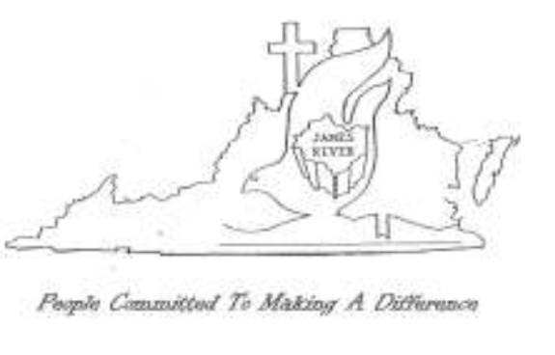
SERVING SINCE 1832

ACCOMPLISHING TOGETHER WHAT WE CANNOT DO ALONE

16

