 THE SERVANT LINK
CHURCHES UNITED TO SERVE -
COMMITTED TO MAKING A DIFFERENCE
James River Baptist Association
P. O. Box 1219, Dillwyn, VA 23936
Mrs. Marilyn Snoddy – Moderator
www.jamesriverbaptistassociation.com
Tel: 434-983-7385 Email: jrba@embarqmail.com
Hours: Monday & Wednesday 8:30 AM – 2:30 PM_____
____________________________________________________________________________________________ ______________
Volume XVI May 20017 Edition IV

EVENTS DETAILS

May 1 JRBA Evangelism Committee Meeting at JRBA Office 7:00 PM

May 3 Meet, Greet, & Eat at Fitzgerald Memorial 6:30 PM

May 3, 17, 24, & 31 Prayer Meeting & Bible Study at Goshen 7:00 PM

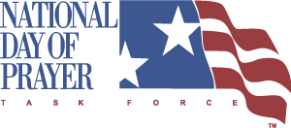
May 4, 2017
National Day of Prayer
Theme: For Your Great Name’s Sake! Hear Us…Forgive Us…Heal Us !
Daniel 9:19
The President shall issue each year a proclamation designating the first Thursday in May as a National Day of Prayer on which the people of the United States may turn to God in prayer and mediatation at churches, in groups, and as individuals.
(Public Law 105-225)
Join others all across our nation in lifting up our country and our leaders in prayer.
Prayer Walk – Mt. Zion – 4:00 – 7:00 PM
Goshen Baptist will be open at Noon for those who want to pray.

May 6 Antioch Union’s Yard Sale & Auction at Toga Fire Department 7:00 AM – 1:00 PM
Breakfast, Bake, Sale, and Lunch available (starting at 7 AM); Auction begins at 10 AM;
Spaces available to sell your items @ $10/table. Call Elaine Jamerson (434-969-4476) or Lynn Perkins (434-969-4914) to reserve your space. All proceeds support Antioch Union Baptist Women.

Jones Chapel Yard Sale at Southworth Power Equipment (Rt. 60) 8:00 AM – 2:00 PM
The youth and children will also be washing cars for donations.

May 7 “Preaching From the Rooftop” at Enon 11:00 AM

Cumberland Baccalaureate at Fitzgerald Memorial 2:00 PM

Buckingham Baccalaureate at B.C.H.S. Gym 4:00 PM

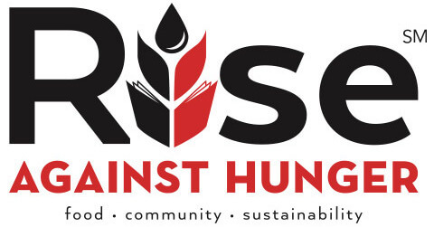
JRBA Meal Packing Event
Sunday, May 7, 2017
3:00 PM
Maysville Baptist Multi-Purpose Center
ATTENTION VOLUNTEERS: We will need some strong folks at 2:00 PM to set up and folks to remain and help clean up after we finish packing the meals. Please utilize the sign-up sheet sent to your church with the newsletters to enlist volunteers for this event. There is something for all ages to do. We hope to have at least 100 volunteers to help with the meals.

May 10 Senior Citizens Fellowship at Mulberry Grove 11:00 AM
Bluegrass/Gospel Music. Covered Dish lunch.

1
May 10 WMU & Brotherhood at Goshen 7:00 PM

Women on Mission at Fitzgerald Memorial 7:00 PM

JRBA Semi-Annual Spring Meeting
Thursday, May 11, 2017
Buckingham Baptist Church
Registration – 5:45 PM, Fellowship Supper – 6:00 PM, Worship – 7:00 PM
Theme: As a prisoner for the Lord, then, I urge you to live a life worthy of the calling you have received.
Ephesians 4:1 (NIV)
Guest Speaker: Dr. Adam Tyler, Grace hills Baptist Church, Appomattox, Former Pastor of Mt. Zion
Special Music from the Grace Hill Ensemble
Missions Emphasis: BGAV More Than Nets
Buckingham Baptist will supply meat, drinks, and paper products. Others in attendance are requested to bring side dishes and desserts.

May 12 & 26 Blue Ridge Food Services Food Distribution at Crystal Cathedral in Dillwyn
Volunteers needed at 9:30 AM.

May 12 – 14 Spring Volunteer Event at CrossRoads Camp and Conference Center
Sponsored by CrossRoads. No charge. Meals and lodging are provided . Great oppoprtunity to fellowship and serve with other Christians from across the state. Work hard during the day and enjoy evenings together in worship, fellowship, playing games, roasting smore’s, and telling stories by the fireside. To register, call 434-277-8465.


Sunday, May 14, 2017

Muffins with Mom at Buckingham – 9:30 AM
Mother’s Day Breakfast at Enon – Prior to 11:00 AM Service

May 14 Youth Group at Goshen 5:00 PM

May 15 Please turn in the number of tickets needed for the JRBA Take Me Out to the Ball Game Event (June 11) today!
Call JRBA at 434-983-7385.

May 15 – 16 FORUM – Equipping/Enriching/Engaging for Youth Workers
Theme: Ephesians 4:11-12
The Forum will be held at the Virginia Baptist Resource Center in the Richmond area. It is a training event for those who work with youth. For more information, contact Karen Rackett at 804-255-2428, Ext. 2243.

May 16 Virginia Baptist Historical Society and the Center for Baptist Heritage & Studies Annual Meeting & Public Program
River Road Baptist Church, Richmond
Dinner (by reservation only) at 6:00 PM (Open to all @ $20/person – send a check to VBHS, P. O. Box 34, University of Richmnond, VA 23173, by May 9.)
Annual Meeting Program at 7:30 PM
Address on Religious Liberty by Amanda Tyler; Presentation by Fred Anderson on “A Rusty Piece of Iron”; Recognition of Religious
Liberty legacy of 18th century Virginia Baptist Churches; Transition of leadership as Fred Anderson retires as Executive Director; and Grand organ music by organist Robert Gallagher on the church’s restored organ.
Terry Towler is the JRBA Representative to the Virginia Baptist Historical Society.

MAY 17
ITEMS DUE FOR BLAND MINISTRY AT THE JRBA OFFICE
- Undies (Adults & Children) – No other clothes
- Adult toothpaste
- Peanut butter
- School supplies - calculators and paperback dictionaries
- Ziploc FREEZER bags (not storage bags)
- Plastic shopping bags – only those already collected!

2
May 17 JRBA Pastor’s Huddle at First Baptist Dillwyn Noon

JRBA BLAND MISSION TRIP
May 21 – 27, 2017

Eleven volunteers will be going to the Bland Ministry Center & Dental Clinic to help in various ways. The Bland Ministry Center is supported through your Alma Hunt State Offering, the East River Baptist Association, and other contributors, including JRBA. The volunteers will help with food distribution, clothing closet work and distribution, yard work and organizational projects around the center.
- Team members are: Rev. Jimmy Dunn and Thelma Childress (FBC), Carol Ragland (Goshen), Rev. Woody Moore, Tom Deane, Brenda McAllister, Barbara Snoddy, and Travis Snoddy (Mt. Zion), Gwynn and Phyllis Tyler (Mulberry Grove), and Audrey Ragland (Sharon)
- We need strong Prayer Warriors to Pray for the team, the Ministry Center, and all those touched by this ministry.

The team appreciates all you are doing to make this trip possible: supplying items for the Bland Minsitry Center, praying for the team, and making monetary donations for the trip.

May 21 – 27 Associational Missions Emphasis Week of Prayer
Pray for the James River Baptist Association and its ministries this week. If your church has not sent in its contribution for 2016-2017, please do so. Also consider taking an offering for any of the special ministries promoted by JRBA.

May 22 & 24
The JRBA Office will be closed as Phyllis will be serving on the Bland Mission Team.

May 22 – 31 BGAV Kairos Initiative Mission Trip to Vienna, Austria
Please pray for our college students who are participating in this mission effort:
Ashley Hellerstedt and Olivia Leatherwood (First Baptist Dillwyn)
Austin Williams (Mulberry Grove)

May 27 5 Loaves and 2 Fish Ministry Meal at Antioch (Scottsville) 11:00 AM – 1:00 PM

PLEASE NOTE:
The JRBA Office will be closed on Monday, May 29, in observance of Memorial Day.
News for the June newsletter is due on May 31, by 9:00 AM.
The newsletter will not go out until the 2nd Sunday in June.
Let Phyllis know if anything needs to go out prior to 1st Sunday and she will
send an email to all churches on May 31.

LOOKING AHEAD>>>

June 3 Jones Chapel’s Annual Fishing Tournament at “Green Acres” 8:00 AM – Noon
Located at 513 Davenport Road, Cumberland. Lots of fishing followed by a picnic lunch of hamburgers, hotdogs, etc.
Prizes will be awarded at church on Sunday, June 4th.



June 4: VBS Registration at Fitzgerald Memorial 5:00 – 7:00 PM
VBS - June 5 – 8 6:30 – 8:30 PM

June 5 – 9: VBS at Goshen 6:30 – 8:30 PM

July 7 – 9: VBS at Chestnut Grove
“CAMP OUT: Getting S’more of Jesus”

July 11 – 15: VBS at Cedar 6:00 – 9:00 PM

JRBA Evangelism Seminar: Which Jesus?
Saturday, June 10, 2017
Sharon Baptist Church
6:00 – 8:00 PM
Facilitator: Rev. Woody Moore, Mt. Zion
There are many expressions of Jesus and who Jesus is, found in Christianity and other religions. As true disciples of Christ, we need to know Him first as our Savior, but also be able to distinguish the real Jesus. This seminar will look at Jesus and who He is as explained in the scriptures. We need to know when a “false” Jesus is being presented:
For if he who comes preaches another Jesus whom we have not preached,
or if you receive a different spirit which you have not received,
or a different gospel which you have not accepted – you may well put up with it!
2 Corinthians 11:4 (NKJV)
3
July 10 JRBA Executive Board Meeting at First Baptist Dillwyn 7:00 PM

July 24 – 28 MC2 Missions Connection Celebration at Eagle Eyrie
LEGACY: Living a Life That Lasts
“…let us throw off everything that hinders and the sin that so easily entangles…let us run with perserverance the race marked out
for us. LET US FIX OUR EYES ON JESUS…” Hebrews 12:1-2
Keynote speaker: Randy Cooksey, Minister of Youth, Broadus Memorial Baptist, Mechanicsville, VA
Missions, Discipleship, Worship, Fellowship, Fun for the whole family. Made possible by the generous Cooperative Missions gifts of Virginia Baptist Churches affiliated with the Baptist General Association of Virginia. For more information and to register online, go
to www.EagleEyrie.org/MC2.

August 27: Homecoming at Enon 11:00 AM
REVIVAL: August 27 – 29
Guest Speaker: Rev. Jeff Whorley

JRBA REACHES OUT>>>

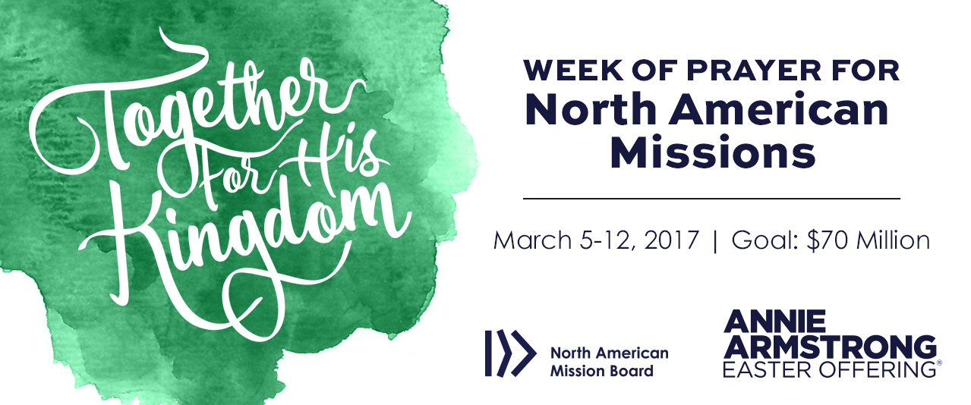

CHURCH | OFFERING-TO-DATE
Antioch (Scottsville) | $ 1,250.00
Arvon | $ 185.00
Buckingham | $ 1,160.00
Cedar | $ 730.00
Chestnut Grove | $ 220.00
First Baptist Dillwyn | $ 585.00
Fitzgerald Memorial | $ 500.00
Goshen | $ 1,600.00
Jones Chapel | $ 320.00
Mt. Zion | $ 2,400.00
Mulberry Grove | $ 265.00
Sharon | $ 215.00
Tar Wallet | $ 577.00

CHURCH OUTREACH>>>

Antioch (Scottsville) is preparing to set up two large tents at Old Farm Day at Pleasant Grove, Palmyra (May 6). They have an additional tent this year for a “baby changing station” and “nursing mothers” area. Their time at Old Farm Day in the past has been very successful. They give away cold bottled water, books, balloons, and stickers, all with the church logo. Erin Lamonte has been their organizer this year and many volunteers will participate. The church also gave over 400 pounds of seed to Malcolm Warfield for his S.E.E.D. Ministry. They are collecting items for Operation Christmas Child shoeboxes – in Apirl they collected “non-liquid hygiene items” and in May they will collect small toys. Antioch has 16 people signed up to help at the JRBA Meal Packing event and plans are also being made by Anthony & Jenni Clore to bring the youth group to the event. Their 5 Loaves and 2 Fish Ministry Meal for April was held on the 22nd. They served 127 meals and sent out 84 food boxes.

Fitzgerald Memorial held a Pie Auction that raised $500 for the Annie Armstorng offering.

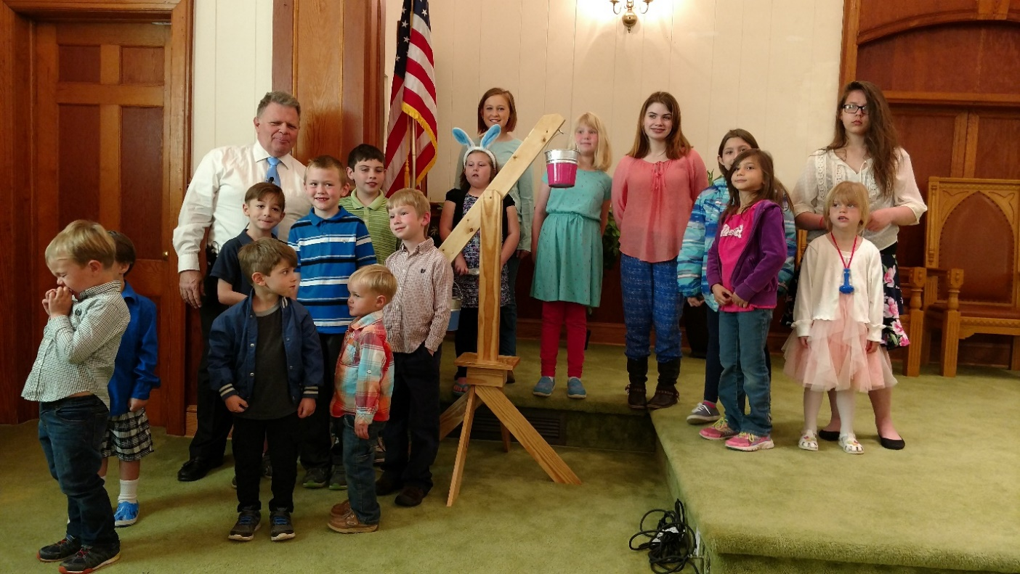

Jones Chapel children (and adults) collected $1,179.00 for Rise Against Hunger. Each Sunday, they were given the opportunity to bring their offerings. Thanks to Danny McCollom for building the “scales” and providing buckets to collect the coins. Danny and his helpers rolled coins each week and made the deposits. The winners of the contest were the girls, who collected the most money!

4
Helping Hands of First Baptist Dillwyn made a monetary contribution to the Bland Ministry Center.

Mulberry Grove worked on three major projects in April. They included the Annie Armstrong Easter Offering , collecting for Rise Against Hunger, and collecting items for the Bland County Ministry Center. Members continued to volunteer at the bi-monthly food distribution at the Crystal Cathedral. The outreach ministry continues on a regular basis. Other members volunteered at the Habitat for Humanity site in Dillwyn. The Mulberry Grove family will continue to collect for the Bland Ministry Center in May and to pack weekend backpacks for the primary school. Austin Williams will be participating in the BGAV Kairos Initiative Mission Trip to Vienna, Austria, May 22 – 31.

Sharon’s congregation provided monetary and in-kind contributions to support JRBA’s Bland County Mission Team, donated 73 dozen homemade cookies to the Kairos Prison Ministry for the recent “Kairos Inside” program at Buckingham Correctional Center, and further supported the ministry efforts by particiapting in the prayer vigil throughout the weekend (http://www.kairosprisonminsitry.org/kairos-inside-prison-ministry.php) Members and visitors of all ages enjoyed an afternoon Easter egg hunt at the home of Brenda and Mike Farrish, during which the true meaning of Easter was shared. Rose of Sharon continues delivering food and visiting with those who are sick and homebound. Current efforts are geared toward “Undie Sunday” – a collection drive to provide new undergarments for the people of Standing Rock.

Tar Wallet hosted the Community Easter Sunrise Service. They had a good crowd in attendance. Breakfast was served following the service and the $781 Love Offering was given to two missionaries. Tar Wallet provided a number of items for the Bland Ministry Center: 427 Ziploc bags, 235 pairs of undies, 14 jars of peanut butter, 5 dictionaries, 9 rulers, 2 pairs of scissors , 3 calculators, 23 pens, 32 pencils, 9 tubes toothpaste, and Campbell’s Soup Labels. Tar Wallet also provided seeds, 2 hammers, and 27+ pairs of flip flops for the S.E.E.D. Ministry.

The S.E.E.D. Ministry International made a monetary donation to JRBA for the Bland Ministry Center.

Missions Committee
- Our next Rise Against Hunger meal packing event will take place on Sunday, May 7, at Maysville Baptist Multi-Purpose Center, at 3:00 PM. All membes of our JRBA churches are challenged to help with this mission by:
- Giving – As of April 24, JRBA churches raised $7,654.68. Maysville Baptist contributed $500.00 and BGAV contributed $1,000.00 from the World Hunger Fund. A total of $9,154.68 has been contributed to purchase over 31,500 meals. I commend our churches for their generous giving to this great effort to end world hunger.
- Serving – Volunteers are urged to volunteer to help package food for Rise Against Hunger at our meal packing event.
- More Than Nets: We are so very pleased that BGAV Mission Teams have purchased and installed 80,000 mosquito nets, resulting in a 43% decline in malaria cases! The teams have planted 280 churches in Ghana, and over 1,000 people have heard the gospel, made professions of faith, and been baptized. At our May 11, Semi-Annual Spring Meeting, we will hear Dr. Adam Tyler speak about this wonderful mission. We will take an offering for More Than Nets. Let us prepare to give very generously to this cause.
- Our Bland Mission Trip will take place May 21 - 27, 2017. Eleven volunteers from JRBA churches have committed to go on this trip. You can help with this mission trip by:
- Bringing items requested by the Bland Ministry Center to the JRBA office by Wednesday, May 17.
- Pray for our mission team and for the work of the Bland Ministry Center.
- Camp CrossRoads will have a work weekend May 12 – 14 , 2017. Work will be done to prepare the camp for the summer camp weeks. If you are willing to volunteer to help, please call 434-384-2211.
- Mission Trips: We are pleased that many individuals and mission teams from JRBA churches wll be going on mission trips in May and throughout the summer.
- Three college students, Olivia Leatherwood and Ashley Hellerstedt (FBC) and Austin Williams (Mulberry Grove), will be going on a mission trip to Vienna, Austria, from May 22 – 31.
- Antioch (Scottsville) will be sending a team to Zimbabwe, Africa, July 10 – 21.
- Some of our youth groups will be going on mission trips this summer as well. (Please notify Phyllis if your Youth are going on a Missions trip.)
Thanks for your fine mission work.

In Christ’s Love,
Jimmy Dunn
Rev. Jimmy Dunn, Co-Chair

JRBA LEARNS AND GROWS>>>

JRBA PASTORS’ HUDDLE

On April 19, six pastors from our association gathered for the monthly Pastors’ Huddle at First Baptist Dillwyn. We are scheduled to meet again on May 17. Pastors, I hope to see you there.

Mike

Rev. Michael Khol

Antioch (Scottsville) requests prayer for Missy and Steve Johnson’s family in the loss of Missy’s father, David Proffitt.
They also extend their sympathies to Jesse Warner in the loss of his wife.

Chestnut Grove extends heartfelt sympathy to the family of Raymond Wooten who passed away on March 20.

5

OTHER EVENTS/NEWS>>>

Antioch’s (Scottsville) renovation on the old chapel is moving along. The old part of the church was built about 1901. The interior of the chapel had to be taken down to the ground, and rebuilt. After it is finished, it will be the children’s wing. One of the deacons, Kevin Hellms, is doing the work along with his son, Joshua. Antioch has a new church Treasurer, Geri Jensen, who will be assisted by Donna Butler.

Buckingham held an Easter Egg Hunt on Saturday, April 15, at 2:00 PM, with 20 children and numerous adults in attendance. After the Easter Story was shared with the children, the three age groups were assigned specific areas to hunt. There were 41 prizes for the lucky individuals who had a number in their egg and a prize for the person who found the most eggs. There was also a jelly bean jar for the person who could guess the number of jelly beans(or the number closest to the number of jelly beans in the jar). There was also a large Easter basket filled with goodies for the person whose name was drawn from a basket. Ethan Heath was the winner of the basket. Refreshments were served to the tired and hungry children. Of course, the adults were ready to eat, too!

Enon is planning a Movie Night sometime in May. (TBA)

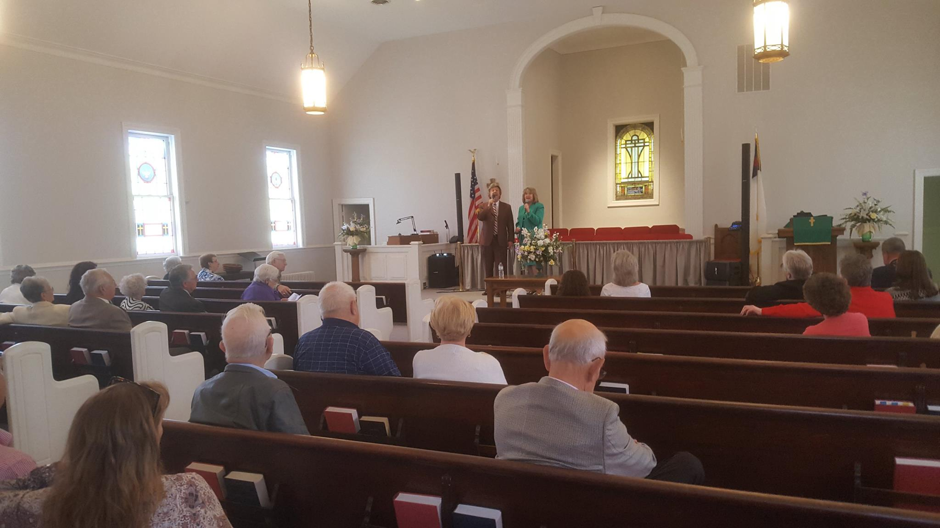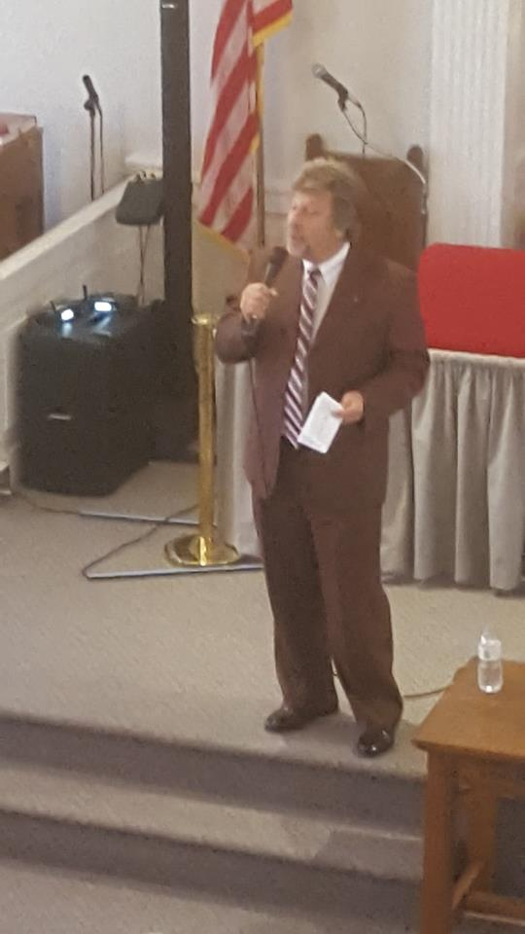

Smokey Wilson in Concert at Fitzgerald Memorial on April 22, 2017.

Rev. Michael Khol and Frank and Valeria Breault, Mulberry Grove, attended a presentation by Yuliya Shubina who is an Operation Christmas Child shoebox recipient. The event was held at Clifford Baptist Church in Amherst on April 19. Yuliya was born in a country in Central Asia where she received the shoebox when she was 9. She still treasures the stuffed puppy that was the first thing that she saw when she opened the box. She also received a letter from the little girl who packed it. Yuliya moved to the U. S. to finish high school. She met the young lady who had sent her the shoebox and was able to visit with her and her family, building a great relationship. She has now graduated from Liberty University with a degree in Government: International Relations. She accepted Christ as a result of receiving that shoebox and now works with Operation Christmas Child. She is the only Christian in her family. This inspirational talk was again a reminder of how important the shoebox ministry is in sharing the gospel.

Volleyball was the highlight of the afternoon on April 1, at the Maysville Multi-purpose Center. There were some high energy games for the adults and the children. Churches represented were Goshen, Maysville, First Baptist Dillwyn, Mt. Zion, Mulberry Grove, and Arvon, as well as some other guests. Many of the attendees enjoyed the lively games while others were entertained as they watched and cheered. It’s always fun to fellowship with our sister churches. The JRBA and Maysville Baptist event was planned by Rev. Michael Khol.

The evening of April 8, at Sharon, was one of warm fellowship, hot soup, and high-spirited music by the Willow Branch Bluegrass Band. Folks from near and far arrived early to fellowship over a wide variety of soups, breads, and desserts, and to enjoy an early musical performance by Marcus Fraticelli and Deanna Burkett. The congregation of Sharon extends heartfelt appreciation for the sustained support of friends and neighbors as it continues to grow the building fund for a new Fellowship Hall.

Tar Wallet held a work day on April 15, with 6 adults and 2 youth participating. They stacked firewood for a church member and cleaned out a storage building.

ACCOMPLISHING TOGETHER
WHAT WE CANNOT DO ALONE

6


JRBA CELEBRATES>>>

Jones Chapel welcomes to its fellowship, Bobby, Sherri, and Travis Green and Bill Knoll, who joined the church on April 9 and 16. Jack Parker, son of Dennis and Christal Parker, accepted Jesus Christ as Savior on Easter Sunday; Savannah Skeens, daughter of Mark and Angel Chambliss, made her profession of faith on April 23; and Marilyn Watson joined the church on April 23, coming from another denomination. The three were baptized on April 30 and a celebration meal was held after the worship service in honor of all the new members. Also, the winners of the Rise Against Hunger competition (girls) were served ice cream. Congratulations to parents, Hunter and Elizabeth and sister, Bailey Spuillman, on the birth of their baby boy, Wade.

Congratulations to Pastor Richard and MichelleTuttle who celebrated their anniversary on April 15.
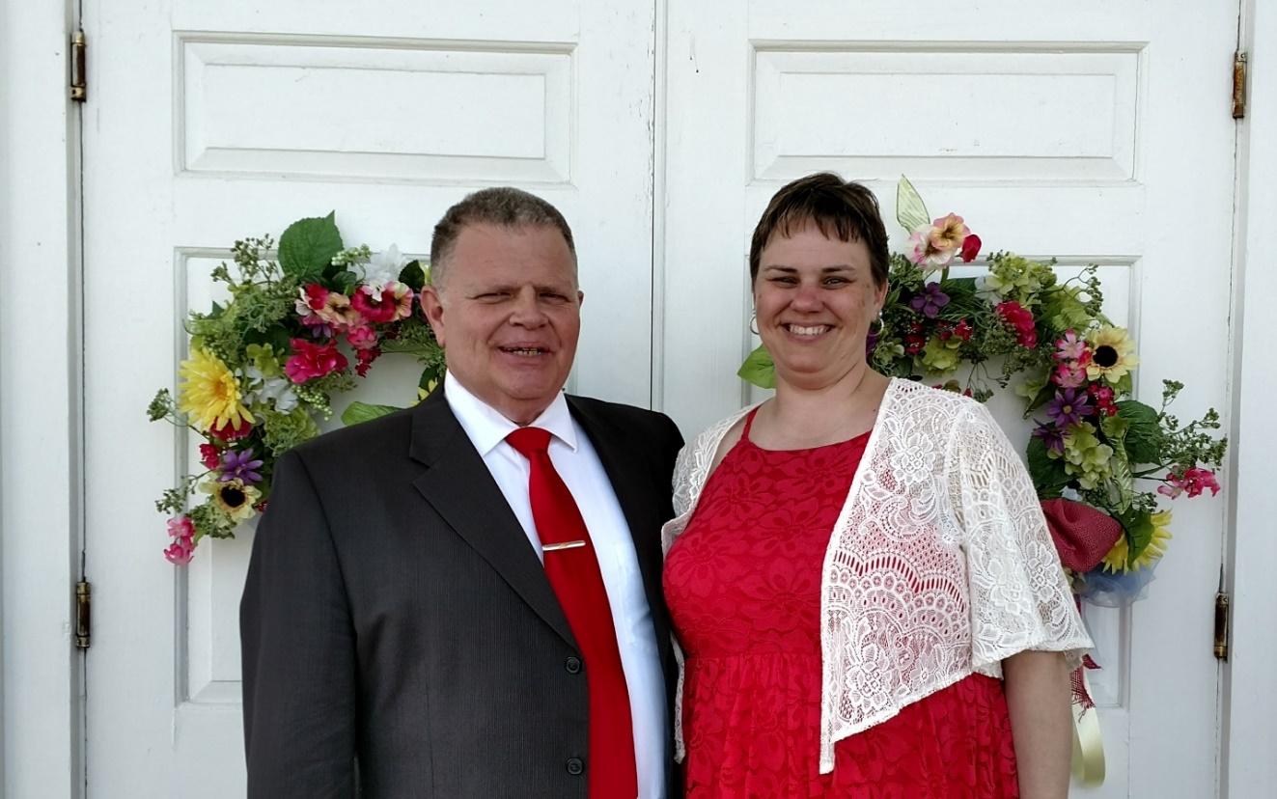

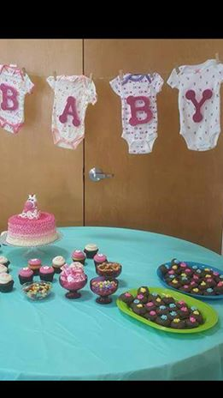
Fitzgerald Memorial held a Baby Shower for Rev. Barry and Jeanine Vassar on April 9.
JRBA extends their congratulations.

Tar Wallet extends congratulations to the following individuals:
- Amber Bruce recently completed LifeGuard, First Aid, and CPR training at Hampden Sydney. She will be a lifeguard at Bear Creek Lake this summer.
- Kayla Johansen will graduate from the Pensacola Christian College on May 10 with a degree in nursing. The Pinning Ceremony will be held on May 9. Kayla plans to attend graduate school in the fall.
- Christopher Johansen will graduate from A Beka on May 13. He plans to attend Pensacola Christian College with a major in Criminal Justice.
- Andrew McHenry participated in a Special Olympics Tournament on April 18 at Lynchburg College. He won a blue ribbon in the 100 meter walk and a red ribbin in the softball toss.
Congratualations to these young people on their accomplishments!

FROM YOUR MODERATOR>>>

May 4 is the National Day of Prayer. I would like for each church in our Association to participate in the National Day of Prayer. If there has ever been a time to pray for America, it is now. Lift our nation up to God, and remember to pray fervently, expecting God to answer
God Bless,
Marilyn
Mrs. Marilyn Snoddy

7


KEEP IN PRAYER>>>

- Those who are lost and need to know the Savior
- Churches without a pastor: Buckingham, Chestnut Grove, Fitzgerald Memorial (has Interim)
- JRBA Mission Team to Bland – May 21 -27
- Olivia Leatherwood, Ashley Hellerstedt, and Austin Williams going with Kairos Mission Initiative
Mission Team to Vienna, Austria – May 22 – 31
- Antioch (Scottsville) team to Zimbabwe, Africa – July 10 - 21
- JRBA Hispanic Ministry
- JRBA Pastors and Pastors’ Huddle
- Victoria Gina Vassile, JRBA WMU Project Ruth adoptee
- Local family serving IMB
- All those in our congregations who are ill or have lost loved ones

…the prayers of the righteous please Him.
Psalm 15:8b

FOR YOUR INFORMATION>>>

- JRBA Take Me Out to the Ball Game Afternoon – Hopefully, you have heard about this event by now! The Lynchburg Hillcats will play the Frederick Keys at 2:00 PM, at the Calvin Falwell Field, Lynchburg City Stadioum, 3180 Fort Avenue, Lynchburg. JRBA group tickets are $5 per person. Reserved seats with backs will be under cover from the weather. As a note of interest: there will be a Postgame Diamond Dig! Fans will be invited to search the infield after the game for a diamond ring supplied by Bowen Jewelry Company. What fun! Call the JRBA office at 434-983-7385 by May 15 to sign up for tickets. (We need to have at least 20 folks to get discounted tickets and reserved seats.)
- There was a bulletin insert sent out a couple of weeks ago letting you know about the BGAV Express magazine that is available FREE to members of BGAV churches. It is a quarterly magazine that gets the word out on what is happening in Virginia Baptist life. If you have not signed up already and would like to receive the magazine, please call the JRBA office and let Phyllis know. Pastors: Please remember to distribute the copies of the BGAV Express that come in a bundle to the church to your key church leaders.
- The Cooperative Baptist Fellowship of Virginia Office has moved. It is now located on the beautiful campus of Baptist Theological Seminary at Richmond. The address is 8040 Villa Park Drive, Suite 250, Richmond, VA 23228. CBFVA extends an invitation to come and see their new home.
- If your church contributes to the BGAV, you may be eligible to utilize some of their World Hunger Funds. BGAV uses half of what they collect for World Hunger Funds to supplement BGAV churches who do community gardens, monthly meals, or food distribution to the needy. The policy is available online at www.bgav.org. If a church or association ministry qualifies, money is available. Applications can be done online, too. If you have questions, you can call Caitlin Figura at 1-800-255-2428, Ext. 7274. It is through this fund that BGAV helps us each year with our Rise Against Hunger Meal Packing Event.
- UPDATES TO THE 2017 DIRECTORY: Please make corrections in your copy!
- PAGE 6: Rev. David Vogt – Antioch (Scottsville) has a new email address: pastordave@antiochva.org
- PAGE 6: Rev. Henry B. Enochs, Jr. – Goshen – Mailing Address: 6872 Wildway Road, Gladstone, VA 24553
- PAGE 12: Goshen has a new Deacon Chair: Mr. Lindsay Tapscott, 1359 Happy Hollow Road, Scottsville, VA 24590
Phone: 434-286-3618; Email: tapscott5@msn.com
- PAGE 13: Antioch (Scottsville) has a new Treasurer: Geri Jensen, 407 Blueberry Hill Drive, Scottsville, VA 24590
Phone: 434-981-0406; Email: treasurer@antiochva.org
- PAGE 24: The zip code is incorrect for:
Baptist General Association of Virginia – should be 23294.
Woman’s Missionary Union of Virginia – should be 23294.
PLEASE NOTIFY PHYLLIS IF THERE ARE OTHER ERRORS IN THE NEW DIRECTORY.

SUNDAY SCHOOL DEVELOPMENT
By Tony Brooks, BGAV Sunday School/Discipleship Specialist
4 Ways to Discover Servanthood for Sunday School/Small Groups
Exerpted from post at www.bgav.org on April 11, 2017
In your relationships with one another, have the same mindset as Christ Jesus: Who, being in very nature God, did not consider equality with God something to be used to his own advantage; rather, he made himself nothing by taking the very nature of a servant; being made in human likeness. And being found in appearance as a man, he humbled himself by becoming obedient to death – even death on a cross! Philippians 2:5-8 NIV

…the best way to transform a Sunday School class/small group, church, and community is having the mindset of Christ as a servant. Picture the upper room where Jesus met with his disciples one last time for a meal. While the disciples had been arguing over which one was greatest in Jesus’ Kingdom, Jesus recognized there was not a servant to wash the feet of the dinner guests before the meal. …Jesus wrapped a towel around his waist and took a basin of water and did what was needed. Then he challenged the disciples to be servants.

In a day when we would rather have a gavel to judge and make decisions, Jesus wants us to grab a towel and be a servant. Are there things in your class, group, church, and community you expect others to do without realizing you could do it? We all have chosen to use the gavel at times, while what was meeded was a servant’s towel. If we want to transform our Sunday School class/small group, it is time to ask, “God what do you want me to do? How can I serve you today?” So, how do we change the mindset of our class?
- Begin every class with a prayer, “How can I serve you today, Lord?”…Make prayer an attitude of asking what God wants instead of just what we want from God.
- Develop a spirit of gratitude for what God has done….When I realize what God has done for me, I can’t help but feel grateful and wonder what I can do for God.
- Find ways to involve every class member in serving…People who serve develop a servant’s mindset.
- Discover the joy of helping someone less fortunate than you are. It is easy for us to get so tunnel focused on our problems that we miss the less fortunate around us. As we begin serving the less fortunate, we discover joy that sets us free from our anxious filled problems and we find Christ.
8



JRBA Executive Board Meeting Summary
April 10, 2017

Moderator, Marilyn Snoddy, opened the meeting by quoting Romans 5:8 – But God demonstrates his own love for us in this: While we were still sinners, Christ died for us. She then shared the song, Who Am I? and led in prayer. Marilyn called the meeting to order and asked for the roll call of churches.

Frank Breault, Clerk, had the roll call. There were 19 in attendance, representing 10 churches. The minutes of the January Executive Board meeting were presented and approved. Tommy Joe Steger, Jr., Treasurer, presented the quarterly Treasurer’s Report. As of March 31, 2017, the checking account balance stood at $37,582.71. This balance includes the designated funds as follows: Additional Missions Fund - $748.04; Hispanic Ministry - $442.18; Rise Against Hunger(Stop Hunger Now) - $3,978.16; Youth Encounter - $400.00’ Memorial gift for JRBA Mission Trip – $100.00; and New Copier - $2,500.00. Total Receipts for the quarter were $11,516.08, including donations from the churches of $7,872.00, Alma Hunt - $187.92, Rise Against Hunger (Stop Hunger Now) - $3,356.16,, and Hispanic Ministry - $100.00. Total disbursements for the quarter were $4,561.25, including $200.00 for mission trips taken by individuals. The Savings Account balance was $4,173.14. The report was approved as presented. It was noted that an additional $$1,734.00 had come in for Rise Against Hunger since March 31. Also, $1,000 has been approved from the BGAV World Hunger Fund for the May 7 meal packing event.
Betty Toney, Benevolence Committee Chair, presented their report. During the quarter, 2 families were assisted with overdue electric bills; a donation was made to the Morning Star Baptist Church Rebuilding Fund; a family was assisted who lost everything in a fire; and one night’s lodging was provided to an individual with no place to stay. Disbursements totaled $447.16. Contributions from Goshen, Enon, and Mt. Zion totaled $550.00. The checking account balance stood at $4,311.75 on March 31, 2017. The report was approved as presented.

Marilyn then gave her Moderator’s Report. She welcomed Rev. Ron Nida, Mt. Tabor, who was in attendance. She announced the names of the new pastors at Antioch Union, Enon, and Goshen. She then reiterated the amount raised for Rise Against Hunger and the approval of $1,000 from BGAV for the event. She explained the BGAV policy for dispersal of World Hunger Funds. All should note that 50% of undesignated World Hunger Funds received by BGAV are distributed to the Southern Baptist Convention, Cooperative Baptist Fellowship and/or the Baptist World Alliance for hunger programs. The remaining 50% is distributed through BGAV churches, associations, mission partners, and other agencies throughout the BGAV network and their hunger initiatives. Associations can request up to $2,000 per project, two projects annually (maximum of $2,000/year) and administered on a rolling basis. Requests can also be made by BGAV contributing churches for ongoing hunger ministries in the community, such as food pantries, community gardens, and regular meal provision. The policy can be viewed online at www.bgav.org. Churches can request up to $500/project annually. No more than 2 projects per year per church, administered on a rolling basis.

Marilyn then noted that there are now 10 confirmed volunteers for the JRBA Bland Mission Trip scheduled for May 21 – 27. If anyone else would like to volunteer, please let Phyllis know by Monday, April 17. She also reminded everyone to turn in the Campbell’s soup labels by April 24 and all other items by May 17. Marilyn then reminded everyone that if Youth Groups or others are planning summer mission trips, they should notify the JRBA office. Next, she presented the Program Committee Report. The committee presented a draft of the Semi-Annual Spring Meeting program for approval and made several recommendations regarding the May 11 meeting: Registration will begin at 5:45 PM; At 6:00 PM there will be a Missions Report by Rev. Jimmy Dunn and Rev. Michael Khol, followed by a fellowship supper. (Messengers are asked to bring side dishes and desserts.); Dr. Adam Tyler has agreed to make a short presentation on BGAV’s More Than Nets efforts in Ghana, and to preach during the worship service; Special music will be provided by Grace Hills Baptist Church; and the offering received will be designated for the BGAV More Than Nets Project. Recommendations and the program were approved.

Marilyn noted that the 2017 JRBA Directories were completed and being distributed. She also announced that there is an upcoming opportunity to hear directly from an Operation Christmas Child shoebox recipient on April 19. Yuliya Shubina will tell her story at Clifford Baptist Church in Amherst, VA, at 7:00 PM.

The BGAV Express, Spring issue, has been sent to the churches. Pastors have received a packet of several copies. This particular issue contains a directory entitled, “Whom Do I Call For…:” It lists all the ministries, missions, and support ministries of the BGAV along with the contact person, phone ext. number, and email address. Pastors were reminded to distributed them to key church leaders. If anyone wants a copy, you should check with your pastor. It should be very helpful when leaders are looking for materials, or have questions about upcoming BGAV events for all ages.

Betty Toney, JRBA WMU Director, reminded everyone of the upcoming JRBA WMU Annual Spring Meeting to be held at Mulberry Grove, on April 30, at 3:00 PM. Rev. Mike Dodson will be speaking on the HOPE Boxes for Appalachia. These boxes are similar to the OCC Shoeboxes and are distributed through the Appalachian region. Jones Chapel and Tar Wallet have done some boxes already and Mt. Zion has contributed $$ to the program. It was noted that in addition to this being a more local ministry, there is no shipping fee. Those who want to know more about the program should attend the WMU Spring Meeting on April 30. There were no other Officers’ reports.

Rita Harris, Nominating Committee Chair, then presented the Slate of Officers for 2017-2018 as follows:
Moderator Rev. Michael Khol
Vice Moderator Mrs. Marilyn Snoddy
Clerk Mr. Frank Breault
Treasurer Ms. Judy Ownby
Reporter/Historian Mr. Terry Towler
Sunday School Director Rev. Jimmy Dunn
Discipleship Director Rev. Geoff Bruschi
Baptist Men’s Director Rev. John Moxley
VBS Team Leaders Frank & Valeria Breault
Music Director Mrs. Marilyn Snoddy
Disaster Relief Coordinator Rev. Dave Vogt
BCM Longwood Rep Mrs. Gale Moss
VA Baptist Historical Society Rep. Mr. Terry Towler
NOTE:
Parliamentarian(appointed by Moderator) Mr. Gwynn Tyler
WMU Director (elected by WMU) Mrs. Betty Toney
Currently serving with the BGAV Mission Council:
Rev. Perry Clore, Rev. Jimmy Dunn, Ms. Judy Ownby, Mrs. Marilyn Snoddy, and Mr. Gwynn Tyler
Rita expressed her appreciation to everyone for their willingness to serve. It had not been easy to complete the slate of officers, but the committee was diligent. Marilyn expressed her thanks to the committee and Jimmy expressed his thanks to Tommy Joe Steger, Jr. for his years of service as Treasurer. The Slate of Officers was approved as presented.

Rev. Jimmy Dunn, Co-Chair, gave the report of the Missions Committee. He reminded everyone of the Rise Against Hunger meal packing event to be held on Sunday, May 7, at Maysville Baptist. He encouraged everyone to give generously so that we can have our largest event ever. He also asked everyone to remind folks to sign up to volunteer at the event. He thanked everyone for their continued support of this effort through the years. Jimmy reminded everyone to pray for the JRBA Mission Team going to Bland. He noted that there are still places for additional volunteers and reminded everyone to pitch in by bringing the listed items being collected for the Bland Ministry Center. He reminded everyone to come out and volunteer at the Blue Ridge Food Distribution at Crystal Cathedral on April 28. Jimmy commented on the More Than Nets success rate with lowering the incidence of malaria cases in Ghana as well as their impact spiritually by planting churches and sharing the Gospel. He encouraged everyone to give generously to the offering for More Than Nets at our spring meeting. He also thanked the churches, pastors, and other individuals who have rallied behind those impacted by the
9
recent tragic accident that resulted in the death of two young children
in Buckingham County. Jimmy also reminded everyone about the volunteer event at CrossRoads Camp and Conference Center to be held on May 12 – 14. Rev. Michael Khol, Co-Chair, who works with Hispanics in the area, noted that he appreciated the support of the community given the Hispanics at Frida’s Restaurant. They are now attending Mulberry Grove on a fairly regular basis and are engaged in Bible Study there. He continues to hold Spanish Bible Studies at the prison on a regular basis, too.

Valeria Breault, Chair, gave a report from the Operation InAsMuch Committee. She said that this year the event will be over the span of an entire week, rather than just one Saturday. This will allow churches to customize their events to their schedules. JRBA churches are asked to plan ministry events during the week of September 30 – October 7, 2017. It is hoped that we can again have one large project which volunteers from several churches can work on as they did last year with the roofing project. Contacts will be made to Habitat for Humanity and Spreading God’s Gifts for possibilities. More information will be distributed in the coming weeks. Please let her know who your Operation InAsMuch contact is for your church as soon as possible.

No one from the Christian Life Committee was in attendance, but the Buckingham Baccalaureatte has been set for Sunday, May 7, at 4:00 PM, at the Buckingham County High School Gym.

Rev. Perry Clore, Evangelism Committee Chair, announced that there will be an Evangelism Seminar held at Sharon Baptist, on Saturday, June 10, 2017, from 6:00 – 8:00 PM. Rev. Woody Moore will be leading the seminar entitled, “Which Jesus” and presenting information on other religions that are growing and thriving here and around the world.

Under Old Business, the request from the Virginia Baptist Foundation to hold a seminar on Stewardship and Charitable Giving was revisited.
Rev. John Moxley briefly described Ron Hall’s visit to FBC earlier this year and noted that he thought having them come to speak could be beneficial. It was noted that it is already difficult to get folks out to our regularly-scheduled meetings. A host church would be needed, too. After some discussion, it was suggested that the Foundation be contacted to see if someone could come to the Annual Fall Meeting next October to make a presentation so that a few folks from every church would have the opportunity to hear the presentation and carry it back to individual churches. If a church is then interested, they could schedule someone to come to their church for a more customized discussion. The Program Committee will contact the Foundation.

Under New Business, Marilyn presented a request from The Gideons International. Over 1,644,000 Scriptures have already been requested by Gideons living and working in countries listed in the top 50 most persecuted nations of the world at a cost of over 2 million dollars. Gideons are asking for prayer and contributions to provide these requested Bibles as soon as possible. A motion was made, seconded, and approved to send $175 to purchase 140 Bibles for countries on the World Watch List . This donation will be taken from the Additional Missions Fund.

Rev. Michael Khol noted that he continues to plan fellowship events for JRBA, and stressed how important it is for us to get together. The kickball game and picnic last year was well attended, but the recent volleyball game was not. Those who came out had a great time. He presented the possibility of JRBA again going to a Lynchburg Hillcats baseball game on June 11. He said that in years past those who went had a good time and he’d like to try it again. He distributed a flyer and asked that each church let him know by May 15 how many are interested in purchasing tickets at $5 each.

Gwynn Tyler announced that the BGAV Mission Council would be meeting at Eagle Eyrie on April 25. Rev. Barry Vassar, long-term supply at Fitzgerald Memorial, was introduced and welcomed to JRBA.

Rev. John Moxley made a motion to adjourn and gave the closing prayer.

JRBA WMU Spring Meeting

The Annual Spring Meeting of the JRBA WMU was held at Mulberry Grove Baptist Chuch on April 30 with 40 in attendance. The offering of $208.00 will be donated to Boxes of Hope. Rev. Michael Khol, pastor of Mulberry Grove, extended a warm welcome and after the hymn, Jesus Saves, led the group in a devotional based on Colossians 3:17 about being committed. Pastors present were Rev. Woody Moore, Rev. Michael Khol, Rev. Jimmy Dunn (Pastor Emeritus), and the guest speaker, Rev. Mike Dodson. Cindy Jones gave a beautiful rendition of How Great Thou Art, after which Nancy Morris and Rita Harris presented a skit about cultivating relationships.

After a short business session, Angie Robertson presented the banner to the church with the most in attendance – Mulberry Grove. Audrey Ragland, after a brief presentation from Ephesians and other references from the Old and New Testaments on the subject of walking, presented the trophy for the most miles walked – 3,580 – to Leslie Davis, and the banner to the church with the most miles – 9,104 – to Mt. Zion.

The hymn, Wherever He Leads, I’ll Go, was an excellent introduction for our speaker, Rev. Mike Dodson, and his wife, Liesa, from the new Salem Baptist Church in Culpepper, VA. They gave a wonderful presentation of the dire need in the Appalachian Region of our country for “hope” due to the economic depression and resulting poverty there. This led to establishing the ministry, Boxes of Hope for Appalachia. The program is similar to the Shoe Boxes for Operation Christmas Child, in that plastic shoe boxes are filled with hygiene items – toothbrushes, toothpaste, and combs – and some fun items, as well as tracts on coming to know Jesus. All the churches present were given folders with a list of the items to put in the boxes. They will be picked up from a central location and taken to the school children in the Appalachian area. There will be no need for postage. The boxes will probably need to be collected around February 1, 2018, as they are delivered prior to Easter. This non-profit ministry is doing an amazing work and God has opened the doors of the public schools in the Appalachian Mountains of Wise County, Virginia, several counties in Kentucky, one county in West Virginia, and one county in North Carolina. The ministry volunteers give out the Boxes of Hope and share the Gospel with every student. For more information, check out the Hope for Appalachia website at www.hfavateam.com. If you have a question, call the Associational Office or Betty Toney at 434-983-2232.

Rev. Woody Moore closed the session in prayer.
Mrs. Betty Toney
JRBA WMU Director

ADDITIONAL INFORMATION ABOUT THE JRBA MISSION TRIP TO BLAND>>>

- Note the addition of a team member to the JRBA Bland Mission Team – Lisa Reid, Mulberry Grove, will also be a volunteer to the Bland Ministry Center.
- Several churches have already donated items for Bland Ministry Center: Antioch Union, Buckingham,Chestnut Grove, First Baptist Dillwyn, Goshen, Mt. Zion, Mulberry Grove, Sharon, and Tar Wallet. A large quantity of plastic shopping bags have come in, along with some undies, toothpaste, peanut butter, calculators, paperback dictionaries, Ziploc freezer bags, school supplies, and Campbell’s Soup Labels. The S.E.E. D. Ministry also donated some school supplies. There will be a more detailed list in the June newsletter. If you still plan to bring in items, they are due by May 17, but earlier would be helpful for sorting/packing, etc. If you have already collected plastic bags, bring them in, but you can stop collecting additional bags now. Thanks for all your help in gathering the needed items.

10

ASSOCIATION FINANCES
2016 – 2 017

REGULAR BUDGET RECEIPTS
Church | April | Year-to-Date
Antioch(Scottsville) | $ 300.00 | $ 600.00
Antioch Union |  | $ 500.00
Arvon |  | $ 1,000.00
Buckingham | $ 261.62 | $ 568.89
Cedar |  | $ 2,000.00
Chestnut Grove
Enon
First Baptist Dillwyn |  | $ 2,000.00
Fitzgerald Memorial
Fork of Willis |  | $ 419,.00
Gladstone Memorial | $ 331.25 | $ 993.75
Goshen |  | $1,180.00
Jones Chapel | $ 162.75 | $ 912.50
Mt. Tabor |  | $ 709.40
Mt. Zion |  | $ 1,800.00
Mulberry Grove |  | $ 1,979.00
Sharon | $ 380.25 | $ 1,140.75
Tar Wallet
Individuals |  | $ 400.00
VBMB – Alma Hunt |  | $ 187.92
TOTAL | $ 1,435.87 | $16,391,21
Approved Budget for 2014 – 2015: $24,371.00

TREASURERS: Please note that unless a specific ministry or project is designated on the memo line of the check or in an accompanying note, the contribution will appear in the regular budget receipts.
ALSO NOTE: Funds received are reflective of the Associational Year (Oct. 1, 2016 – Sept. 30, 2017), NOT the calendar year.

ADDITIONAL MISSIONS FUND
(Combines Local Missions + Additional Missions Funds 2015-2016)
Carryover: $198.04
April Expenditure: Gideons’ International - $175.00
Balance: $573.04

OTHER DESIGNATED FUND BALANCES
Youth Encounter - $400.00
Earmarked for Copier - $2,500.00
JRBA BLAND MISSION TRIP
Memorial Gift - $100.00
Cedar - $100.00
Sharon - $ 79.80
Individuals - $300.00
TOTAL : $579.80

JRBA Hispanic Ministry
Carryover: $ 432.90
Church | April | Year-to-Date
Enon |  | $ 100.00
Mulberry Grove |  | $ 100.00
TOTAL |  | $ 200.00
No Expenditures in March
Balance: $ 442.18

Funds for May 7, 2017 Event

Church | April | Total-to-Date
Antioch (Scottsville)
Antioch Union | $ 403.00 | $ 403.00
Arvon | $ 107.00 | $ 107.00
Buckingham | $ 250.00 | $ 250.00
Cedar | $ 459.50 | $ 459.50
Chestnut Grove | $ 786.00 | $ 786.00
Enon |  | $ 300.00
First Baptist Dillwyn | $ 399.02 | $ 1,546.18
Fitzgerald Memorial
Fork of Willis
Gladstone Memorial | $ 132.00 | $ 576.00
Goshen  Individual  (WOM) | $ 100.00  $ 50.00 | $ 500.00  $ 100.00  $ 80.00
Jones Chapel | $ 1,159.00 | $ 1,179.00
Mt. Tabor
Mt. Zion |  | $ 600.00
Mulberry Grove | $ 281.00 | $ 281.00
Sharon |  | $ 300.00
Tar Wallet | $ 50.00 | $ 187.00
JRBA TOTAL | $ 4,176.52 | $7,654.68
Maysville Baptist |  | $ 500.00
Baptist General Association of Virginia | $ 1,000.00 | $ 1,000.00
TOTAL | $ 5,176.52 | $9,154.68
*$ 417.00 collected in 2016.

John E. Mann, Sr. Benevolence Fund

Church | April | Year-to-Date
Cedar |  | $ 300.00
Enon |  | $ 200.00
First Baptist Dillwyn |  | $ 500.00
Goshen |  | $ 250.00
Mt. Zion |  | $ 100.00
Mulberry Grove |  | $ 300.00
Sharon |  | $ 200.00
TOTAL |  | $ 1,850.00
No Expenditures in April
Balance: $ 4,311.75*

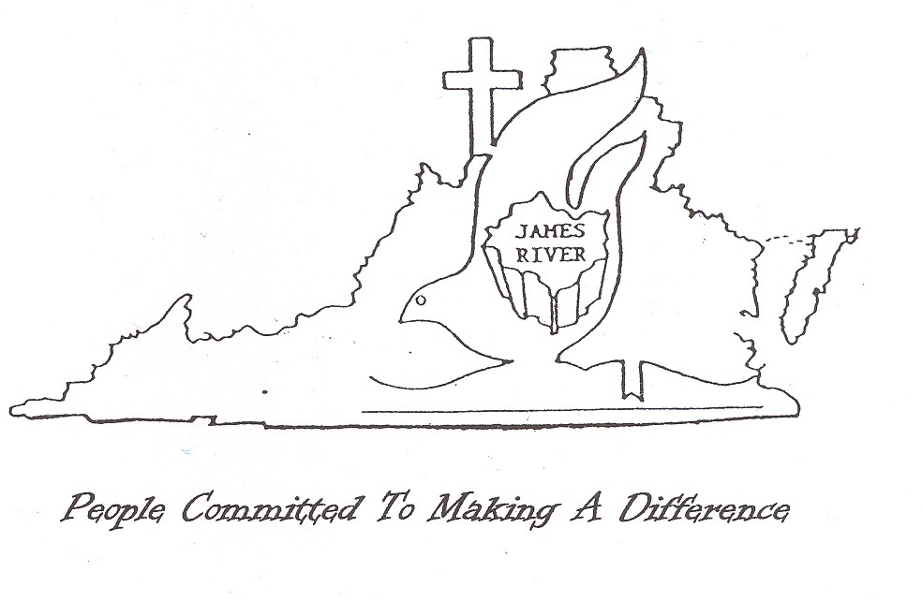

11

