THE SERVANT LINK
CHURCHES UNITED TO SERVE -
COMMITTED TO MAKING A DIFFERENCE
James River Baptist Association
P. O. Box 1219, Dillwyn, VA 23936
Rev. Michael Khol – Moderator
www.jamesriverbaptistassociation.com
Tel: 434-983-7385 Email: jrba@embarqmail.com
Hours: Monday & Wednesday 8:30 AM – 2:30 PM__________________
____________________________________________________________________________________________ ______________
Volume XVII February 20017 Edition I

EVENT DETAILS

February 3 Indoor Yard Sale at Jones Chaple 7:00 AM – 2:00 PM
Proceeds for Youth Mission Trip

February 4 The Trinity Quartet in Concert at Buckingham 11:00 AM

Hope Box Packing Party at Jones Chapel Noon

February 6, 13, 20 & 27: Tuesday Bible Study at the Goshen Parsonage 11:00 AM

February 7, 21 & 28: Prayer Meeting at Goshen 7:00 PM

February 7 Women on Mission & Deacon’s Meeting at Fitzgerald Memorial 7:00 PM

February 9 & 23 Blue Ridge Food Services Food Distribution at Crystal Cathedral, Dillwyn
Volunteers needed at 9:30 AM

February 10 WMUV Come to the Table Leadership Training at Melrose Baptist, Roanoke 8:30 AM – 3:00 PM
3520 Peters Creek Road
Missions Leadership Team Training for Churches and Associations
Cost/person: $15.00

Valentine Dinner & Movie at Mt. Zion 5:00 PM
Movie: The Song
A Couples’ Bible Study will follow up the night.

Antioch Union’s Valentine Banquet at Antioch Facility 6:00 PM

February 11 “Bring a Friend to Jesus” Day at Enon 11:00 AM
Dinner following the service – Everyone Welcome!

Baked Potato Bar Fundraiser at Jones Chapel Noon
Proceeds to support Mission Trip to Eagle Eyrie

Valentine’s Covered Dish Luncheon at Buckingham after the Worship service.

WMU Annual Enlistment/Enlargement Banquet at Chestnut Grove 5:30 PM
Church Fellowship Hall
Bring a salad and/or dessert and a small gift to exchange. The ladies will also be making children’s blankets for the Hope
for Appalachia Project.

February 11 – 18 WMU Focus Week

February 12 Tax & Compensation Seminar at First Baptist Dillwyn 9:30 AM – NOON
PASTORS, CHURCH TREASURERS, AND FINANCIAL SECRETARIES PLEASE MARK YOUR CALENDARS NOW
AND PLAN TO ATTEND. IF YOU HAVE NOT REGISTERED, PLEASE CONTACT ANGELA HOUSE AT 1-800-255-2428 OR EMAIL HER AT angela.house@bgav.org.



February 14
1
February 14 ASH WEDNESDAY

Senior Citizens Fellowship at Mulberry Grove 11:00 AM
Bluegrass/Gospel Music and Covered Dish Lunch

“Be Our Date” Valetnine’s Dinner at Fitzgerald Memorial 6:30 PM
Free Spaghettin Dinner for the community with Newlywed Game.
R.S.V.P. at 804-492-5151 or contact Fitzgerald on:
Facebook: https://www.facebook.com/fitzgerald.memorial
Website: https://fitzgeraldmemorial.wixsite.com/website
Twitter: https://twitter.com/fitzgeraldmbc1
Email: fitzgeraldmemorial@gmail.com

WMU & Brotherhood at Goshen 7:00 PM

February 16 Hot Dog & Movie Night at Buckingham 6:00 PM

February 16 – 18 Camp Piankatank Winter Blast
Theme: #DEATHTOSELFIE
For ages 13 – 17
Drop Off: Friday, 6:00 – 7:00 PM
Pick Up: Sunday, 2:00 PM
Cost: $130 per person inclues meals, snack, & shirt
For more information and registration: www.camppiankatank.org/winter-blast

February 17 WMUV Children’s Missions Day

JRBA Pastors Wives Fellowship at Arvon 10:30 A
Pastors’ Wives please plan to attend!

February 18 Women on Mission at Enon Noon

February 19 PRESIDENT’S DAY

INFORMATION IS DUE TODAY BY 9:00 am for the March edition of the JRBA calendar and newsletter.
Be sure to include your Lottie Moon Offering total and the number of HOPE boxes provided by your church.

February 21 JRBA Pastors Huddle at First Baptist Dillwyn Noon
Pastors, mark your calendar and join your fellow pastors for a timie of fellowship.

February 24 5 Loaves 2 Fish Ministry Meal at Antioch (Scottsville) 11:00 AM – 1:00 PM
Volunteers needed at 8:00 AM.

Children’s Ministry Day at Buckingham Time TBD

Central Virginia Baptist Association’s 2018 Women’s Retreat at Beaver Dam Baptist 8:45 AM – 2:00 PM
1794 Richmond Road, Troy, VA
Theme: Ask, Praise, Bless
8:45 – 9:00 AM Registration, Coffee & Pastries, etc.
9:00 AM – 2:00 PM Program
Cost/Person: $10 (Lunch Provided)
Childcare Provided
RSVP: Jeanette McCloud at cvbawomensministry@gmail.com

WMUV Standing Rock Orientation & New Volunteer Training at Virginia Baptist Resource Center
9:00 AM – Noon New Volunteer & Orientation
1:00 PM – 4:00 PM Site/Team Leaders Training
If you are interested in going to Standing Rock in 2018, go to www.wmuv.org for more information and to register for the training.

LOOKING AHEAD>>>
ANNIE ARMSTRONG EASTER OFFERING FOR NORTH AMERICAN MISSIONS
MARCH 4 – 11, 2018

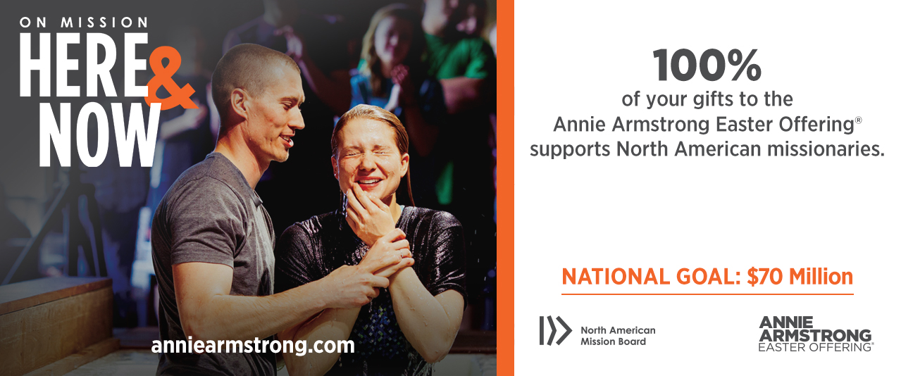
2
March 9 Movie Night at Enon 7:00 PM
Everyone Welcome!

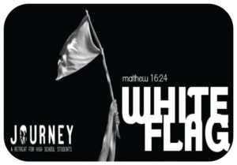

JOURNEY: A RETREAT FOR HIGH SCHOOL STUDENTS
Eagle Eyrie Camp & Conference Center
March 9 – 11, 2018
Theme: Matthew 16:24
Featured Speaker: Will Sipes
Music by Relinquish
Go to https://bgav.org/events/journey-a-retreat-for-high-school-students-4/
for more information and to register.

March 16 Corn Dogs & Family Game Night at Buckingham 6:00 PM

March 16 – 18 CBFVA Mission Madness at First Baptist Church, Waynesboro
Exciting weekend full of community missions, fellowship and fun for Youth Groups! If you would like to learn more about Mission Madness and find out more details, go to cbfva.org/studentministry-opportunities.
Cost/person: $95 (or $55 for Commuters)

WILLOW BRANCH BLUEGRASS BAND
IN CONCERT
Saturday, March 17, 2018
Sharon Baptist Church
7:00 PM
Fundraiser for Fellowship Hall Building Fund



EASTER EGG HUNTS

March 24 Enon’s Easter Egg Hunt at Ellis Acres Noon – 2:00 PM

March 25 Easter Egg Hunt at Jones Chapel Noon

Marach 31 Easter Egg Hunt & Spring Festival at Buckingham 2:00 PM

March 25 “Fill the Church for Jesus” Sunday at Enon 11:00 AM
Lunch will follow the service. Everyone Welcome!

March 30 GOOD FRIDAY



APRIL 1: Sunrise Service at Enon 7:00 AM
Breakfast following the service. No Sunday School.
Easter Celebration Services beginning at 10:30 AM, including an Easter Cantata.

April 13 -15 CBFVA Mission Madness at Central Baptist Church, Richmond
See info on March 16 – 18 event.

April 21 The Promising Future of Small Churches at Crozet Bapitst 10:00 AM – 2:00 PM
5804 St. George Ave., Crozet, VA 22932
Presenter: Dr. Chuck Warnock, Pastor, Chatham Baptist Church, Chatham, VA
For more information, contact Dr. Jeff Cranford at jeff.cranford@bgav.org or by phone at 804-921-3945.
(Some of you will remember Dr. Warnock from a seminar he led for us several years ago.)

3
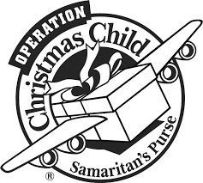
JRBA REACHES OUT>>>

OPERATION CHRISTMAS CHILD SHOEBOXES UPDATE

Church | # shoeboxes
Antioch (Scottsville) | 118
Buckingham | 61
Cedar | 126
Chestnut Grove | 31
First Baptist Dillwyn | 100
Mt. Zion | 231
Mulberry Grove | 63
Sharon | 67
Tar Wallet | 322


HOPE BOXES FOR APPALACHIA

Antioch Union 6
Goshen 41 + Extra Supplies & Baby Blankets
Sharon 22
Hilton Baptist (Newport News) 10

Mt. Zion has partnered with a school in Kentucky through Hope for Appalachia. 424 Hope Boxes will need to be provided for the children in Grades PK -8th. Boxes need to be completed and turned in by February 28. They can be delivered to the JRBA Office, Mt. Zion or Tar Wallet.
Please mark the boxes for Boys or Gilrs and the Grade Level for which it is appropriate: PK – 2nd,
3rd – 5th, or 6th – 8th. Also, please put the Bodywash in a ziploc bag.

HYGIENE KITS FOR FLUVANNA WOMEN’S CORRECTIONAL CENTER UPDATE

Church | Items Donated
Antioch (Scottsville) | 14 Hygiene, 9 Stationery
Buckingham | 6 Hygiene Kits
First Baptist Dillwyn | 7 Greeting Card Paks
Goshen | 35 Hygiene Kits, Envelopes, Cards
Mt. Zion | Stamps, 8 Stationery Paks, Cards, Pencils
Tar Wallet | 91 Hygiene Kits, 3,000+ Stationery Items
Rocky Mount UMC | 10 Hygiene Kits



CHURCH | OFFERING-TO-DATE
Antioch (Scottsville) | $ 3,000.00
Buckingham | $ 1,500.00
Cedar | $ 705.00
Chestnut Grove | $ 375.00
Enon | $ 158.00
Fork of Willis | $ 450.00
Goshen | $ 1,740.00
Jones Chapel | $ 351.15
Mt. Tabor | $ 210.00
Mt. Zion | $ 1,871.00
Sharon | $ 317.00
Tar Wallet | $ 440.00

4

JRBA MISSIONS COMMITTEE REPORT
- Our Rise Against Hunger Meal Packing Event will be held on Sunday, June 3, at Maysville Baptist Multipurpose Center. We are very pleased that some of our churches recently turned in gifts for this important mission. As all members of all of our JRBA churches give generously to Rise Against Hunger we will have enough funds raised by the middle of May to package more meals than ever before.
- Hope Boxes for Appalachia is an exciting mission cause through which we give boxes of useful supplies for needy children throughout Appalachia. We are pleased that some of our JRBA churches are working to diligently package many Hope boxes. I pray each of us will fill at least one Hope box. Please bring your filled Hope boxes to the JERBA office or to Mt. Zion or Tar Wallet before Wednesday, February 28.
- Disaster Relief – Rev. Woody Moore is working diligently to provide Disaster Relief Training for all who are interested in being certified to assist with Disaster Relief Ministry. Let us all cooperate fully with Woody in his fine Disaster Relief work.
- The Blue Ridge Food Distribution at the Crystal Cathedral helps so many needy people during the winter months. Please be present on Friday, February 9, and Friday, February 23, by 9:30 AM to help with this important mission.
- Mission Trips
- India – Malcolm Warfield has been on a 3-week mission trip to India during January. Rev. Anthony Clore and Rev. Dave Vogt were with Malcolm part of the time.
- Uganda – Malcolm Warfield will be on a 3-week mission trip to Uganda in February.
- The JRBA Bland Mission Trip is scheduled for May 20 – 26. Begin to pray about whether YOU are being called to participate in this opportunity.
- Many others from our association will be going on mission trips this spring and summer.
Let us pray for all these individuals and groups as they go on mission for our Lord.
In Christ’s Love,
Jimmy Dunn

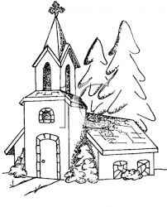
CHURCH OUTREACH

Antioch, Scottsville’s 5 Loaves 2 Fish Ministry Meal was held on December 16. They served 211 meals (78 households). They distributed 85 food boxes that day and 8 more boxes during the week. They also had a ministry meal on January 27. Rev. Dave Vogt and Rev. Anthony Clore joined Malcolm Warfield on his mission trip to India. They are scheduled to return on January 31 and are reporting great success, with many peole coming to Christ. The police officer for “Shield A Badge” in January has been Richard Morrison, III. Members were expected to pray for this officer and other officers every day. Members had a successful work day at the Bibb home on January 20. A general yard cleanup and small trees were cut down. About 30 members showed up to help out.

On December 12, some of Buckingham’s ladies prepared and delivered 13 quarts of chicken soup to the elderly and shut-in of the neighborhood. Some of the members prepared and delivered 5 Christmas boxes with a large turkey in each box. A Live Nativity was held on December 16 with the members portraying the true meaning of Christmas. There were live animals and the weather was cold. The Children in Action made cards for each resident at the nursing home in Dillwyn. They delivered the cards with a Christmas greeting and the singing of carols. On January 9, 18 spaghetti dinners were prepared and delivered.

On December 8, the Cedar church family visited Heritage Hall Nursing Home with filled stockings for each of the residents and also enjoyed singing Christmas carols with them. Cedar sponsored an Angel Tree for Christmas and gifts were delivered for 16 children.

Chestnut Grove adopted two local families for Christmas for their December mission project. They paid $300 towards one family’s heating bill. $400 was given to a lady with three children to provide for their Christmas. They also bought clothes, toys, ham, turkey breast, canned goods, cookies, and candy.

First Baptist Dillwyn carried out the following outreach actions during December and January:
- On Sunday, December 3, the youth of FBC presented a live nativity scene on the front lawn of the church. Many members and non-members were blessed by it.
- On Sunday, December 10, over 30 children and several adults presented the Christmas Play, It Happened in the Country. About 200 people were blessed by the play directed by Debbie Branch and Kayla Jamerson.
- The adult choir presented a Christmas cantata for the church and community on Thursday, December 14.
- On Sunday, December 17, a group from FBC sang Christmas carols in the homes of many shut-ins.
- The Christmas Eve Service at Heritage Hall featured Christmas caroling by the adult choir.
- During December and January, FBC reached out to help financially and spiritually many families in need.
- Grocery bags filled with groceries were given to families of the area.
- FBC’s Helping Hands Ministry prepared and delivered Christmas gifts to shut-ins of the church and community.
- Helping Hands prepared and presented Christmas Gift Bags to the boys of the Dakota tribe at the Discovery School.
- The Youth of FBC visited and sang Christmas carols for the residents of Heritage Hall and carried out a ministry at Food Lion.
- On Sunday, January 28, Helping Hands prepared and served a soup and sandwich lunch at the church to raise money for their scholarship fund for mission volunteers.

Fork of Willis was blessed in 2017 to be able to help several families throughout the year.

Goshen made donations to the Ruth School, Grace Inside, and Hope Tree Family Services. A young woman of the church is working on starting a clothes closet at the church in the near future. (Watch for details to come.)

Jones Chapel bought gifts for 21 children through the Christmas Mother program and sent food boxes for 8 families served by Cumberland Social Services. They gave many hats, gloves, and scarves to Hope for Appalachia. Some scarves were handmade specifically for this purpose. Jones Chapel is grateful for the concern and care for these children. They are now collecting items for the spring distribution of Hope Boxes.

Mt. Zion’s Baptist Men provided wood for a family dealing with cancer. Mt. Zion sent gallon bags to Bland County WMU and a Christmas care package to a soldier.

5

Mulberry Grove worked on several projects in December and January. Poinsettias and other gifts were delivered to shut-ins and residents at Heritage Hall. Members are working on Hope boxes for school children in Appalachia. Individuals were notified that their Operation Christmas Child Shoeboxes were on their way to South America, Zambia, Colombia, the Baltics and Balkans, Ukraine, Malawi, Ecuador, Shana, Burundi, Angola, and a hard to reach area. Members continue to volunteer at the bi-monthly food distribution at the Crystal Cathedral as well as conduct other outreach to shut-ins. February’s focus will continue to be the Hope boxes.

Sharon’s congregation contributed to special offerings for Spreading God’s Gifts ($124.50) and Grace Inside ($124.50), provided gift items for residents of Heritage Hall, and contributed hats, coats, gloves, and scarves for Charlottesville area homeless. Operation Christmas Child boxes from Sharon were delivered to children in Ecuador, Malawi, South Sudan, Uganda, and Burundi. Rose of Sharon continues providing meals and visits to those who are sick or homebound. Current efforts are focused on Hope for Appalachia gift boxes, and on growing a special offering for Rise Against Hunger.

OTHER EVENTS>>>

Buckingham began their celebration of the birth of our Savior with lighting the Advent Candle on December 3 which culminated in the Candlelight Service on Christmas Eve. The service was well attended. They continued their celebration with the lighting of the Chrismon Tree with a brief explanation of the background and the meaning of some of the Chrismons. On New Year’s Eve, Rev. Bill Gillespie reviewed the year since his arrival in June with a slide show. He also presented his goals for the New Year. On January 9, game night was held. Spaghetti was served. There were 26 in attendance.

On Sunday, January 14, a group of 45 from Cedar went tubing at Wintergreen. Cedar extends many thanks to their Youth Committee for planning and organizing this adventure for children of all ages!

Chestnut Grove’s Youth Sunday School Class held a movie night on Friday, January 19, in the Fellowship hall. Dinner was served at 6 PM followed by the movie, God Is Not Dead 2. Twenty-six folks attended. On Saturday, January 27, Chestnut Grove held their first Wild Game Pot Luck Dinner. The Old Time Gospel Singers provided music after the meal.

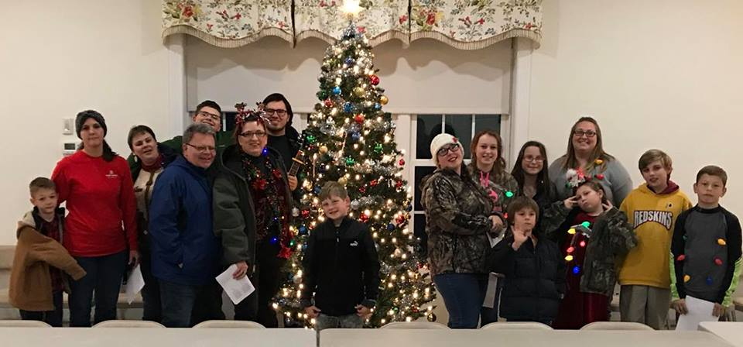
Everyone (Above) at Jones Chapel had fun decorating the Christmas tree after a pizza lunch in the fellowship hall. Also, the group had a fun night of Christmas caroling and returning to the fellowship hall for refreshements.

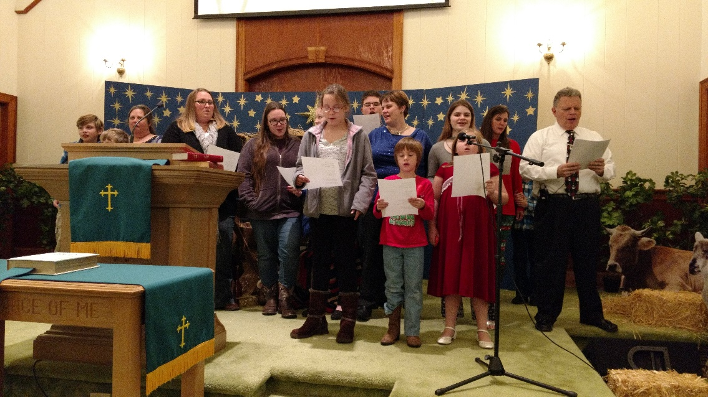
The children and youth of Jones Chapel gave an outstanding performance of the Christmas Story on Dedember 17.
Pastor Richard planned a special Christmas Eve candlelight service for the church. He and his son, Mark, acted as shepherds who heard about the Christ Child and then went to worship him. The service closed with everyone carrying lighted candles as they departed the sanctuary. Gloira Tuttle played and sang, O Holy Night and Michelle Tutle gave a gift of a candy cane to everyone on the way out. The children and youth sang during the service. (Above) After the Christmas program, Pastor Richard, Michelle, and the family were presented with a Christmas gift from church members.

6

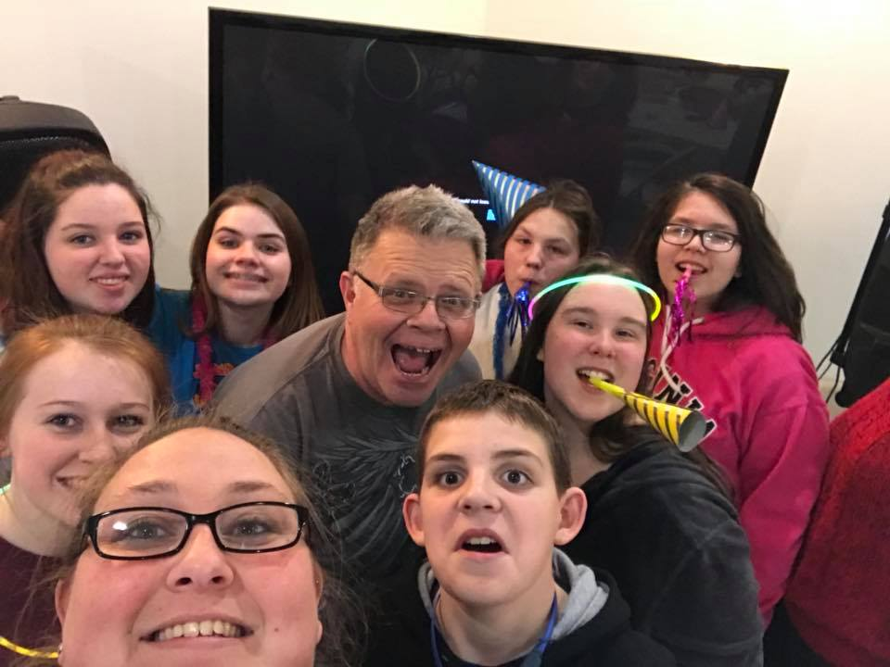

The Jones Chapel Youth Group spent New Year’s Eve at church, playing games, eating, and having fun with each other. They didn’t go home until after breakfast on New Year’s Day!

Mt. Zion’s Prayer Council hosted a New Year’s Lunch with traditional New Year’s food. They had the meal, a devotion to start the New Year, and great fellowship.

JRBA LEARNS AND GROWS>>>

The Youth of Antioch (Scottsville) will be attending the Valley Youth Conference at First Baptist Church of Roanoke on March 16. Anthony and Jenni Clore and others are the sponsors and chaperones.

Arvon continues to host AWANA on Sunday nights from 4 – 6 PM for Kindergarten through 6th grade students. On February 11, children are encouraged to wear Red, Pink, or Hearts for Valetines. Pajama Night will be the theme on February 25. Please contact Geoff or Angela Bruschi for more information.

On November 30, approximately 70 Cedar church family members attended the Bethlehem Walk in Goochland. What a wonderful job by all involved in this outside drama where guests were exposed to First Century Bethlehem.

Goshen continues with Missionary Moments during their morning worship services. They have a list of missionary names that they pray for during Sunday School.

JRBA Pastors Wives Fellowship

Greetings Ladies,
Our monthly Pastor’s Wives Fellowship met on Saturday, January 13. We welcomed a new pastor’s wife, Darlene, whose husband recently became the pastor of Chestnut Grove. Thank you for joining us; we enjoyed meeting and fellowshipping with you!

Please continue to lift each other and our husbands and congregations in prayer. Continue to remember other requests made.

Our next fellowship will be held on Saturday, February 17, at 10:30 AM at Arvon. Please let me know you can make it! If you can’t let me know prayer requests or concerns we can be praying for. The point of this fellowship is to strengthen each other; we have a unique call on our lives, as do our husbands.
God Bless!
AngelA


JRBA CELEBRATES>>>

In December, Antioch (Scottsville) added two new members, Cameron and Samantha Herndon. During January, Kevin and Christy Marshall joined. Their children are Carter, Jaelyn, Bailey, and Kendall. All are warmly welcomed into the church fellowship.

Cedar recently welcomed into their church family Mollie Throckmorton by letter of transfer. Also, making a profession of faith to be followed by baptism are Colin Throckmorton, Robert Tyree, Ariyanna Tyree, and John Tackett.

For a perfect ending to 2017, Jones Chapel celebrated three baptisms: Emily Cox, Jennifer Cox, and Joshua Estep, all members of the same family. God is blessing Jones Chapel in so many ways!

7


IN LOVING MEMORY

Paul Glen Boley, 84, died on December 20, 2017. He was a member of the Taylor Lodge #117, and a longtime, faithful member of Sharon Baptist Church where he served as deacon and in many other capacities through the years. Paul was a big man, with a big heart, and his presence is greatly missed. Sharon extends their deepest condolences to Paul’s wife, Barbara, and the entire Boley family, and continues to lift them in their prayers.

FOR YOUR INFORMATION>>>

- The Youth and Children of Jones Chapel are selling 2018 calendars to help raise funds to attend Eagle Eyrie MC2 in July, 2018. Several other fund-raisers are planned during the upcoming months, since a large group of adults and children plan to attend.
- Buckingham Baptist has a website and an email address:
Website: www.buckinghambaptistchurch.org
Email: buckinghambaptistchurch@gmail.com
- If you are interested in serving on any of the BGAV Boards or Committees, please notify Phyllis as soon as possible. Nominees must be members of BGAV supporting churches, must give permission to be nominated, and supply some basic information about their church affiliation and service. Nominations are due by May 1, 2018. Nomination does not ensure appointment, but rather consideration. This is an opportunity to serve Virginia Baptists and to get more involved! Nominations are being sought for the following: Christian Life, Memorial, Program, Religious Liberty, Resolutions, and Scholarship Committees, Averett University, Baptist Center for Ethics, Baptist Extension Board, Inc., Baptist Joint Committee for Religious Liberty, Baptist Ministers’ Relief Fund, Baptist News Global, Baptist Theological Seminary at Richmond, Bluefield College, Center for Baptist Heritage & Studies, Grace Inside, Fork Union Military Academy, Hargrave Military Academy, Hope Tree Family Services, John Leland Center for Theological Studies, Oak Hill Academy, Virginia Baptist Foundation, Inc., and Virginia Baptist Homes, Inc. Boards.
- Bluefield College has scholarship money available for high school juniors in your congregation who would like to attend a a 4-year Christ-centered college with an outstanding academic repurtation. Bluefield is offering $1000 per student per year for 4 years! For more information, contact Jordan Dillon, Campus Visit Coordinator, at 276-326-4231 or by email at jdillon@bluefield.edu.

The JRBA Copier Committee, per directive of the Executive Board, has purchased a new copier for the JRBA office and it is now in place! The new copier was used for this edition of the newsletter and is providing faster, more efficient service! Phyllis expresses her thanks to committee members for their efforts in securing the new equipment. It should give JRBA many years of good service and high quality copies. (The cost of the new copier was covered by a donation that had been earmarked for this purpose.)


KEEP IN PRAYER>>>
- Those who are lost and need to know the Savior
- PRAISE: All JRBA Churches currently have pastors!
- JRBA Churches
- JRBA Hispanic Ministry
- JRBA Pastors and Pastors’ Huddle
- JRBA Pastors Wives Fellowship
- Malcolm Warfield’s Mission trip to Ugand (February)
- Victoria Gina Vassile, JRBA WMU Project Ruth Adoptee
- Local family serving IMB & recent uprisings in their area of service
- All those in our congregations who are ill or have lost loves ones

…the prayers of the righteous please Him.
Psalm 15:8b

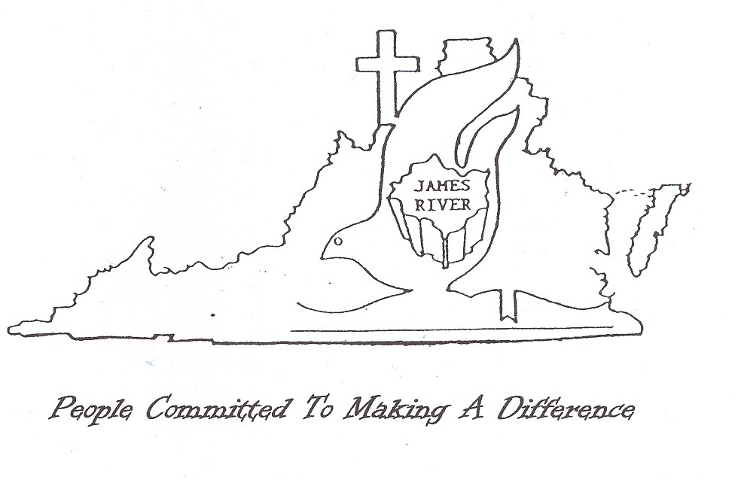
8



JRBA Quarterly Executive Board Meeting Summary
January 8, 2018

Moderator, Rev. Michael Khol, opened the JRBA Quarterly Executive Board meeting with a devotional based on John 3:16. God SO LOVED the world…how much did God love the world? How much did/does he love each of us? He SO loved us that he sent Jesus to be born in a lowly manger. He SO loved us that he sent Jesus to die on the cross for our sins. The strange stories of his birth and His death/resurrection are evidence of His Love for us! That is the Good News of how God loved the world SO much. Michael challenged JRBA to share that Good News! He then led in prayer and called the meeting to order. Frank Breault, Clerk, had the roll call of churches. There were 19 in attendance, representing 8 churches.

The minutes of the October Executive Board Meeting were presented and approved. The summary of the Annual Fall Meeting waspresented and approved. The Treasurer’s Report for the first quarter was presented and approved. Total Contributions = $8,614.84 (Regular church contributions, Interest, and Designated contributions to Rise Against Hunger, BGAV Disaster Relief, and Operation InAsMuch 2017). Total Disbursements = $6,013.91 (Includes contributions to Southside Pregnancy Center, Missions Trip, Hispanic Ministry, and designated contributions to BGAV Disaster Relief.)

Betty Toney, Benevolence Chair, presented the quarterly report. From October 1 – December 31, 2017, two families were assisted with overdue electric bills. Disbursements totaled $200.00. Cedar, Buckingham, Sharon, First Baptist Dillwyn, and Mulberry Grove made contributions for a total of $1,500.00. The checking account balance as of December 31, 2017, stood at $5,076.75. The report was approved.

Michael then gave his Moderator’s Report. He began by telling us about how he grew up in Ecuador and how the New Year is viewed differently there. Instead of resolutions for the New Year, Ecuadorians look back at the year just finished and celebrate its accomplishments.
He noted that JRBA had been very active in 2017, mentioning the various mission trips, the Back Pack Ministry, assistance with Blue Ridge Food Distributions, the Rise Against Hunger Meal Packing Event, contributions to Disaster Relief in Florida and Texas, assisting Habitat for Humanity and Standing Rock, Hat/Gloves for Appalachia, and contributions to Lottie Moon, Alma Hunt, and Annie Armstrong Missions Offerings. 2017 was an exciting year. He is looking forward to 2018 and working hard to fulfill our motto: Accomplishing Together What We Cannot Do Alone. Michael introduced Rev. Roger Woody, the new pastor at Chestnut Grove, and welcomed him to JRBA. He encouraged Pastors’ Wives to attend the Fellowship for them on January 13. He encouraged Pastors to attend the Pastors’ Huddle on January 17. He announced the Tax & compensation Planning Seminar scheduled for Monday, Feb. 12, at FBC, and encouraged participation by the pastors and church treasurers. He also noted that Bluefield College has scholarship money available. (Jimmy Dunn noted how the Bluefield scholarship had made it possible for one of their students to go to college. Gwynn Tyler reminded everyone that the Virginia Baptist Foundation also has scholarships available – application deadline is Jan. 31!) Michael mentioned that Habitat for Humanity has 2 builds planned for Buckingham in 2018. Rev. Barry Vassar noted that there are also 2 planned for Cumberland. Fitzgerald Memorial is hosting Cumberland Habitat Meetings on the 4th Thursday of each month.

Officers’ Reports were called for next. Betty Toney, WMU Director, noted that we are currently doing 20 backpacks here in the Buckingham County Schools at the Primary, Elementary and High School levels. If other churches are interested in participating please contact her.

Rev. Woody Moore, Disaster Relief Coordinator, updated us on what he is planning for 2018. He is currently putting together a list of those in the association who are already certified by BGAV Disaster Relief for call out in the event of a disaster. He distributed a bulletin insert to assist with getting this information. He is also hoping to host a training session. He plans to hold a meeting for all those interested in Disaster Relief in the near future. Be on the lookout for information from Rev. Moore.. Rev. Barry Vassar noted that cooperation with FEMA can be beneficial to churches who want to work with local needs. (Contact him for more details.)

Next, Rev. Jimmy Dunn , Sunday School Director, talked about the importance of Sunday School and Bible Study in our churches. He would love to see Sunday School participation on the same level as folks in Worship Services. He gave tips for SS teachers, pupils, and classes. He encouraged everyone to work on SS attendance, excellence in teaching, participation in Bible Study, and making everyone feel at home in the SS setting. He also noted that having Bible Study at other times might better suit some people’s schedules. He also stressed the importance of SS classes taking on ministry projects.

Rev. Dunn also gave the Missions Committee Report. He noted the good time had at the Hispanic Fiesta and thanked Buckingham for hosting. He mentioned the upcoming Mission trip of Malcolm Warfield, Rev. Dave Vogt, and Rev. Anthony Clore to India, as well as Malcolm’s Feb. trip to Uganda. (Gwynn Tyler mentioned the upcoming JRBA Bland Mission Trip, May 20 – 26, If he and Phyllis lead it again, they will be coming home on the 25th. If someone else wants to take on the leadership for this trip, please let him or Phyllis know.) Jimmy then mentioned the Hope for Appalachia ministry project. Marilyn Snoddy noted that they have adopted Evarts Elementary School with a need of 424 boxes – if any of the other churches can do some of the boxes, they need to let her know the number they can do. Rev. Woody Moore also noted that the boxes will be delivered during Holy week and that if anyone is interested in participating with that delivery, they should be in touch with him. Rev. Dunn then noted the good work of the Blue Ridge monthly food distribution and encouraged everyone to get involved with that ministry on the 2nd and 4th Fridays of each month.

A report was presented from the Copier Committee. The committee has met with Dave Stinnett, representing Sharp Electronics Corporation, formerly Lynchburg Business Machines Office Solutions, and arranged for the purchase of a new copier at a cost of approximately $2,000. The new copier will be faster and produce better quality copies as well as save time and effort. The committee made a motion that the remaining designated funds be held for the purchase of a new computer when needed. The motion was approved.

Under Old Business, Rev. Perry Clore presented information obtained concerning the Fellowship of Christian Athletes and their role in the public schools in Fluvanna. It was noted that Cumberland and Buckingham Counties are also receiving services from this organization. A motion was made and approved to contribute $150 (Additional Missions Fund) to this organization to assist them in reaching our young people with the Good News of Jesus Christ.

Under New Business, Rev. Khol presented the list of Committees for 2018. A motion was made and approved to accept these appointments. He noted that he wants to meet with each committee this year and have them be active.

There being no other new business, Rev. Barry Vassar made a motion to adjourn. It was seconded and the meeting was adjourned with prayer by Rev. Roger Woody.

9

ASSOCIATION FINANCES
2017 - 2018
REGULAR BUDGET RECEIPTS
Church | December | January | Year-to-Date
Antioch(Scottsville) | $ 300.00 |  | $ 300.00
Antioch Union
Arvon
Buckingham |  |  | $ 281.91
Cedar |  |  | $2,500.00
Chestnut Grove
Enon
First Baptist Dillwyn |  |  | $1,000.00
Fitzgerald Memorial
Fork of Willis |  |  | $ 456.00
Gladstone Memorial |  | $ 321.25 | $ 652.50
Goshen
Jones Chapel | $ 146.23 | $ 163.43 | $ 630.71
Mt. Tabor
Mt. Zion |  | $1,800.00 | $1,800.00
Mulberry Grove | $2,115.00 |  | $2,115.00
Sharon |  | # 393.25 | $ 786.50
Tar Wallet
Individuals
VBMB – Alma Hunt |  | $ 190.05 | $ 190.05
TOTAL | $2,561.23 | $2,867.98 | $10,712.67
Approved Budget for 2017 - 2018: $23,881.00

TREASURERS: Please note that unless a specific ministry or project is designated on the memo line of the check or in an accompanying note, the contribution will appear in the regular budget receipts.
ALSO NOTE: Funds received are reflective of the Associational Year (Oct. 1, 2017 – Sept. 30, 2018), NOT the calendar year.

DESIGNATED FUNDS

ADDITIONAL MISSIONS
Carryover: $573.04
Budgeted - $700.00
Fall Meeting Offering - $603.00
Expenditures
BGAV Disaster Relief - $603.00
Pregnancy Support Center (Farmville) - $200.00
January Disbursement:
Fellowship of Christian Athletes - $150.00
Balance: $923.04

Youth Encounter
Carryover: $300.00

Earmarked for Copier
$2,500.00*
*Once the invoice for the new copier arrives and is paid, this will be deducted from this designated fund. The Executive Board has directed the remaining funds to be held towards the purchase of a new computer when needed.

JRBA Hispanic Ministry
Carryover: $ 542.18
Budgeted - $200.00
Buckingham Baptist – Christmas Fiesta - $100
No expenditures in Dec. or Jan.
Contribution:
Enon - $100.00
Balance: $ 742.18

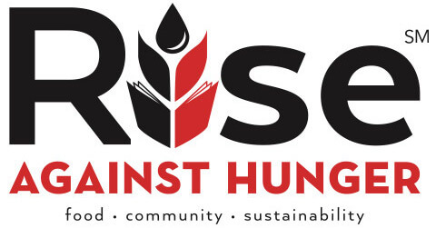

NEW CONTRIBUTIONS FOR 2018 EVENT
Church | December | January | Total-to-Date
Enon |  | $ 300.00 | $ 300.00
Gladstone |  | $ 138.00 | $ 422.00
Mt. Zion |  | $ 500.00 | $ 500.00
Buck. Co. Men’s Prayer Group |  | $ 35.00 | $ 35.00
 |  | $ 973.00 | $1,257.00

John E. Mann, Sr. Benevolence Fund

Church | Dec. | Jan. | Year-to-Date
Buckingham |  |  | $ 200.00
Cedar |  |  | $ 300.00
Enon |  | $ 200.00 | $ 200.00
First Baptist Dillwyn |  |  | $ 500.00
Mt. Zion |  | $ 100.00 | $ 100.00
Mulberry Grove | $ 300.00 |  | $ 300.00
Sharon |  |  | $ 200.00
TOTAL | $ 300.00 | $ 300.00 | $1,800.00
December/January expenditures: $155.00
Balance: $ 5,221.75



10

