THE SERVANT LINK
CHURCHES UNITED TO SERVE - COMMITTED TO MAKING A DIFFERENCE:
ACCOMPLISHING TOGETHER WHAT WE CANNOT DO ALONE
James River Baptist Association
P. O. Box 1219, Dillwyn, VA 23936
Mrs. Marilyn Snoddy – Moderator
Phyllis R. Tyler - Secretary
www.jamesriverbaptistassociation.com
Tel: 434-983-7385 Email: jamesriverbaptistassociation@gmail.com
Hours: Monday & Wednesday 9:00 AM – 3:00 PM__________________
____________________________________________________________________________________________ ______________
Volume XXI December 2022 Edition XII

ATTENTION
Please call ahead if you plan to drop in during regular operating hours, or to schedule an appointment.
Your cooperation is greatly appreciated. (434-983-7385)

PLEASE NOTE THE NEW EMAIL ADDRESS IN THE HEADING ABOVE.

May you be blessed this Christmas season with renewed wonder in the birth of our Savior, sent to redeem us from our sins and
to give us hope for the future.

EVENT DETAILS

Nov. 30 – Dec. 3 JRBA Hope Team to Kentucky
Keep the team in your prayers as they travel and minister to the children in Kentucky.

December 1 Scholarship Applications from EverBless (Baptist Foundation) are available online today!
To assist families with the rising cost of education, EverBless Foundation and its donors are committed to providing scholarships to Virginia Baptist students. Applicants for scholarships must be full-time students at an accredited institution, members of a BGAV church and have a minimum grade point average of 3.0. Online applications for the 2023-2024 academic year are available on the foundation’s website: http://everbless.org/scholarshps, beginning Dec. 1, 2022. The deadline for submission is January 31, 2023. Contact EverBless Foundation at 804-672-8862 with questions.

December 2 Brunswick Stew at Buckingham Noon
Get a bowl of stew and fellowship with the good folks at Buckingham…and take a free quart home!

Very Merry Joyful Noise Celebration at Antioch (Scottsville) 7:00 PM

December 2 & 3 Outdoor Walking Christmas Drama at Antioch Union
O Night Divine – The Birthday of Our Savior
December 2: 7:00 and 8:00 PM
December 3: 6:00, 7:00 and 8:00 PM
Please rejoice with Antioch Union as they celebrate the birth of Jesus!
The church is located at 2135 Austins Road, Gladstone, Virginia.
RSVP DATE AND TIME: Pastor Brian Faison at 434-610-0138.

1
Dec. 2-4 & 9-11 Lights at the Lake (Bear Creek) 5:00 – 7:30 PM
Jones Chapel Youth Group decorated a space for this event. A new, unwrapped toy or a monetary donation will be accepted
to take the tour and will be given to the Christmas Mother for families in need..

December 3 Christmas Extravaganza at Jones Chapel Starting for Children at 3 PM
Children (Grades 5 and below) will gather in the fellowship hall to decorate, bake treats, hear stories, make ornaments, and practice some caroling songs. Children K – 5th grade may stay if parent signs permission slip. Children under Age 5 must be accompanied by a parent. Parents and community members are invited to drop in from 4:00 – 6:00 PM to enjoy warm cocoa, hot coffee, hot apple cider, etc. Nativity characters will be there to sing along and tell you a little about themselves.

December 4 WMU Sunday at Mt. Zion 11:00 AM
WMU will be leading the morning Worship Service.

“Welcome the Pastor” Christmas Lunch at Fitzgerald Memorial NOON
Fitzgerald welcomes Rev. Steve Emory and his wife, Kenita, to the church as he begins his pastorate there.
December 4

Christmas Caroling at Cedar 3:00 PM
The church family will go caroling and invites everyone to join them!

Christmas Cantata at Sharon 7:00 PM
The Church Choir will present the cantata, Christ was Born for This: Christmas Blessings, followed by a reception with light refreshments. Bring family and friends to share the message of joy and love, and experience once again the fulfillment of God’s promise. It is a great way to kick off the Christmas season!

Live Nativity at First Baptist Dillwyn 6:00 – 7:00 PM
On the front lawn of the church.

December 4 – 11, 2022
Lottie Moon Christmas Offering
Week of Prayer for
International Missions

Be sure to report your Lottie Moon Offering total to the JRBA Office.

December 9 & 23 Blue Ridge Food Distribution at Crystal Cathedral
Volunteers needed at 9:30 AM.

December 10 Deacon Fellowship Dinner at Antioch (Scottsville) TBA
December 11 Children’s Christmas Plays:

Antioch (Scottsvillel) 8:30 AM and 11:00 AM

First Baptist Dillwyn 11:00 AM
The children of FBC will present the Christmas play, Christmas Every Day.

Youth Christmas Program at Cedar 5:00 PM
The Youth will be presenting Just a Little Christmas. Join the folks at Cedar
for this special time. There will be refreshments afterwards with a special guest
coming to visit the children.

December 11 Christmas Cantata at Enon 11:00 AM
The choir will be presenting Silent Night, Holy Night. Everyone is invited.

December 14 Senior Citizens Fellowship at Mulberry Grove 11:00 AM
Bluegrass and Gospel Music with Covered Dish Lunch

Christmas Cantata at First Baptist Dillwyn 7:00 PM
The FBC Choir will present O Holy Night. Everyone is invited.

December 16 Women’s Christmas Retreat at Antioch (Scottsville) 6:00 PM
The women will meet in the Chapel for a devotional, meal, craft, and gift exchange.

December 17 Loaves and Fish Ministry Meal at Antioch (Scottsville) 9:30 – 10:30 AM
There will be a hot meal and food boxes will be given out including a ham!

2

December 18 Children’s Christmas Programs:

Enon 10:00 AM
The children will present their Christmas play during the 10 AM service. The
service will be followed by a meal. Everyone is encouraged to join Enon for this
special Christmas event.

Jones Chapel 11:00 AM
The children will present their Christmas program during the Worship hour.

Mulberry Grove 5:00 PM
Dinner to follow the program.

December 18 Deacon Ordination at Mt. Zion 11:00 AM
Richard Bickford and Richard Shumaker will be ordained as Deacons during the Worship service.

Christmas Caroling at Chestnut Grove 3:00 PM
While caroling, fruit baskets will be given to the families visited. Refreshments will be served after caroling.

Town of Dillwyn Christmas Parade 3:00 PM
Enon will be participating in the parade. Come out and join in the fun!

Children’s Christmas Shop at Antioch (Scottsville) Chapel 3:30 – 5:00 PM
The Antioch Christmas Shoppe will be opening the chapel for their children to shop for their parents. The children are encouraged to do chores to earn money for their shopping. All proceeds will be donated to the Antioch Building Fund. Gifts will be priced $5.00 and below. Volunteers will be available to help the children shop and package their gifts. It is always a blessing to see how excited the children are to give!

Christmas Concert at Gladstone Memorial 5:00 PM
Jim and Suzanne Blaine will be in concert, followed by refreshments. All are invited.

Mt. Zion’s Live Nativity at Oak Grove Chapel 5:30 PM
Live nativity followed by a candlelight service.

Monday, December 19
Information for the January edition of the JRBA calendar and newsletter is due today by 9:00 AM.
Be sure to include your Lottie Moon Christmas Offering total-to-date as well as your outreach and celebrations for December and any events scheduled for January.

I will be taking some time off during the holidays, so the January edition will come out on the
2nd Sunday of January. The JRBA Office will be closed December 21 through January 2. I may be in and out of the office, but if you need to come by, be sure to call ahead. If you cannot reach me at the office number, call me at home. (969-4378)
Have a blessed Christmas!
Phyllis

MORE CHRISTMAS CAROLING EVENTS

December 21 Caroling at Fitzgerald Memorial 5:00 PM

December 22 Caroling at Enon 6:00 PM

Christmas Eve Services

Mulberry Grove Noon – 1:00 PM
Join the folks at the Grove for a time of worship and fellowship.

First Baptist Dillwyn 5:00 PM
Everyone is invited to the Candlelight Service.
Arvon 5:30 PM
Join in for a Candlelight Service.

Enon 6:00 PM
Everyone is invited to a Candlelight Communion Service.

Antioch (Scottsville) will NOT be hosting a Christmas Eve Service this year.

3
December 24 Christmas Program at Chestnut Grove 6:00 PM
The play, The Innkeeper at Bethlehem, will be presented and refreshments will be served after the program.

CHRISTMAS DAY
Sunday, December 25, 2022

Changes to Sunday, December 25, schedules:
Antioch (Scottsville) will only have one service, at 10:00 AM. No Sunday School

Fitzgerald Memorial will have Worship at 11:00 AM. No Sunday School.

Changes to Wednesday, December 28, service:
Goshen will have no Wednesday night service.

December 31 New Year’s Eve Youth Lock-In at Jones Chapel Starting at 8:00 PM

PASTORS: DON’T FORGET THAT EARLY BIRD PRICING FOR THE “PREACH 2023” CONFERENCE ENDS ON DECEMBER 31!
Also please note: The JRBA Executive Board approved $50 for each JRBA pastor who participates to offset the cost of the conference.
(Money is budgeted through the Christian Education, Training, and Evangelism Line Item.) Save your receipt upon registration and get a copy to the JRBA office for the approved assistance. See below for more information on the conference.

LOOKING AHEAD>>>

SUNDAY, JANUARY 1, 2023
NEW YEAR’S DAY

Antioch (Scottsville) will have only ONE Service for Ordination and Installation at 10:00 AM.

Mt. Zion will host its Annual New Year’s Luncheon at Noon.

January 9 JRBA Quarterly Executive Board Meeting at First Baptist Dillwyn 7:00 PM
Pastors, JRBA Officers and Committee Chairs, and Church Representatives to the Executive Board: Please plan to attend.
CROSSROADS WINTER YOUTH CAMP
January 6 – 8, 2023
For Youth Grades 6 – 12

Cost: $115 includes lodging, 4 meals (breakfast Saturday – breakfast Sunday),
plus all activities.
Theme: Connect
Winter Camp is an opportunity to “disconnect” from the noise and busyness of the world, screens, and daily responsibilities to “reconnect” with God, Christian community, and the call to live missionally. For more details, or to register
https://www.crossroadscamp.com/events/wintercamp
PREACH 2023 CONFERENCE
Sunday, March 12 – Tuesday, March 14, 2023
A Preaching Conference sponsored by the Augusta Baptist Association
Eagle Eyrie Conference Center
Theme: Then I heard the voice of the Lord saying, “Whom shall I send? And who will go for us?”
And I said, “Here am I, Send me!” Isaiah 6:8

SPEAKERS: Chris Cadenhead (Pastor, Bonsack Baptist), Ken Pruitt ( President, John Leland Center for Theological Studies), Jim Somerville (Pastor, FBC of Richmond), and Tom Stocks (BGAV Field Strategist)
Breakout Sessions: Preaching into the Digital Void, Shadow of the Steeple, Rhythms of Rest: Resources to Retreat Weekly, Monthly & Yearly, Preaching to Children, Preaching When There is Turmoil in the Home, Sunday is Coming, Ideas for Sermon Series, Transitions, Leading a Congregation Through Conflict, and The Funeral Sermon: 7 Questions to Ask
Check-In is on Sunday at 4:30 PM and the conference ends on Tuesday after lunch.
COST: Conference with Meals & Lodging - $225 (Early Bird: $175 – deadline Dec. 31, 2022), Conference with Meals (NO lodging) $65
JRBA PASTORS: SEE NOTE AT THE TOP OF THE PAGE ON OFFSETTING YOUR COST!
Make checks payable to Augusta Baptist Association (include “Preach 2023” and your name on the memo line} and mail to:
Augusta Baptist Association, c/o Harrisonburg Baptist Church, 501 South Main Street, Harrisonburg, VA 22801
For additional information: www.preach2023.org
4
JRBA REACHES OUT>>>
ALMA HUNT UPDATE

Church | Total-
Antioch (Scottsville) | $1,400.00
Buckingham | $1,100.00
Cedar | $ 840.00
Chestnut Grove | $ 365.00
First Baptist Dillwyn | $ 130.00
Fitzgerald Memorial | $ 283.33
Goshen | $ 400.00
Jones Chapel | $ 895.00
Mt. Tabor | $ 120.00
Mt. Zion | $1,120.00
Mulberry Grove | $ 475.00
Sharon | $ 285.00
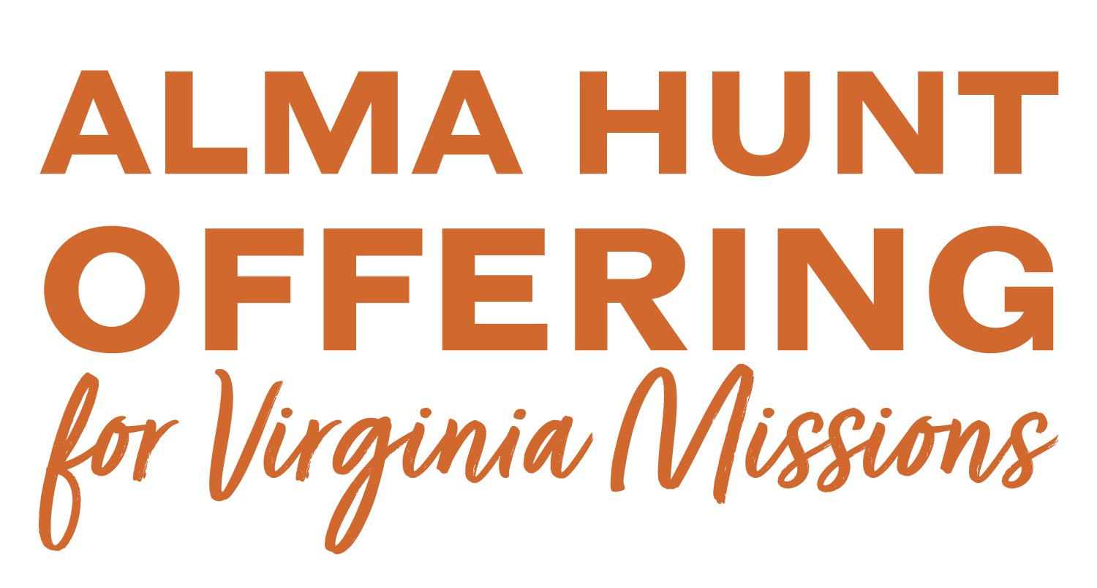

OPERATION CHRISTMAS CHILD SHOEBOXES

Church | # Boxes
Antioch (Scottsville) | 434
Antioch Union | 95
Buckingham | 35
Cedar | 26
First Baptist Dillwyn | 104
Mulberry Grove | 36
Tar Wallet | 48

WINTER WEAR CLOTHING DRIVE - 2022

Church | Kindergarten Bags | Coats | Hats | Gloves | Scarves | Blankets | Other
Antioch (Scottsville) | 110 |  |  |  |  |  | Extra Items  Christmas for 1 child provided by a member
Antioch Union | 88 | 51 | 7 |  | 2 |  | 14 other warm clothing items
Buckingham |  | 13 | 15 | 17 |  |  | 2 Hoodies
Cedar |  | 25 | 11 | 12 |  | 24
Enon |  | 44 | 12 | 16 | 12 | 7
First Baptist Dillwyn |  | 50 | 59 | 22 | 1 | 12 | 21 Other warm clothing items
Fitzgerald Memorial | 24 |  |  |  |  | 53
Goshen | 16 | 13 | 29 | 40 | 2
Jones Chapel | 22 |  | 144 | 144 |  | 72
Mt. Zion  WMU | 68 | 22 | 124 | 124 | 26 | 206 | Handmade scrunchies, 64 Pillow Buddies,  23 dozen cookies, 48 cupcakes, 3 cakes,  300 packs of candy,  240 gifts for teachers and staff,  Christmas for 2 children provided by 2 members
$1,200.00 ($300 for the resource officer in each
of our team’s schools: Page, Bell Central,
Lone Jack, & Right Fork)
Mulberry Grove | 60 | 22 | 28 | 98 | 1 | 16 | 13 extra items + school supplies  Christmas for 6 children by Adult SS Class
Sharon |  | 13 | 31 | 60 |  |  | $100.00
Tar Wallet | 18 |  | 242 | 287 | 4 | 63
Hilton Baptist (Newport News) |  |  | 6 | 6 | 7 |  | 22 Other warm clothing items
Hope Team |  |  |  |  |  |  | Christmas for 19 children

IF YOUR CHURCH, WMU, OR OTHER MISSION GROUP DONATED TO THE HOPE FOR APPPALACHIA WINTER WEAR CLOTHING DRIVE AND IS NOT LISTED ABOVE (OR GAVE ADDITIONAL ITEMS OR FUNDS),
PLEASE GET YOUR LIST OF DONATIONS TO PHYLLLIS FOR THE JANUARY NEWSLETTER BY DECEMBER 19.
5
MISSIONS COMMITTEE
- BLUE RIDGE FOOD MINISTRY: During these days of high food prices and low income for many people, our Blue Ridge Food Ministry helps hundreds of people have wholesome food. Please join us by 9:30 AM on Friday, December 9, and December 23, as we share good food and Christian love at the Crystal Cathedral.
- RISE AGAINST HUNGER: Please set aside some money each week for Rise Against Hunger. As we all do so, we will have a large amount to submit to Rise against Hunger in July.
- HOPE FOR APPALACHIA: Thanks to each individual and each church for your generous gifts of warm clothing for our friends in Appalachia. Thanks also to our Mission Team carrying the gifts to Appalachia November 30 – December 3.
- LOTTIE MOON CHRISTMAS OFFERING: As we realize millions of people have never heard the Gospel news – Jesus saves – let us give very generously to our Lottie Moon Christmas
Offering used to send missionaries all over the world.
- As we conclude 2022, and move into 2023, let us, individually, and as churches, be on mission for
Jesus locally, in Virginia, and around the world.
In Christ’s Love,
Jimmy Dunn
Chair

CHURCH OUTREACH

ANTIOCH (SCOTTSVILLE): The Loaves and Fish Ministry served hot meals on November 19, and gave out 67 boxes of food. The Fall Festival was held on November 4 – Antioch extends their thanks to community businesses and families for their donations for that event: Fitzgerald Farms donated pumpkins; Baked on the James donated the cupcakes; two families and a grant donated monies for the bounce houses; and another family took care of the apples and other items. Without the help of the community and families, Antioch couldn’t have reached so many hearts and souls. THANK YOU! On November 3, a Fluvanna County Public Schools Special Education Dinner was held at which 40 guests were served dinner and dessert. On November 8, the church held an Election Outreach, giving coffee and snacks to the voters.

ARVON: A Thanksgiving lunch was held on November 20, following the Sunday church service.

BUCKINGHAM: The church will be giving food boxes to shut-ins and those in need during December.

CEDAR” Through the generosity of the church family to the Annual Thanksgiving Food Drive, the Women on Mission were able to bless 5 families. Due to the rain and cold on October 31, Cedar hosted their Trunk-or-Treat in the Fellowship Hall rather than from car trunks, but it was a really good turnout of all shapes and sizes!

CHESTNUT GROVE: 80 coats were donated to the Central Virginia Christian School’s coat drive to help local children in need of a warm coat for winter.

FIRST BAPTIST DILLWYN: A Fall Festival was held on October 29. Over 100 friends of all ages , including many guests, had a wonderful time eating homemade chili and other foods and sharing in many games and rich fellowship. FBC reached out to the military veterans and their spouses and other guests on Veteran’s Day by serving them a ham and chicken dinner. Many FBC members and friends from other churches prepared and served the meal and shared in rich fellowship with the guests. Members prepared and delivered about 100 Thanksgiving meals to friends of the area with special needs on Sunday, November 20. Following the meal delivery, FBC members enjoyed sharing a fellowship meal together. Helping Hands continues to minister to many people through sending cards to over 50 people each month, visiting, giving grocery and gas cards, and in other ways. A generous love offering was given to Todd Leighty to help with expenses incurred in a recent house fire.

JONES CHAPEL: The youth and adults gave out candy and treats at the Community Trunk-or-Treat and won a prize for “Best Candy”. On November 20, the Jones Chapel Youth Group hosted a Thanksgiving luncheon after worship. The donations will be used for the youth to purchase gifts for the Cumberland Christmas Mother. Jones Chapel has adopted a family (single parent with 5 children) through the Cumberland Christmas Mother program and will purchase gifts and other needed items during the Christmas season. Beginning in December, donations will be collected for the Lottie Moon Christmas Offering.

MULBERRY GROVE: The WMU hosted an Ornament Exchange on November 18. There were 53 in attendance and $300 was collected to assist a local family in need. The WMU purchased and donated 3 cases of wipes for the residents of Heritage Hall Nursing Home.

SHARON: A Thanksgiving luncheon was enjoyed on November 20, with meals delivered afterward to multiple families. Rose of Sharon WMU continues visiting with, and delivering meals to, those who are sick or homebound. Current mission efforts are focused on special Christmas collections supporting a range of worthy causes.

JRBA LEARNS AND GROWS>>>

GLADSTONE MEMORIAL: Pastor Fetty will begin a new sermon series entitled, Two Places, Two People.

JONES CHAPEL: The free Bible study offered through the Virginia Baptist Foundation has been ordered to be used at a future date after a period of “settling in” for Pastor Dane and Marilyn. The materials were ordered online and came within a week, with an accompanying flash drive (or CD, if preferred). Unstoppable is a life-changing Bible study that explores how ordinary people respond to extraordinary challenges. It is designed to strengthen and equip your congregation to cope with loss, grief, and financial hardship. (If interested, go to www.vbfinc.org/ustoppagle to get your free materials.)

6

BGAV ANNUAL MEETING SUMMARY

Eight folks from JRBA traveled to Hampton Roads for the 2022 BGAV Annual Meeting on November 14 – 16. Attending were:
ANTIOCH (SCOTTSVILLE): Rev. Dave Vogt
MT. ZION: Rev. Woody Moore, Janice Moore, John McAllister, and Brenda McAllister
MULBERRY GROVE: Rev. Austin Williams, Gwynn Tyler, and Phyllis Tyler4
Gathering once again with Virginia Baptists from across the state and beyond was inspiring and informative. A “Meet and Greet” with Dr. Wayne Faison (Nominee for Executive Director) was held on Monday afternoon. This was followed by Breakout Sessions dealing with Discipleship and the Current Decline of the Church. There was also a Pastor’s Conference during which Dr. John Upton, and his wife, Debra, spoke. Dr. Upton retired in July as the Executive Director after 20+ years serving Virginia Baptists. The evening service, held at First Baptist Church, Newport News, was a retirement celebration for Dr. Upton. The music was excellent and many stories were shared of Dr. Upton’s impact on the BGAV through his years of service. Dr. Upton and his wife were presented with various items and gifts and a video of his service through the years was a highlight of the celebration.

On Tuesday morning, reports were given by the various committees, officers, the Executive Board, and the Executive Director Search Committee. Special Observances for 2023 were outlined and Resolutions of Appreciations were given. A unique presentation was made of Dr. Upton’s recent portrait to be displayed along with other past directors in the Resource Building. The artist was on hand and a fascinating video was shown of the process of its completion. David Washburn presented the 2023 Budget. He also discussed the new mission initiative, ASCENT, which will be movemental for the Kingdom! A goal of $1 million in donations for this program has been set to honor Dr. Upton in the coming year. $275,000 has already been given by individual members of the Executive Board and a few churches. After the close of the Business Session, everyone enjoyed congregational worship The keynote speaker, Carey Nieuwhof, brought a message concerning the future of the church in America. He gave a great deal of data and statistics about how the church of tomorrow will look and emphasized that the decline in church membership signals the need for change in how we do church. On Tuesday afternoon, regional meetings were held, followed by numerous Breakout Sessions. On Tuesday evening, messengers and guests again gathered for worship. The sermon was presented by Freddy Villarreal, a pastor of “The Dirt Church” of Hampton Roads. He is an innovative pastor who thinks “outside the box” to reach people for Christ and to build up the church. He was inspiring and challenging as he talked about ways the church must change in order to succeed for the Kingdom post pandemic without changing the Gospel message! Business Sessions and Worship Gatherings throughout the meeting opened with old-fashioned hymn sings led by songwriter/musician, Kate Campbell. Carey Nieuwhof spoke again as well.

On Wednesday morning, messengers were called on to vote and approve the various reports, the budget, and the officers for the coming year. During this Business Session, the 2023 Budget was approved as were the following: BGAV Constitution/Bylaws(very slight changes), and Resolutions. Election of the following occurred: Mission Council, Executive Director (Dr. Wayne Faison), BGAV President (Herbert Ponder), 1st Vice-President (Becky McKinney), 2nd VP (Mark Hughes), Clerk (Nathan Taylor), Executive Board, and the Executive Board Chair (Brook Lake). Committee Chairs and retiring Executive Board members were recognized. During the final worship gathering, a memorial service recognized leaders throughout Virginia Baptist life who passed away during the past year. From JRBA, Robert Bryant who served on the Virginia Baptist Mission Board, and Rev. Richard Tuttle, Pastor, Jones Chapel, were remembered. Pastor Freddie Villarreal preached again and closing thoughts were presented by the newly elected Executive Director, Dr. Faison.

Each of the JRBA folks serving as messengers received a copy of the 2022 Book of Reports containing all the reports, the budget, and numerous other information. If there is a report you are interested in, let Phyllis know and she will copy the specific information for you.

OPPORTUNITIES TO SERVE>>>

REQUEST FROM B.C.H.S.

Many of our students need something to carry them over to lunch or afterschool. We invite the churches of JRBA to help provide one large box of shelf-stable snacks that are individually wrapped (like pretzels or cheese/crackers, etc.). I’d be glad to meet anyone to pick items up or to accept money to purchase snacks. The items would be kept in either the office or Libbie Ranson’s office. We would like items to be available to the students beginning in January, 2023. If you have questions, call me at 434-547-2214. Thank you in advance for helping with this outreach.
Michelle Wright
English Department Chair
Buckingham County High School

PREGNANCY SUPPORT CENTER OF SOUTHSIDE VIRGINIA
Annual Sanctity of Life Baby Bottle Fundraiser
January 15 – February 14,2023

FILL BABY BOTTLES AND MAKE A DIFFERENCE!
PSC invites you to be a part of their new vision: To support and equip persons impacted by pregnancy with hope. We “stand in the gap” between a young woman’s unplanned or planned pregnancy and the choices she will make about her pregnancy. We provide FREE services, and share the love of Christ as we come alongside the men and women God leads to our doors. Surely, 2023 will bring new changes for the ministry. We are all excited to see what God does next!

The Baby Bottle Drive is an easy and fun way for churches, individuals, and families to get involved.
Simply:
- Plan to participate in the Sanctity of Human Life fundraising drive.
- Two to four weeks prior to your drive, request the Baby Bottle Banks from PSC. Plan to provide one for each household in your congregatin, and add a few additional ones for individual children or teens.
- Instruct participants that the Baby Bottle Banks may collect coins, bills, or checks. (Please make checks payable to the Pregnancy Support Center.)
- Distribute Baby Bottle Banks to each household on the start date of your drive.
- Remind participatns of the drive throughout the collection period.
- Remind participants the week prior to your collection day (Valentine’s Day) to return all bottles, even empty ones.
When bottles are returned you may:
- Call the PSC contact to pick up the Baby Bottle Banks with the donations in them.
- OR count the money (cash) and the church can write a check for that amount to the Pregnancy Support Center and submit individual checks payable to PSC. (And PSC can arrange pickup of the used bottles.)
Thank you for partnering with us. If you can have questions, please call 434-391-1011 or email dawnhicks@pscsupport.org.
7
IN APPRECIATION>>>
The Gideons International

Dear Friends,

Thank you for your generous gift of $100.00* to The Gideons International! The hope of the Gospel is more powerful than the fear and despair overtaking so many people in our society. That’s why it’s so important your gift provides the hope of God’s Word. Thank you for partnering with us.
May the God of hope fill you with all joy and peace in believing, so that by the power of the Holy Spirit you may abound in hope. Romans 15:13 ESV

A woman named Naticia shared about the all-consuming fear she experienced because of the pandemic. She had two little ones at home, and she had trouble discerning how to live safely and normally with them. But because of your partnership, a faithful Gideon was able to share with her the hope found only in the life, death, and resurrection of Jesus. Because of our partnership, Naticia knows Jesus today and has the Peace she has desperately needed. Thank you!

So please remember, your gifts are always effective because God is always at work in His perfect timing. Than you again for your faithful giving.
In Christ,
Dan Heighway
Executive Director
*$100 donated to The Gideons International through the Additional Missions Fund of the approved JRBA Budget.

Habitat for Humanity

Dear James River Baptist Association,

Thank you for your support and involvement in our mission here at Piedmont Habitat for Humanity. Let me share one example of how your partnership is providing assistance for homeowners of our area:

A senior widow living alone applied for the affordable repair program, for the place she has called home for over 30 years. With the help of excellent volunteers from Woodland Baptist Church (and donations from our partners), she now has a much safer and stable back porch and steps.

Beyond repairs, the bold vision of 14 new homes built over the next two years continues to progress. The cleared land is awaiting foundations on the first site, which will feature four new homes, ready in early 2023!

Whether making needed safety improvements or helping a family experience the benefits of affordable homeownership, you can know that when you give, you are making a positive impact for good in the lives of so many!

On behalf of our neighbors, thank you for your $100.00* donation.
With deepest gratitude,
Jayne Johnson
Executive Director
*$100 donated to the Piedmont Habitat for Humanity through the Additional Missions Fund of the approved JRBA Budget.

JRBA CELEBRATES>>>

CHESTNUT GROVE: The church family welcomes Dwayne Wilkinson, husband of Sarah Wilkinson, as a new member!

SHARON: Pastor Appreciation Day was celebrated with an old-fashioned “Pounding” for Perry and Shari Clore.

JONES CHAPEL: On November 6, Rev. Dane Gressett preached his first sermon as Pastor of Jones Chapel. At the end of the service, Pastor Dane and his wife, Marilyn, along with Rev. Lewis Brandt and his wife, Gail, joined the church as new members. Pictured below, Deacons with Pastor Gressett: Dennis Parker, Gene Bradbury, Rev. Gressett, Rev. Lewis Brandt, and Ryan Whaley.

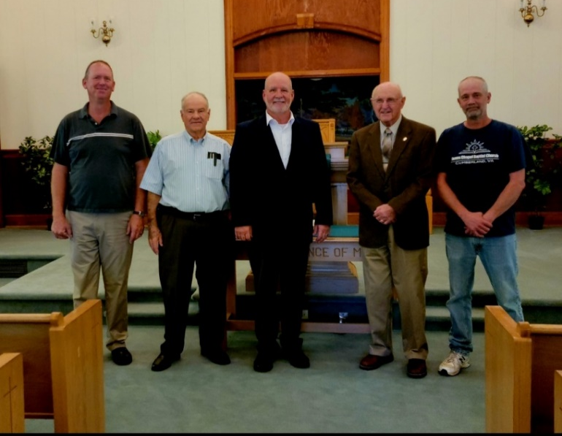

8
STAFF CHANGES>>>

Rev. Steve Emory will start his Pastoral duties at Fitzgerald Memorial on December 1, 2022. He and his wife, Kenita, will reside at 125 Carter Street, Dillwyn VA 23936. His phone number is 434-907-0011. JRBA welcomes Steve and Kenita and looks forward to working with them.

Rev. Henry Enochs, Jr. has resigned as Pastor of Goshen. JRBA wishes the very best for Henry and Jayne in this new season of retirement. (Henry is available for Supply Preaching in our churches. He can be reached at 434-660-4282.)

Rev. Austin Williams, former Associate Pastor, Mulberry Grove, assumed the role of Interim Pastor on November 1.

FROM YOUR MODERATOR>>>

I hope everyone had a Blessed Thanksgiving. We have a lot to be thankful for every day. We’ve had a lot of beautiful sunsets. The other day I looked out of the window as the sun was setting and it looked like a flag in the sky. I have never seen stripes of red (dark pink), white, and the deep royal blue like that. I was talking to my cousin and told her about it – she went outside to take a picture, but she said the picture didn’t do it justice. I have been wondering if it’s a sign from God. Maybe He is saying, “America, remember me!”

This will be the last newsletter before Christmas – May you have a Merry Christmas and Happy New Year.

If I haven’t gotten in touch with you yet and you are serving on a JRBA Committee, please continue. But if you feel you cannot, please let me know.
Call me at 434-581-3957.
In Christ,
Marilyn Snoddy
Moderator

KEEP IN PRAYER>>>
- Those who are lost and need to know the Savior
- The families of recent victims of violence in our state and around the nation
- First Responders
- JRBA Churches without a Pastor: Buckingham, Chestnut Grove, Goshen, and Mulberry Grove
- JRBA Churches, Pastors, and Leadership
- JRBA Hope for Appalachia Mission Team to Kentucky ( November 30 – December 3)
Rev.Woody Moore (Mt. Zion), Wayne & Linda Gough (Mulberry Grove), Darlene Woody, Teresa Glascock, Adrienne Temple, Patricia Shepherd, Michael Shepherd, and Nat Hyatt
- Leaders (Local, State, Nation, and World)
- Victoria Nina Vassle, JRBA WMU Project Ruth Adoptee
- Jimmy & Suzanne (Bryan) Brock – Church planters in Virginia Beach
- All those in our congregations who are ill or who have lost loved ones
Do not be anxious about anything, but in everything, by prayer and petition, with thanksgiving, present your requests to God
And the peace of God, which transcends all understanding, will guard your hearts and your minds in Christ Jesus.
Philippians 4:6-7 (NIV)

FOR YOUR INFORMATION>>>
- ATTENTION NEWSLETTER CONTACTS: Please note that each church should send no more than 4 photos per newsletter. Also please note that the photos need to be “close up shots” in order for them to transfer to print clearly. Please identify the person(s) in the photos.
- ATTENTION AMAZON SHOPPERS: Don’t forget to go to https://smile.amazon.com when you shop Enter your Amazon username and password and select James River Baptist Association as the non-profit to which you wish to donate. Amazon donates 0.5% of the price of
eligible purchases to JRBA. This is a great way to financially support JRBA at NO cost to you.
- ATTENTION CHURCH CLERKS: If you have not completed your 2022 Annual Church Profile, please be aware that the Final Due Date for ALL churches is January 16, 2023. Thank you for your attention to, and completion of, this important report.

THOUGHTS TO PONDER>>>
HYMNS, HYMMODY, AND HYMNALS: FIVE SIGNIFICANT TRENDS
Paraphrased from the original article by Thom S. Rainer

Pre-pandemic, many churches engaged in “worship wars” over the use of hymns and hymnals versus contemporary music. While evidence is anecdotal at this point, it is still worth looking at five significant trends that have developed or accelerated since the pandemic quarantine.
- More churches include at least one hymn in their worship services.
- Congregational singing is as important as the worship style. (There has been a move toward congregational singing rather than performance-based singing.)
- Hymnals are not rebounding even as hymns do. (Most churches now have their songs on screens instead of in books. Congregants can look UP to the screen instead of DOWN at a hymnal.)
- Churches with multiple styes of worship are fewer in number every year. (Offering separate services based on worship style tended to divide churches rather than unite them.)
- Churches still engaging in “worship wars” are headed toward steeper declines and death. (Local churches cannot afford to expend time and energy on worship style disputes. These divisions render congregations spiritually impotent and missionally ineffective. Churches must choose if their energies will be expended on obedience to Christ (through evangelistic activity and the Great Commission) or infighting with each other over worship styles.)
9

FINANCIAL PAGE
REGULAR BUDGET RECEIPTS
2022 - 2023

Church | November | Year-to-Date
Antioch (SV) |  | $ 500.00
Antioch Union
Arvon
Buckingham | $ 500.00 | $ 500.00
Cedar | $3,000.00 | $ 3,000.00
Chestnut Grove
Enon
FBC Dillwyn
Fitzgerald
Fork of Willis |  | $ 420.00
Gladstone Memorial
Goshen
Jones Chapel | $ 159.00 | $ 293.00
Mt. Tabor
Mt. Zion
Mulberry Grove
Sharon |  | $ 302.00
Tar Wallet
Alma Hunt
Individuals
Amazon Smile
TOTAL | $3,659.00 | $ 5,015.00
Approved Budget for 2022 – 2023: $30,342.52
Actual Budget $29,694.00 + $648.52 Carryover Missions Blitz
TREASURERS: Please note that unless a specific ministry or project is designated on the memo line of the check or in an accompanying note, the contribution will appear in the regular budget receipts.
ALSO NOTE: Funds received are reflective of the Associational Year (Oct. 1, 2022 – Sept. 30, 2023), NOT the calendar year.

OTHER BUDGETED LINE ITEMS:

RAH Beginning 8/01/22

Church | November | Year-to-Date
JRBA Budget 2022-2023 |  | $ 500.00
Antioch (Scottsville)
Antioch Union
Arvon
Buckingham
Cedar
Chestnut Grove
Enon
First Baptist Dillwyn
Fitzgerald Memorial
Fork of Willis
Gladstone Memorial |  | $ 221.99
Goshen
Jones Chapel
Mt. Tabor
Mt. Zion
Mulberry Grove
Sharon
Tar Wallet
Individual Gifts | $ 150.00 | $ 150.00
TOTAL | $ 150.00 | $ 871.99

ADDITIONAL MISSIONS:
ALL monies expended for Additional Missions
are listed each month.
Budgeted
$1,600.00
Expended in October: $100 Each:
Southside VA Pregnancy Center, Grace Inside Prison Ministry, Gideons, BCM (Longwood/HampdenSydney), Southside Fellowship of Christian Athletes, BGAV Disaster Response, Piedmont Habitat for Humanity
NO EXPENDITURES IN NOVEMBER
BALANCE: $900.00

MISSIONS BLITZ

Contributor | November | Year End
Carryover from 2021 – 2022 |  | $ 648.52
JRBA Budget 2022 – 2023 |  | $ 250.00
TOTAL |  | $ 898.52
NO EXPENDITURES IN NOVEMBER.

BLAND MINISTRY CENTER

Church | November | Year -to-Date
JRBA Budget-Bland Ministry Center |  | $ 500.00
TOTAL |  | $ 500.00

MISSION TRIPS

Budgeted for 2022 – 2023: $ 2,500.00
EXPENDED IN NOVEMBER:
Rev. Woody Moore, Wayne Gough, and Linda Gough – Hope for Appalachia (Kentucky) - $50 each = $150.00
BALANCE: $2,350.00

NON-BUDGETED MINISTRY:
(ALL monies by donation.)

JOHN E. MANN, SR. BENEVOLENCE FUND

DONATIONS | November | Year-to-Date
Carryover from 2021 – 2022 |  | $ 11,753.38
NEW CONTRIBUTIONS 2022 - 2023
Buckingham | $ 300.00 | $ 300.00
Sharon |  | $ 200.00
TOTAL | $ 300.00 | $ 500.00

EXPENDITURES IN NOVEMBER: $300.00
AVAILABLE DESIGNATED FUNDS: $11,722.28

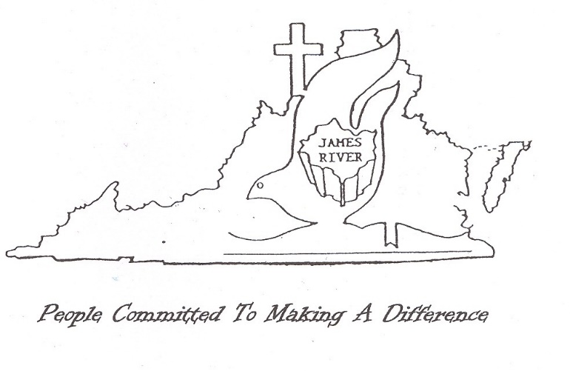
ACCOMPLISHING TOGETHER WHAT WE CANNOT DO ALONE

10

